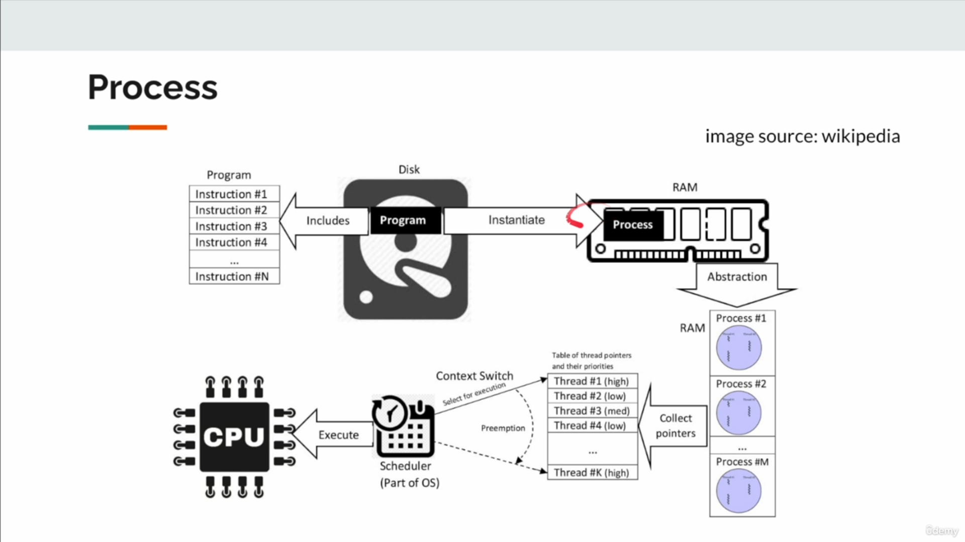
- Sync/Async/Non Blocking/ Non-Blocking+Async
- IO Communication Patterns
- What is Reactive Programming?
  - Why do we need Reactive Programming?
  - How does Reactive Programming work?
  - Why can I not use virtual threads?
  - Principles of Reactive Programming?

1. Synchronous
- Behavior: Tasks execute one at a time. The next task waits for the current one to finish before starting.
- Blocking: Yes. The program halts until the current task is complete.
- Use Case: Simple operations where tasks are dependent on each other, such as reading a file and immediately processing its content.
- Advantages: Easy to implement and understand.
- Disadvantages: Inefficient for tasks that involve waiting (e.g., I/O operations).

2. Asynchronous
- Behavior: Tasks can begin and run concurrently without waiting for each other to finish. The program continues executing while waiting for a result.
- Blocking: No. The program does not stop; it relies on callbacks, promises, or event-driven mechanisms to handle results.
- Use Case: Fetching data from an API while performing other computations or rendering UI elements.
- Advantages: Improves efficiency and responsiveness by using system resources effectively.
- Disadvantages: Can be complex to implement and debug due to concurrency issues.

3. Non-blocking
- Behavior: Tasks return immediately without making the caller wait, even if the operation is not yet complete. The program remains responsive.
- Blocking: No. Results are either checked later or handled through event listeners.
- Use Case: Non-blocking I/O, where the system does not wait for data to be read or written but allows other operations to proceed.
- Advantages: Prevents the program from being "stuck" while waiting for slow operations.
- Disadvantages: Requires mechanisms (e.g., polling or events) to manage the incomplete operations.

4. Non-blocking + Asynchronous
- Behavior: Combines the non-blocking nature with asynchronous execution, ensuring that operations do not block the thread and also allow tasks to run concurrently.
- Blocking: No. Fully event-driven and responsive.
- Use Case: Reactive programming, such as handling high-throughput web requests or streaming data in real time.
- Advantages: Maximizes system resource utilization, ideal for scalable systems.
- Disadvantages: High complexity, requiring reactive libraries or frameworks like Project Reactor or RxJava.

Key Differences
Aspect | Synchronous | Asynchronous | Non-blocking | Non-blocking + Async
Execution | Sequential | Concurrent | Concurrent | Concurrent
Thread Blocking | Yes | No | No | No
Responsiveness | Low | High | High | High
Complexity | Low | Medium | Medium | High
Common Use | Dependent tasks | Independent tasks | I/O operations | Reactive programming

I/O communication patterns define how data is exchanged between components (e.g., client and server) or systems, particularly when interacting with I/O devices like files, databases, or networks. These patterns determine how the system handles requests, responses, and resource utilization.

1. Blocking I/O
- Behavior: The thread initiating the I/O request waits (blocks) until the operation completes (e.g., reading a file or receiving data over a network).
- Characteristics:
  - Simple to implement and understand.
  - The calling thread cannot perform other tasks during the wait.
  - Suitable for low-throughput systems.
- Use Case:
  - Reading from a file or database in a traditional application.
- Example:
  - A file read operation that blocks until all data is read into memory.
- Advantages:
  - Predictable and straightforward.
- Disadvantages:
  - Inefficient for high-latency operations (e.g., waiting for a slow network response).

2. Non-blocking I/O
- Behavior: The I/O request returns immediately with a status indicating whether the operation is complete or in progress. The caller continues execution without waiting.
- Characteristics:
  - Requires polling or event-based mechanisms to track completion.
  - Improves responsiveness by allowing other operations to proceed.
- Use Case:
  - Network communication in high-performance servers.
- Example:
  - Checking whether data is available to read from a socket without blocking.
- Advantages:
  - Increases resource utilization and responsiveness.
- Disadvantages:
  - More complex, requiring mechanisms to handle partial results or retries.

3. Asynchronous I/O
- Behavior: The caller initiates the I/O operation and continues execution. When the operation completes, a callback, event, or signal is triggered.
- Characteristics:
  - Combines non-blocking behavior with notification mechanisms.
  - Ideal for systems with many simultaneous I/O operations.
- Use Case:
  - Handling multiple client requests in web servers.
- Example:
  - Reading from a file system using an event-driven framework.
- Advantages:
  - High scalability and efficient resource usage.
- Disadvantages:
  - Debugging and error handling are more challenging due to asynchronous flow.

4. Multiplexed I/O
- Behavior: Uses a single thread to monitor multiple I/O streams, typically employing a mechanism like select, poll, or epoll.
- Characteristics:
  - Efficiently handles multiple I/O channels.
  - Relies on system calls to check the readiness of I/O streams.
- Use Case:
  - High-performance web servers managing thousands of simultaneous connections.
- Example:
  - Monitoring multiple network sockets for incoming data.
- Advantages:
  - Reduces thread overhead by handling many I/O streams with fewer threads.
- Disadvantages:
  - Requires careful programming to manage event loops and state.

5. Reactive I/O
- Behavior: Combines asynchronous and non-blocking I/O with event-driven programming. It uses a reactive model where data flow and propagation are expressed declaratively.
- Characteristics:
  - Fully event-driven and non-blocking.
  - Fits well with functional and reactive programming paradigms.
- Use Case:
  - Real-time applications, such as live chat systems or IoT data streaming.
- Example:
  - Using frameworks like Project Reactor or RxJava for reactive streams.
- Advantages:
  - Highly scalable and efficient.
  - Ideal for systems requiring real-time responsiveness.
- Disadvantages:
  - High complexity, requiring understanding of reactive programming principles.

6. Memory-Mapped I/O
- Behavior: Maps files or devices into memory, enabling direct access without explicit read/write operations.
- Characteristics:
  - Provides efficient data access and manipulation.
  - Limited by system memory constraints.
- Use Case:
  - File processing, where large files are accessed as memory regions.
- Example:
  - A database engine accessing large datasets stored on disk.
- Advantages:
  - Faster than traditional I/O for random access.
- Disadvantages:
  - Not suitable for dynamic or large-scale data streams.

Comparison Table
Pattern | Blocking | Concurrency | Use Case | Key Mechanism
Blocking I/O | Yes | Low | Simple, low-throughput applications | Blocking calls
Non-blocking I/O | No | Medium | Network servers, responsive systems | Polling or events
Asynchronous I/O | No | High | Real-time systems, high I/O demand | Callbacks or promises
Multiplexed I/O | No | Medium to High | High-performance servers | Select/poll/epoll
Reactive I/O | No | Very High | Real-time and streaming applications | Reactive streams
Memory-Mapped I/O | No | Medium | File processing, database engines | Memory mapping

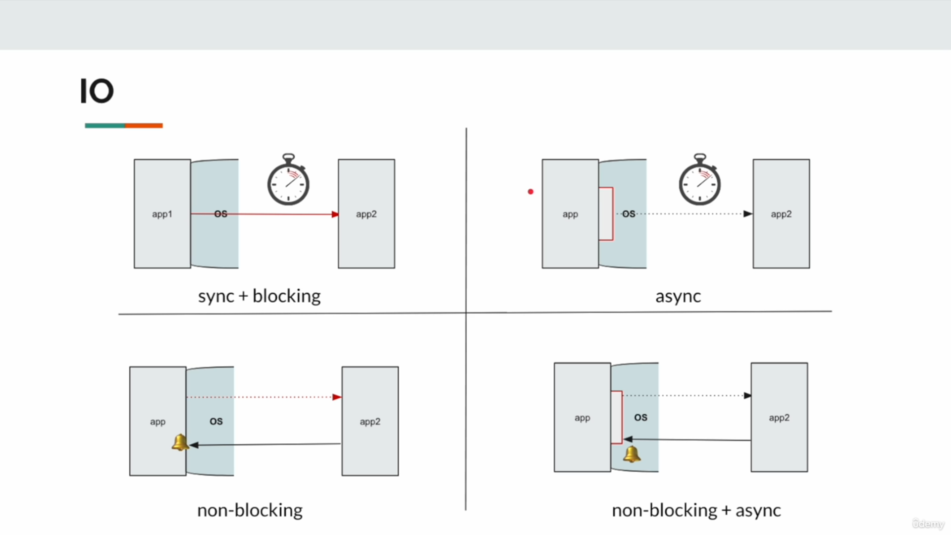

What is Reactive Programming?
Reactive Programming is a programming paradigm focused on building asynchronous, non-blocking, and event-driven systems. It works by reacting to changes (events, data streams) and propagating these changes through the system in a declarative and predictable manner. Reactive systems are designed to handle large amounts of data and concurrent tasks efficiently, making them ideal for modern, distributed, and scalable applications.

Why Do We Need Reactive Programming?
- Efficiency in High-Concurrency Environments:
  - Traditional blocking models are inefficient when managing thousands of simultaneous tasks, as threads are blocked while waiting for I/O operations.
  - Reactive Programming enables non-blocking and asynchronous execution, utilizing fewer resources for the same workload.
- Scalability:
  - It allows applications to scale efficiently by handling more tasks or users with the same resources.
- Responsiveness:
  - Ensures low latency and high throughput, even under heavy loads, making systems more responsive to user interactions.
- Stream Processing:
  - Reactive Programming is particularly well-suited for applications that process continuous streams of data, such as real-time analytics or event-driven architectures.
- Resilience:
  - By isolating components and using message-driven architectures, reactive systems can handle failures gracefully without affecting the entire system.

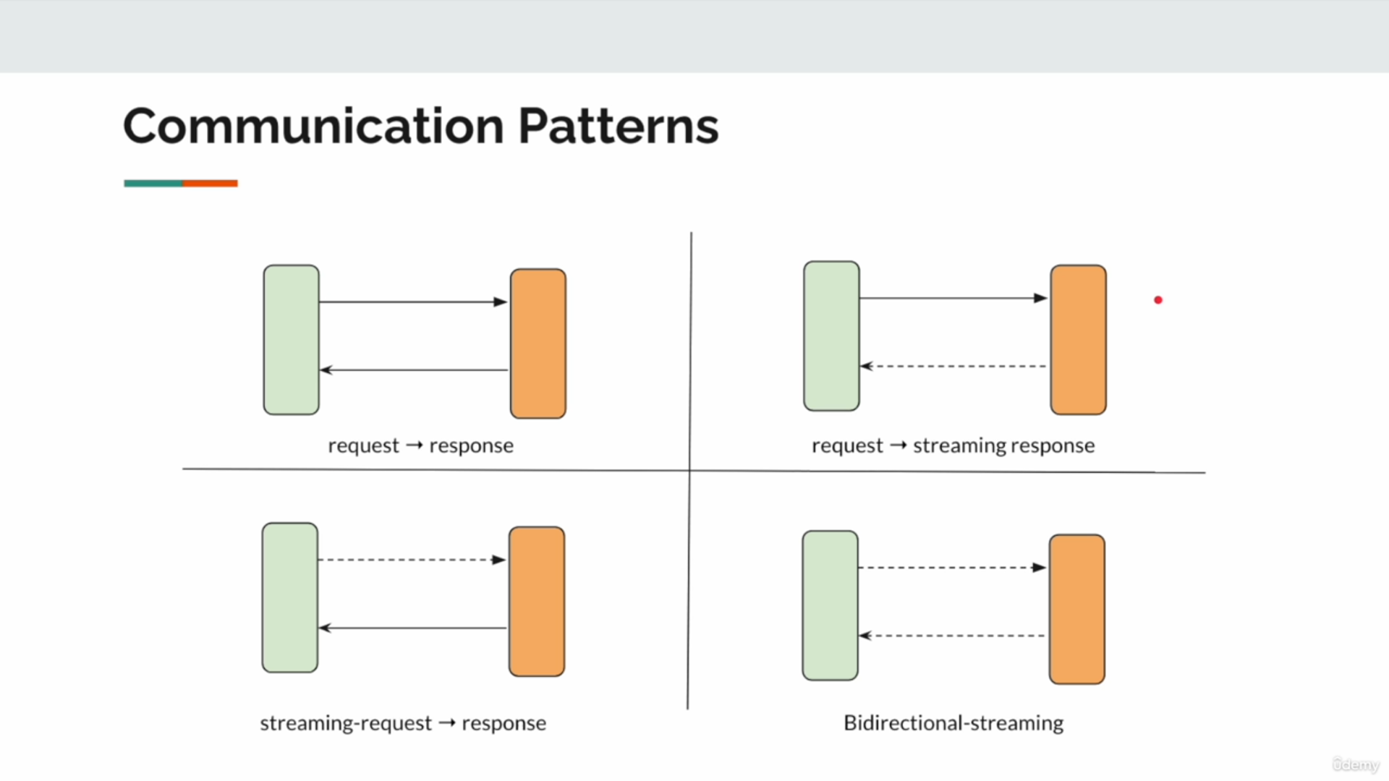

How Does Reactive Programming Work?
- Data as Streams:
  - Data flows through the system as streams of events. These streams can be transformed, filtered, or combined using declarative operators.
- Event-Driven Architecture:
  - Instead of polling or actively waiting for changes, reactive systems "react" to events as they occur, using callbacks, promises, or subscriptions.
- Asynchronous Execution:
  - Tasks are executed asynchronously, freeing up threads and ensuring non-blocking operations.
- Backpressure Management:
  - Reactive Programming manages the flow of data between producers and consumers, preventing overload by allowing consumers to signal how much data they can handle at a time.
- Declarative Style:
  - Code is written declaratively, focusing on what to do with data rather than how to handle the underlying execution.

Why Can I Not Use Virtual Threads Instead?
Virtual threads, such as those introduced in Project Loom in Java, simplify concurrency by making threads lightweight. However, there are cases where reactive programming still has advantages:
- Scalability and Resource Efficiency:
  - Virtual threads reduce the overhead of blocking threads, but they still use underlying system threads. Reactive programming eliminates blocking altogether, leading to better resource utilization.
- Backpressure Handling:
  - Virtual threads do not inherently manage backpressure, while reactive frameworks like Project Reactor or RxJava have built-in mechanisms to ensure consumers are not overwhelmed.
- Declarative Approach:
  - Reactive programming provides a rich set of declarative APIs for stream manipulation, making complex workflows easier to manage than imperative virtual-thread-based code.
- Integration with Existing Reactive Ecosystems:
  - Many libraries and frameworks are built on reactive principles, such as reactive database drivers and messaging systems. These cannot directly leverage virtual threads.
- Stream Processing:
  - Reactive Programming is designed for handling continuous data streams, a use case virtual threads are not optimized for.

Principles of Reactive Programming
- Responsiveness:
  - The system should remain responsive under various load conditions, ensuring a good user experience.
- Asynchronous and Non-Blocking:
  - Tasks should be executed asynchronously, without blocking threads, to maximize efficiency and resource utilization.
- Backpressure Management:
  - The system should balance the flow of data between producers and consumers, ensuring consumers are not overwhelmed.
- Event-Driven:
  - Systems should react to events and propagate changes in a predictable and isolated manner.
- Declarative Data Flow:
  - Focus on describing how data flows and transforms rather than managing control flow explicitly.
- Resilience:
  - Systems should gracefully handle errors, isolate failures, and recover without disrupting the entire application.
- Scalability:
  - The system should be able to handle increasing loads by efficiently utilizing resources.

Publisher/ Subscriber

1.Publisher
  - Generates and publishes messages.
  - Does not know who the subscribers are or how they will process the messages.
  - Publishes messages to a "topic" or "channel."
- Subscriber:
  - Expresses interest in specific topics or channels by subscribing to them.
  - Receives messages from the topics it subscribed to.
- Message Broker:
  - Acts as an intermediary between publishers and subscribers.
  - Manages message delivery, ensuring that messages reach the appropriate subscribers.
  - Examples: RabbitMQ, Apache Kafka, Redis Pub/Sub, MQTT.
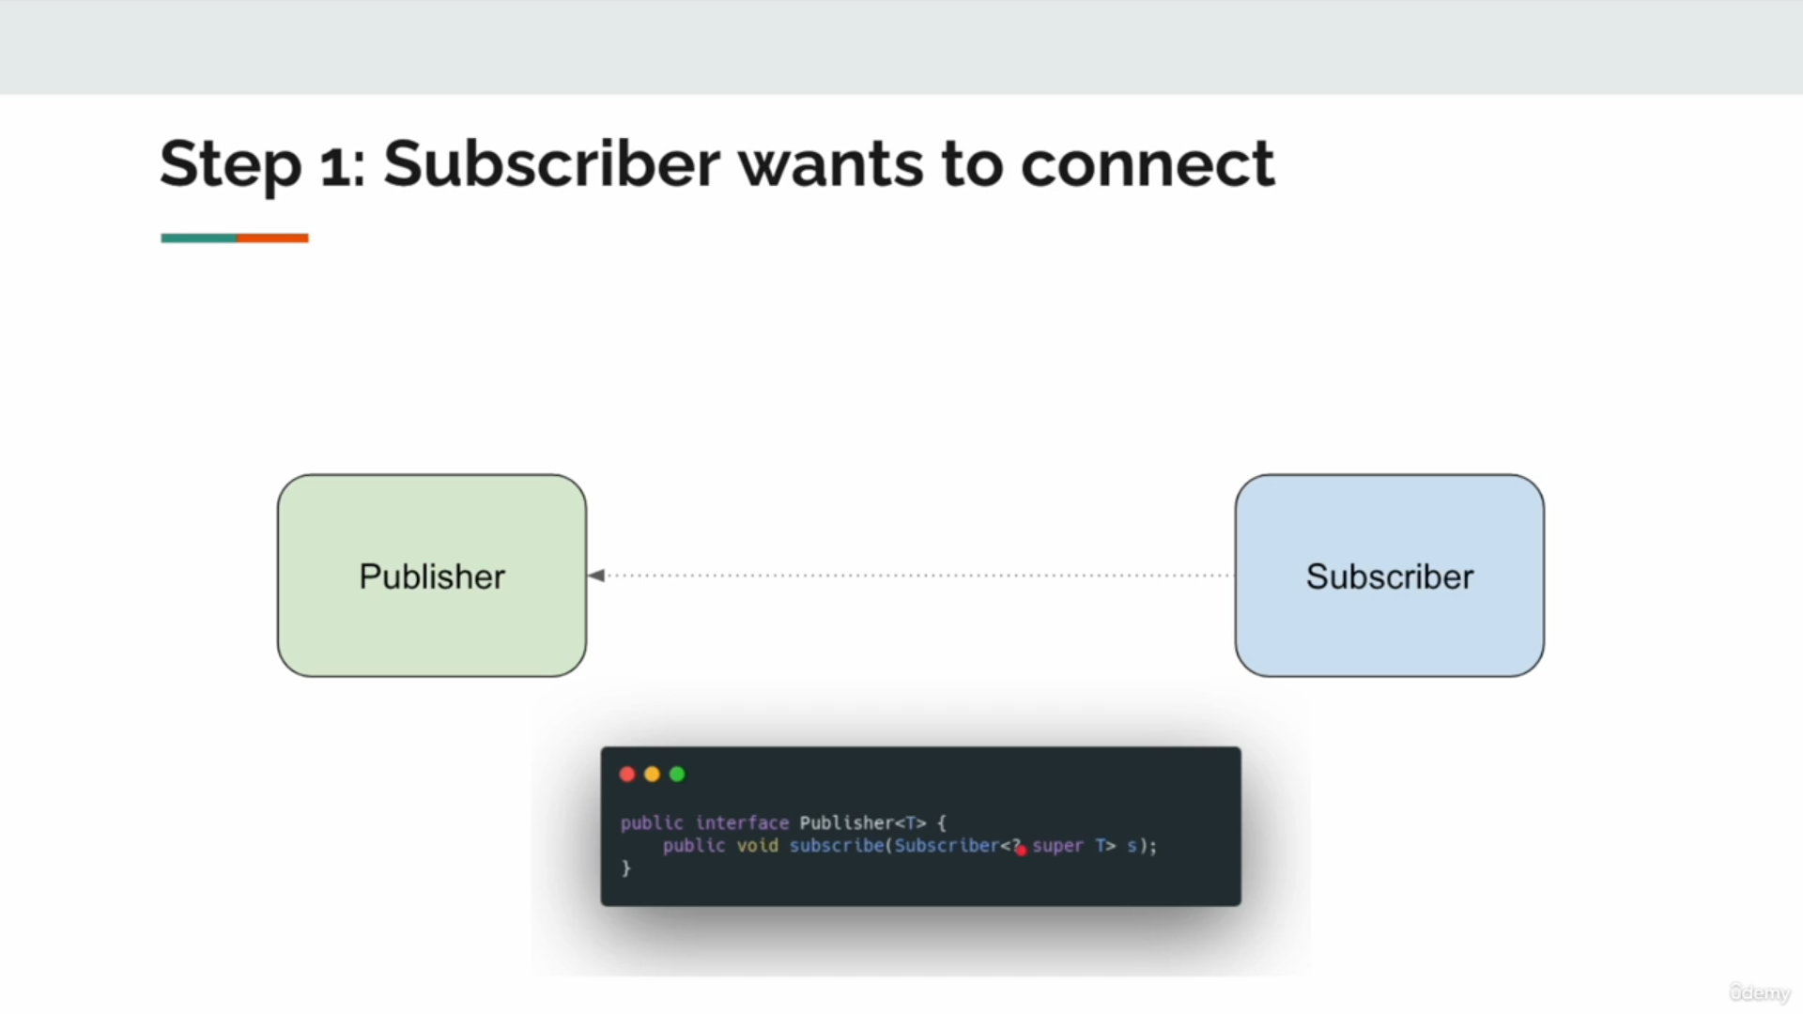

Explanation of Step 1: Subscriber Wants to Connect
- Interaction:
  - The Subscriber initiates a request to subscribe to the Publisher.
  - The communication follows the contract defined by the Publisher interface.
- Publisher Interface:
  - The Publisher<T> interface in the Reactive Streams specification includes the subscribe(Subscriber<? super T> s) method.
  - This method is used by the Subscriber to connect to the Publisher.
- Responsibilities:
  - Publisher:
    - Manages the subscription.
    - Ensures data or events are sent to the subscriber when available.
  - Subscriber:
    - Implements the Subscriber interface to handle data, errors, or completion signals.
    - Declares interest in the data stream by calling the subscribe method.
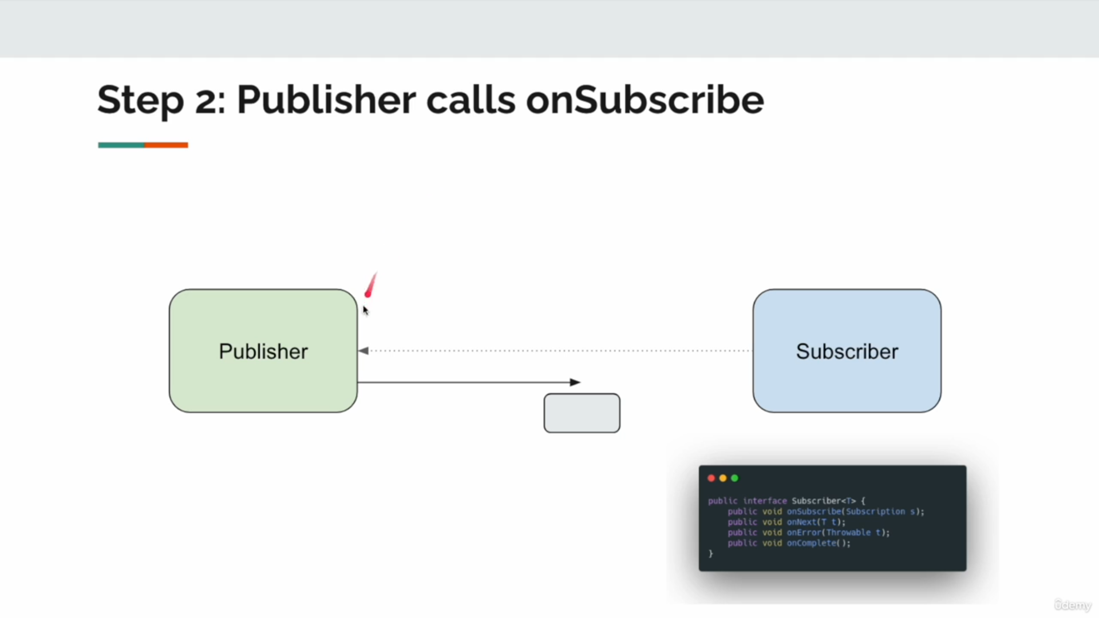

Explanation of Step 2: Publisher Calls onSubscribe
- What Happens:
  - After the Subscriber expresses its intent to subscribe (Step 1), the Publisher acknowledges the subscription by calling the onSubscribe method on the Subscriber.
  - The onSubscribe method provides a Subscription object to the Subscriber.
- Key Roles:
  - Publisher:
    - Sends the Subscription to the Subscriber.
    - The Subscription serves as a contract between the Publisher and Subscriber.
  - Subscriber:
    - Receives the Subscription and can use it to:
      - Request data (request(n)).
      - Cancel the subscription (cancel()).
- Subscription:
  - The Subscription object allows the Subscriber to control the flow of data using backpressure.
  - This ensures that the Subscriber can handle data at its own pace, preventing overloading.
- Subscriber Interface:
  - The Subscriber<T> interface has the following key methods:
    - onSubscribe(Subscription s): Called once when the subscription is established.
    - onNext(T t): Called whenever the Publisher emits a data item.
    - onError(Throwable t): Called if an error occurs during data processing.
    - onComplete(): Called when the Publisher signals that all data has been emitted.

Significance of Step 2:
- Establishes Flow Control:
  - The Subscription handed to the Subscriber allows it to manage the rate of data flow, preventing it from being overwhelmed.
- Starts the Communication:
  - This step ensures that the Subscriber is ready to receive data or signals from the Publisher.

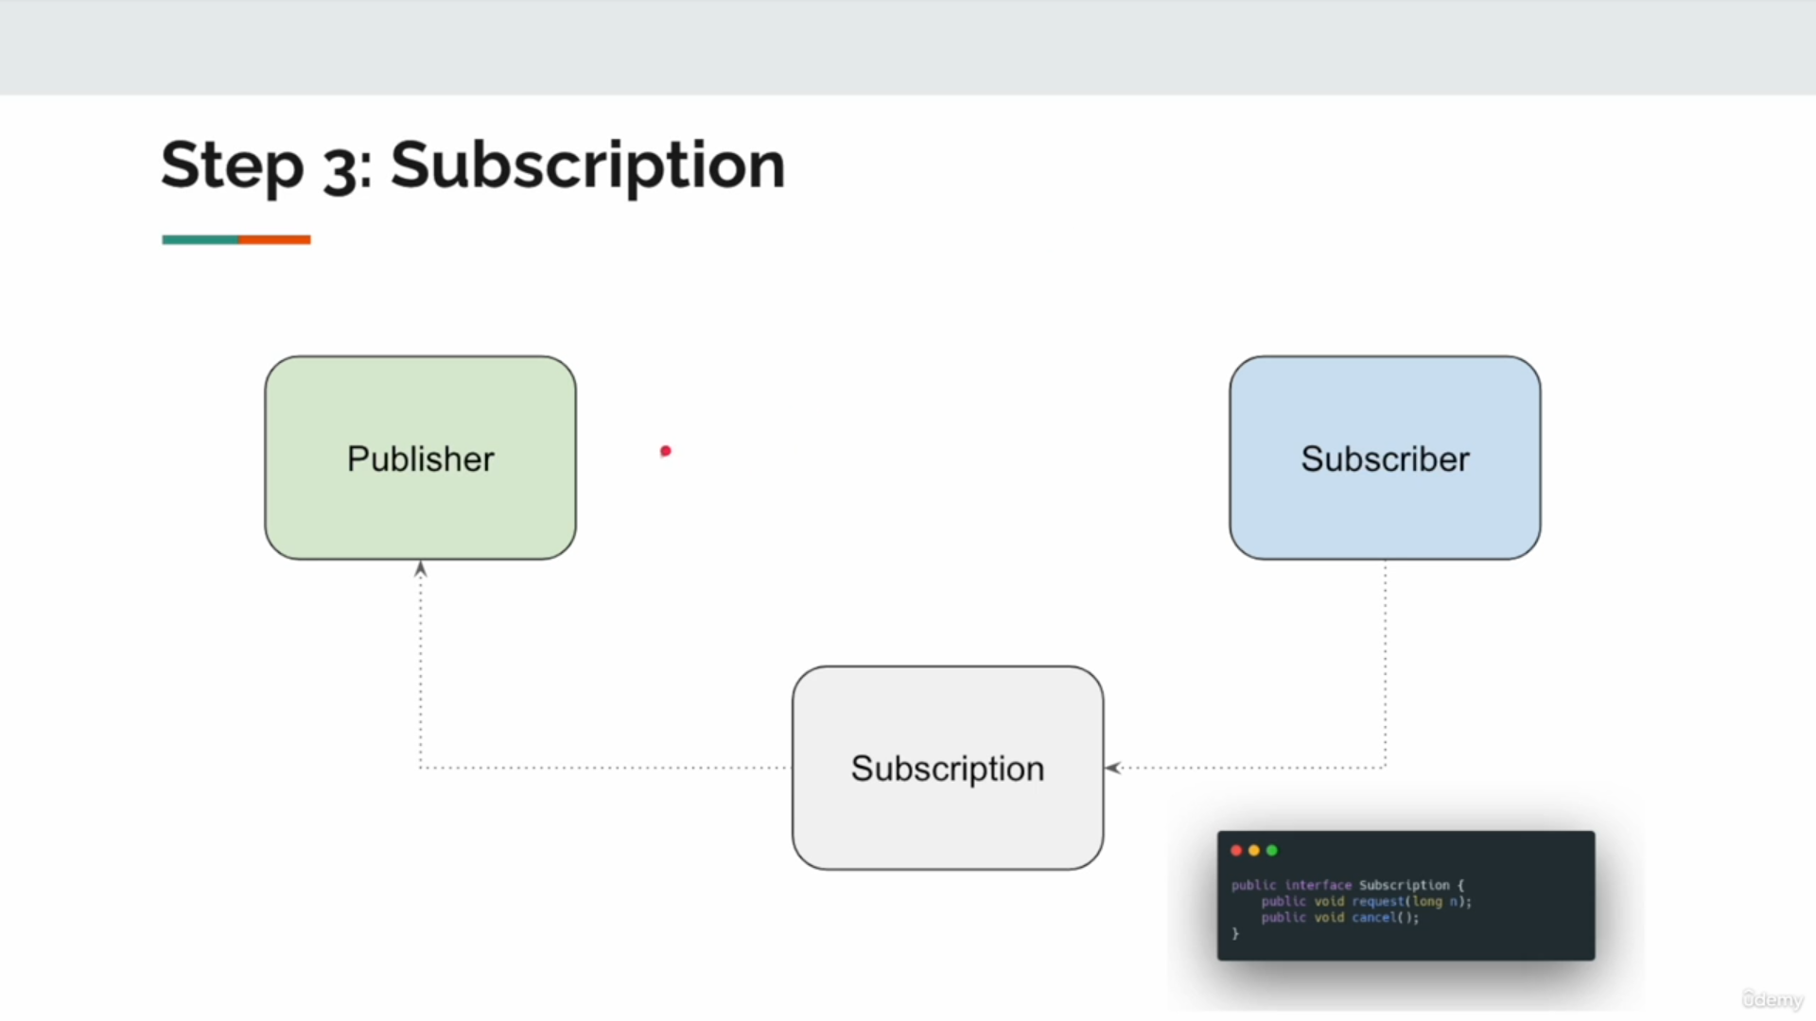

Explanation of Step 3: Subscription
- What Happens:
  - Once the Publisher calls onSubscribe on the Subscriber (Step 2), it provides the Subscription object.
  - The Subscription acts as a contract between the Publisher and Subscriber, enabling the Subscriber to control the flow of data.
- Key Methods of Subscription:
  - request(long n): The Subscriber requests a specific number (n) of items it can handle.
    - This is critical for implementing backpressure.
  - cancel(): The Subscriber cancels the subscription, signaling that it no longer wants to receive data.
- Responsibilities:
  - Publisher:
    - Sends data only when requested by the Subscriber.
    - Stops sending data if the subscription is canceled.
  - Subscriber:
    - Determines how much data it can process by calling request(n).
    - Signals termination by invoking cancel() if it no longer needs data.
- Flow Control (Backpressure):
  - The Subscription ensures that the Publisher does not overwhelm the Subscriber with too much data at once.
  - By explicitly requesting data in chunks (request(n)), the Subscriber maintains control over the flow.

Significance of Step 3:
- Decoupling:
  - The Publisher and Subscriber are loosely coupled. The Subscriber dictates the pace of data flow through the Subscription.
- Backpressure Handling:
  - Prevents system overload by ensuring the Subscriber can process data at its own pace.
- Control:
  - The Subscriber can terminate the connection anytime using cancel(), providing flexibility.
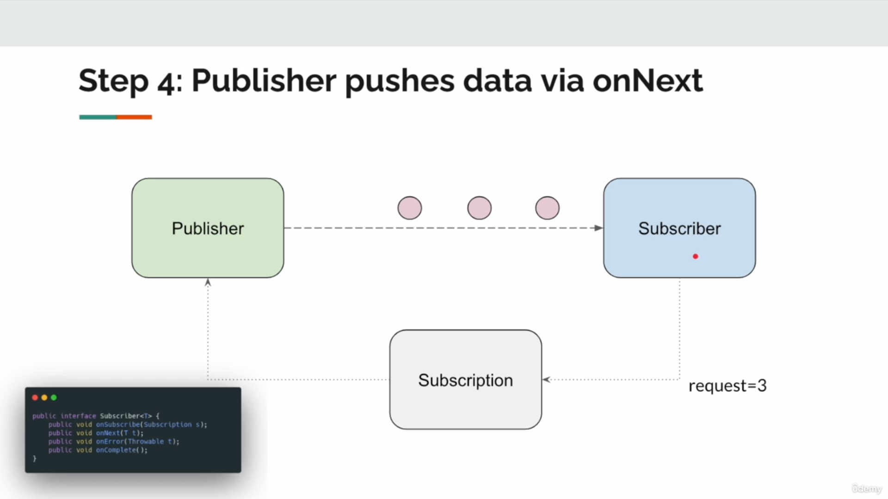

Explanation of Step 4: Publisher Pushes Data
- What Happens:
  - The Subscriber makes a request for data (e.g., request=3) using the Subscription object it received in Step 3.
  - The Publisher responds by emitting the requested number of data items (3 in this example) via the onNext method of the Subscriber.
- Key Interaction:
  - Publisher:
    - Sends data to the Subscriber using the onNext(T t) method.
    - Emits data only up to the amount requested by the Subscriber to respect backpressure.
  - Subscriber:
    - Processes each data item as it is received via onNext.
- Flow Control:
  - The Subscriber controls the rate of data flow by calling request(n) for n items.
  - This ensures that the Subscriber is not overwhelmed with more data than it can handle.
- Responsibilities:
  - Publisher:
    - Ensures that only the requested number of items are sent.
    - Waits for further requests before sending additional data.
  - Subscriber:
    - Processes data items one by one as they are received.
    - Requests more data when it is ready to process additional items.

Significance of Step 4:
- Backpressure Management:
  - The Subscriber dictates the pace of data delivery, ensuring efficient resource usage and preventing overload.
- Non-blocking Data Flow:
  - Data is pushed from the Publisher to the Subscriber asynchronously, maintaining system responsiveness.
- Event-Driven Model:
  - The onNext method is invoked as a callback whenever a new data item is available, adhering to the event-driven paradigm.

Lifecycle Continuation:
- Once the Publisher has sent all requested data items, it waits for the Subscriber to request more (request(n)).
- If there is no more data to send, the Publisher signals completion via onComplete().
- If an error occurs during data emission, the Publisher signals it via onError(Throwable t).
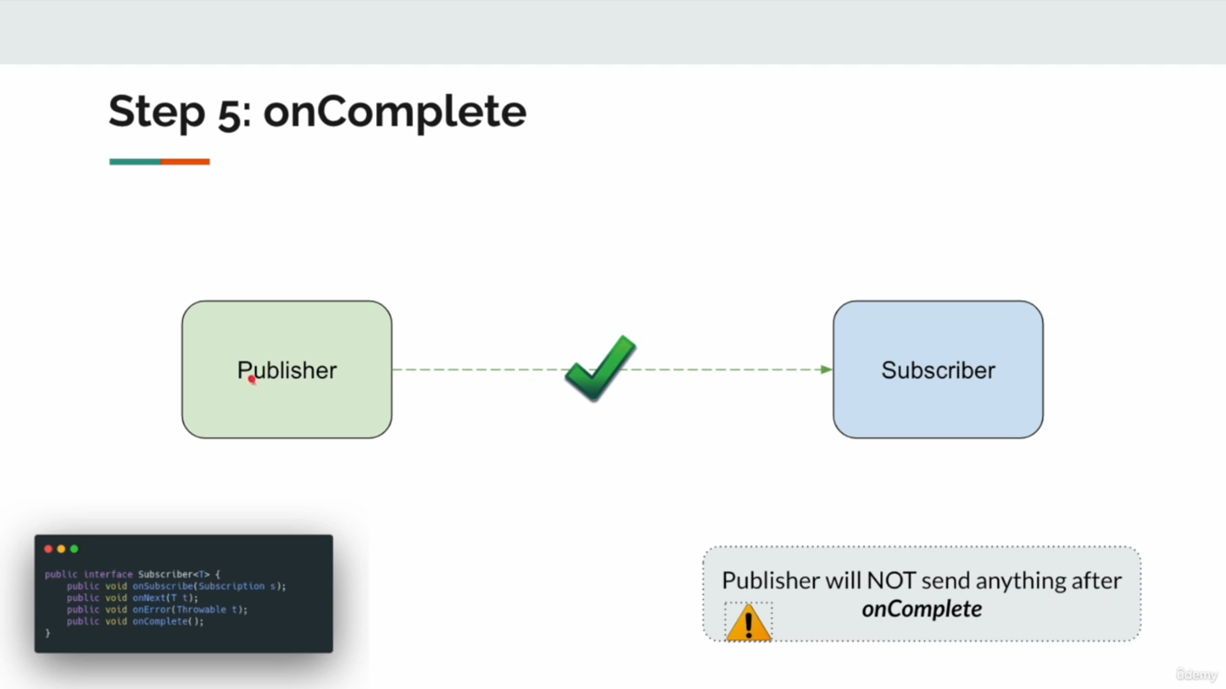

Explanation of Step 5: onComplete
- What Happens:
  - Once the Publisher has emitted all data requested by the Subscriber, and there is no more data to send, the Publisher calls the onComplete() method on the Subscriber.
  - This informs the Subscriber that the data flow has successfully concluded.
- Key Characteristics:
  - The onComplete() signal is terminal, meaning the Publisher will not send any further data or events after this.
  - This marks the successful completion of the communication between the Publisher and Subscriber.
- Responsibilities:
  - Publisher:
    - Calls onComplete() only when all data has been sent, and no errors occurred.
    - Ensures no further calls to onNext() or onError() after onComplete().
  - Subscriber:
    - Handles the completion signal in its implementation of onComplete() (e.g., performing cleanup or finalizing resources).
- Behavior After Completion:
  - Once onComplete() is called:
    - The Subscription is considered terminated.
    - The Subscriber no longer requests or receives data.
    - The Publisher releases resources tied to the Subscription.

Significance of Step 5:
- Finalization:
  - Clearly defines the end of the communication, ensuring both Publisher and Subscriber can safely clean up resources.
- Error-Free Completion:
  - The onComplete() method is called only when the process concludes successfully without errors.
- Contract Adherence:
  - Reactive Streams ensure that no more signals (onNext, onError, or onComplete) are sent after onComplete().

Important Notes:
- No Further Actions:
  - After onComplete() is called, neither the Subscriber nor the Publisher performs further communication related to this Subscription.
- Distinct from onError():
  - If an error occurs during data emission, onError() is called instead of onComplete().
  - The Subscriber will not receive both onComplete() and onError()—only one is terminal.
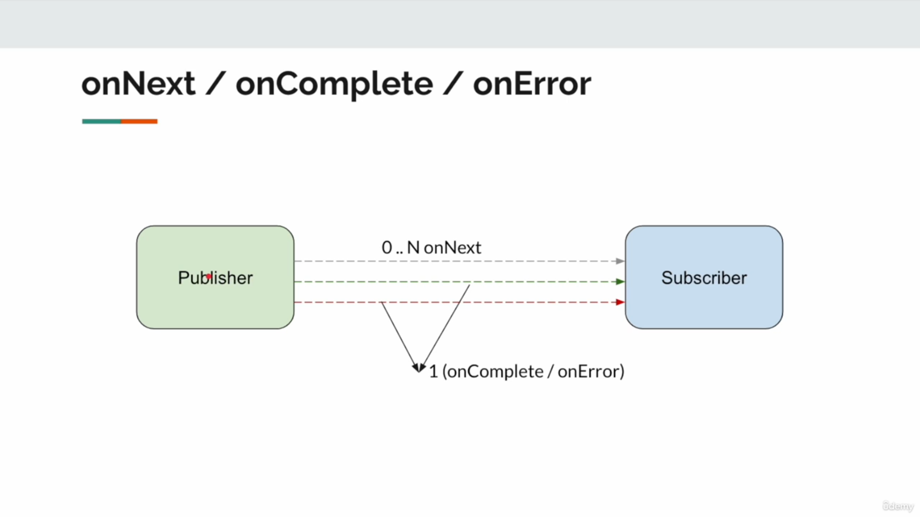

Explanation of onNext / onComplete / onError
- onNext:
  - Represents the data emission phase.
  - The Publisher can emit 0 to N items to the Subscriber using the onNext(T t) method.
  - The flow of onNext signals is dictated by the Subscriber's demand (via request(n) in the Subscription).
  - Key Characteristics:
    - Called multiple times for each item emitted by the Publisher.
    - Does not terminate the communication; the stream remains active unless explicitly ended.
- onComplete:
  - Represents the successful completion phase.
  - Called by the Publisher when all requested data has been emitted and no more data is available.
  - Key Characteristics:
    - A terminal signal, meaning no further onNext or onError calls can occur after onComplete.
    - Used to signal that the Publisher has successfully completed the task.
- onError:
  - Represents the error-handling phase.
  - Called by the Publisher when an error occurs during data processing or emission.
  - Key Characteristics:
    - A terminal signal, similar to onComplete, meaning no further onNext or onComplete signals can occur after onError.
    - Typically used to propagate the exception or error cause to the Subscriber.

Lifecycle Rules:
- Sequence:
  - The Publisher may emit 0 to N onNext signals.
  - Only one terminal signal (onComplete or onError) is sent after all onNext signals are completed or an error occurs.
- Mutual Exclusivity:
  - onComplete and onError are mutually exclusive; only one can occur, not both.
- No Further Signals:
  - After a terminal signal (onComplete or onError), the Publisher must not send any additional signals to the Subscriber.

Key Takeaways:
Signal | Purpose | Characteristics
onNext | Sends a single data item to the Subscriber | Can occur multiple times (0 to N).
onComplete | Signals the successful end of data emission | Terminal, called only once.
onError | Notifies the Subscriber of an error | Terminal, called only once.

Example Scenarios:
- Normal Flow:
  - onNext -> onNext -> onNext -> onComplete
- Error Handling Flow:
  - onNext -> onNext -> onError
- No Data Flow:
  - onComplete (if no data was emitted but no error occurred).

Terminologies
- Publisher:
  - Represents the source of data or events.
  - Other equivalent terms:
    - Source: The origin of data in a stream.
    - Observable: Often used in frameworks like RxJava to represent the producer.
    - Upstream: Refers to components producing data that flow "up" the pipeline.
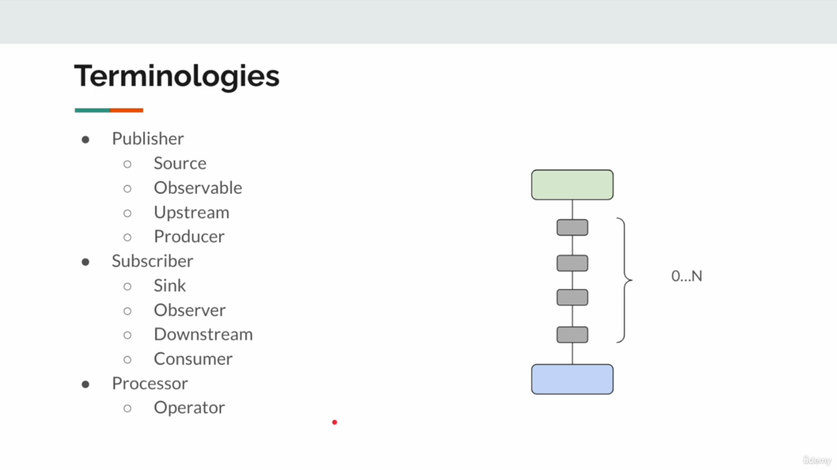
    - Producer: Another term for the entity emitting data.
  - Role: Emits 0 to N data items and ends with either onComplete or onError.
- Subscriber:
  - Represents the sink or consumer of data.
  - Other equivalent terms:
    - Sink: The endpoint where data is processed or consumed.
    - Observer: Common in Rx-based systems; it "observes" emitted data/events.
    - Downstream: Refers to the part of the pipeline consuming data.
    - Consumer: Describes the component that processes or uses the emitted data.
  - Role: Receives data through onNext, handles completion via onComplete, or errors via onError.
- Processor:
  - Represents an intermediary component in the data stream that acts as both a Subscriber (to upstream) and a Publisher (to downstream).
  - Other equivalent terms:
    - Operator: Used in Reactive Streams and RxJava to refer to components that transform or process data in the middle of a pipeline.
  - Role: Transforms, filters, or processes data before passing it downstream.

How These Fit Together
- Flow of Data:
  - The Publisher produces data.
  - The Subscriber consumes the data.
  - A Processor can sit between the Publisher and Subscriber to modify or transform the data flow.
- Pipeline:
  - The system can include 0 to N Processors between the Publisher and Subscriber, creating a chain of operations.
- Direction:
  - Upstream refers to data being emitted from the Publisher or earlier stages in the pipeline.
  - Downstream refers to data flowing toward the Subscriber or later stages.

Diagram Context
- The diagram illustrates a typical data flow pipeline:
  - The green box represents the Publisher (source/upstream/producer).
  - The blue box represents the Subscriber (sink/downstream/consumer).
  - The gray boxes in between represent Processors (operators), handling transformations, filters, or other intermediary tasks.

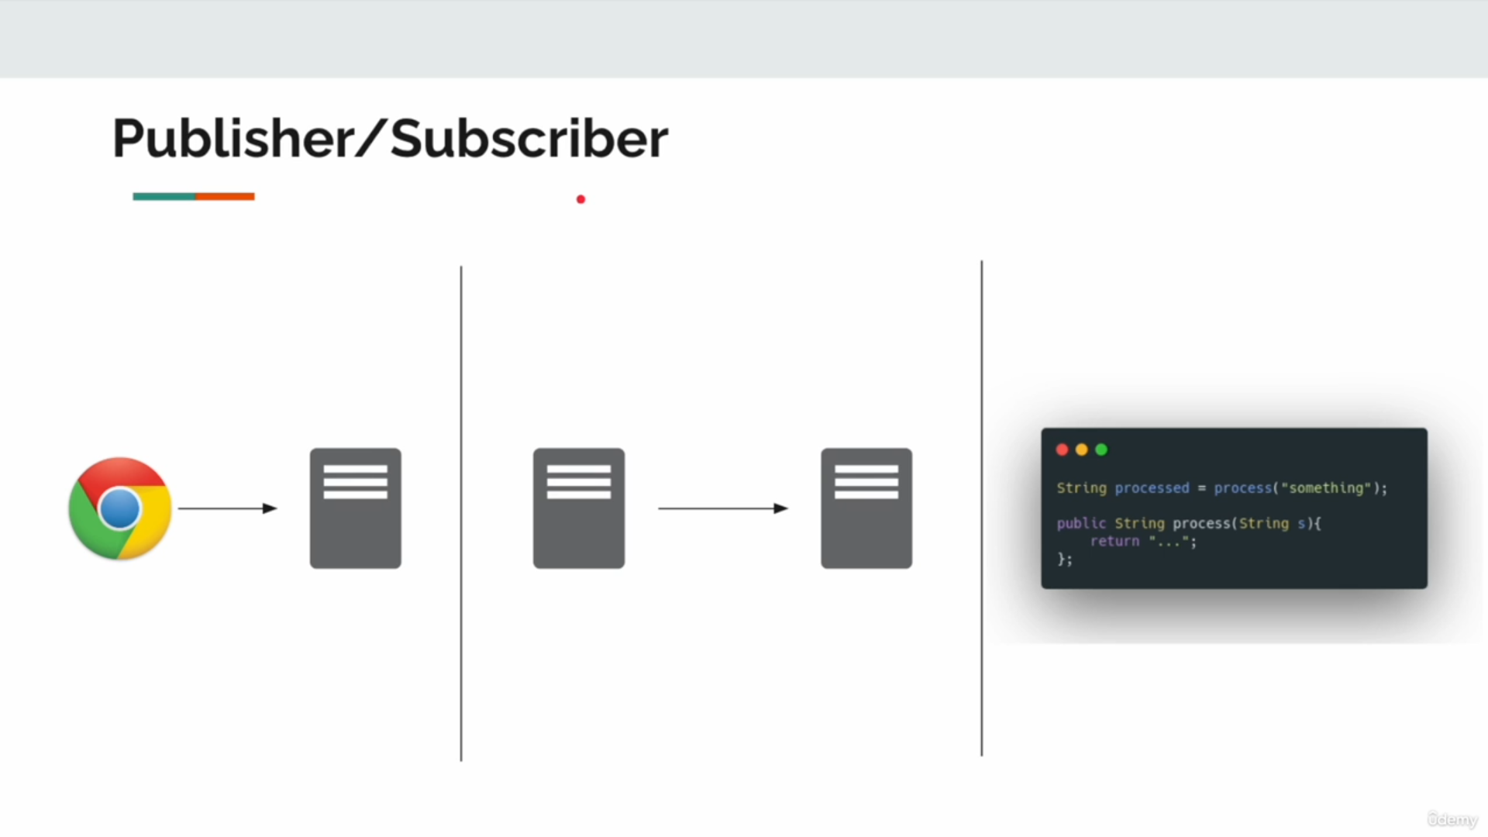

This slide represents a Publisher/Subscriber workflow, demonstrating the flow of data through a system involving multiple components, such as a client (e.g., a browser) and multiple servers, following the Publisher/Subscriber model in the Reactive Streams paradigm.

Explanation
- Entities in the Workflow:
  - Client (Chrome):
    - Acts as the initiator of a request. In this example, it could be a web browser sending a request to fetch data or trigger a process.
    - This client can be thought of as a Subscriber, as it consumes the response or data produced by the servers.
  - Intermediate Servers:
    - These servers act as processors or intermediaries in the data flow.
    - They can:
      - Transform the data.
      - Pass data upstream or downstream.
      - Act as both Publishers (to the next component) and Subscribers (to the previous component).
  - Final Processor or Sink:
    - The final stage in the pipeline that processes the data or returns a result back to the client.

- Data Flow:
  - The Client initiates the communication, which triggers the chain of events between the various servers.
  - Each server may act as:
    - A Publisher, sending data downstream.
    - A Subscriber, receiving data from upstream.
- Code Context:
  - The provided code snippet shows a transformation operation (process function), which represents the processing done at an intermediate or final stage:
java
Copy code
String processed = process("something");
public String process(String s) {
return "...";
}
  - This operation:
    - Takes input ("something").
    - Processes it to produce a transformed output (processed).

Conceptual Mapping to Publisher/Subscriber
- Publisher:
  - In this system, the Intermediate Servers and the final server act as Publishers when they emit processed data downstream.
- Subscriber:
  - The Client and each Intermediate Server subscribe to the output of the previous component in the chain.
- Processor:
  - The Intermediate Servers are processors, as they receive data from upstream, transform it, and emit it downstream.

Use Case Context
This example demonstrates a distributed system with multiple processing stages, commonly used in scenarios like:
- Web Application Pipelines:
  - A browser request flows through an API gateway, microservices, and a database, with each stage processing or transforming the data.
- Data Processing Pipelines:
  - Data flows through various services for enrichment, filtering, or transformation.
- Reactive Systems:
  - Event-driven systems where each component reacts to and processes events as they flow through the system.

Rules in Reactive Programming
Subscription and Request:
  - A Subscriber must subscribe to a Publisher and explicitly request data for the Publisher to start producing items.
  - Until a request is made, the Publisher does not emit any data.
  - Principle: "Be lazy as much as possible," meaning the Publisher only produces data when there is explicit demand.
- Cancellation:
  - A Subscriber can cancel its subscription at any time.
  - Once canceled, the Producer (Publisher) must stop producing data for that Subscriber.
- Data Production via onNext:
  - The Publisher sends data items to the Subscriber using the onNext method, adhering to the requested count.
  - This ensures backpressure is respected, preventing the Subscriber from being overwhelmed.
- Completion via onComplete:
  - After emitting all requested data (or if there is no data to emit), the Publisher signals completion using onComplete.
  - The onComplete signal indicates a successful end to the data flow.
- Error Handling via onError:
  - If an error occurs during data production, the Publisher calls onError to inform the Subscriber of the issue.
  - No further data is sent after this signal.
- No Further Signals After Completion or Error:
  - Once a terminal signal (onComplete or onError) is sent, the Publisher must not emit any additional signals (onNext, onComplete, or onError).
- Subscription Effects:
  - Once a subscription is canceled, further requests or cancellations from the Subscriber have no effect on the Publisher.

Takeaways
- The Publisher/Subscriber relationship is based on strict contracts that ensure predictable and efficient communication.
- Backpressure is a core concept, enabling Subscribers to control the data flow by requesting only what they can handle.
- The system is reactive, with components responding to signals (onNext, onComplete, onError) rather than proactively pulling or pushing data without demand.

Publisher-Subscriber demo is missing

Mono
Mono is a Reactive Streams Publisher provided by Project Reactor, a popular reactive programming library for Java. It represents a Publisher that emits at most one item (or none) and provides mechanisms to handle the emitted item, errors, and completion signals in an asynchronous, non-blocking manner.
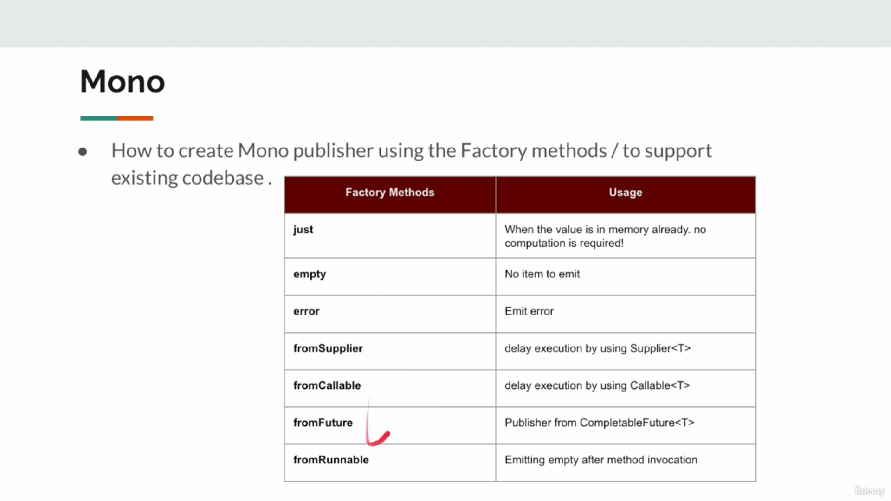

Key Characteristics of Mono
- Single Value or Empty:
  - A Mono can either emit one value, complete empty (without emitting any value), or emit an error.
- Asynchronous and Non-blocking:
  - Operations on Mono are performed asynchronously, ensuring non-blocking execution.
- Compliant with Reactive Streams:
  - Mono adheres to the Reactive Streams Specification, supporting backpressure and interoperability with other reactive libraries.
- Immutability:
  - Mono instances are immutable, meaning any transformation creates a new instance without modifying the original one.

When to Use Mono
- When your logic involves a single result or completion:
  - Examples:
    - Fetching a single item from a database.
    - Performing an HTTP request that expects a single response.
    - Returning a single processed value from a service.

Reactive Lifecycle in Mono
- Creation:
  - You create a Mono using factory methods like just(), empty(), or error().
- Subscription:
  - The Subscriber subscribes to the Mono, triggering its execution.
- Emitting Items:
  - The Mono emits either:
    - A single value (onNext).
    - A completion signal (onComplete).
    - An error signal (onError).

Comparison Between Mono and Flux
Aspect | Mono | Flux
Purpose | Emits 0 or 1 item | Emits 0 to N items
Use Case | Single value responses, HTTP requests | Streaming data, multiple data elements
Lifecycle | onNext -> onComplete/onError | onNext -> (repeat) -> onComplete/onError
Operators | Focused on single-item transformations | Focused on batch or stream transformations

Mono.just
When you have the value already in the memory, and for some reason you will have to create a publisher using that value you can simply use the just method to make it as a publisher.

public class MonoJust {
public static void main(String[] args) {
// Step 1: Create a Mono from an already available value
var mono = Mono.just("Hello World");
// Step 2: Create a subscriber (custom implementation)
var subscriber = new SubscriberImpl();
// Step 3: Subscribe the subscriber to the Mono
mono.subscribe(subscriber);
// Step 4: Request 10 items (Mono will emit at most 1)
subscriber.getSubscription().request(10);
// Step 5: Additional requests and cancellation
subscriber.getSubscription().request(10); // No effect
subscriber.getSubscription().cancel(); // No effect
// Step 6: Pass the Mono to another method for processing
save(Mono.just("Hello World"));
}
// Method to accept and process a Publisher (e.g., saving to a database)
private static void save(Publisher<String> publisher) {
// Example of saving the publisher (e.g., DB operations)
}
}

1. Key Concepts Demonstrated
- Mono.just("Hello World"):
  - Creates a Mono that emits the string "Hello World".
  - Mono.just() is used when the value is already available in memory and no further computation or asynchronous behavior is needed.
- Subscribing to the Mono:
  - A custom subscriber (SubscriberImpl) subscribes to the Mono.
  - The subscription triggers the onSubscribe lifecycle method in the SubscriberImpl, providing a Subscription.
- Requesting Data:
  - The request(10) call specifies that the subscriber is ready to receive 10 items.
  - In the case of Mono, which emits at most one item, this request will cause it to emit the single value ("Hello World") immediately, followed by a complete signal.
- Effect of Additional Requests or Cancel:
  - Subsequent request(10) calls or cancellation (cancel()) have no effect because:
    - The Mono has already completed its lifecycle by emitting the value and sending the completion signal.
- Passing the Mono to Another Method:
  - The save(Mono.just("Hello World")) method call demonstrates how a Mono (or any Publisher) can be passed to other parts of the program for further processing.

2. What Happens When You Run This Code?
- Mono Creation:
  - The Mono.just("Hello World") creates a Mono that emits "Hello World".
- Subscription:
  - The SubscriberImpl subscribes to the Mono. During subscription:
    - onSubscribe is called, providing the subscription to the subscriber.
    - The subscriber stores the subscription for later use (e.g., requesting data).
- Data Request:
  - The first request(10) triggers the Mono to emit "Hello World". The following sequence occurs:
    - The onNext("Hello World") method is called, and "Hello World" is passed to the subscriber.
    - The onComplete() method is called because the Mono has no more data to emit.
- Additional Requests or Cancel:
  - Subsequent calls to request(10) or cancel() have no effect because:
    - The Mono already completed its lifecycle and cannot emit additional data or react to cancellation.
Mono Subscribe
To discuss some of the subscribe overloaded methods
The Mono.subscribe() method in Reactive Programming initiates the reactive flow by subscribing a Subscriber to the Mono. Without calling subscribe(), a Mono (or any reactive stream) is essentially "cold" and does nothing. Here's what happens when you call Mono.subscribe():

1. Purpose of Mono.subscribe()
The subscribe() method triggers the following actions:
- Connects a Subscriber:
  - Attaches a Subscriber to the Mono.
  - The Subscriber is notified of events emitted by the Mono, such as onNext, onComplete, or onError.
- Triggers Data Flow:
  - The Mono starts emitting its data (or an error/completion signal) when subscribe() is called.
  - This makes the Mono "hot" and active.
- Processes Emitted Signals:
  - The Subscriber handles the emitted signals:
    - onSubscribe: Provides a Subscription to manage the flow.
    - onNext: Receives the single emitted value.
    - onError: Handles errors, if any.
    - onComplete: Signals the successful completion of the flow.

Method | What It Does
Mono.subscribe() | Subscribes to the Mono, initiating the reactive flow.
Mono.subscribe(onNext) | Handles the emitted value with the provided onNext consumer.
Mono.subscribe(onNext, onError) | Handles both emitted values and errors.
Mono.subscribe(onNext, onError, onComplete) | Handles values, errors, and completion signals.
Mono.subscribe(Subscriber) | Attaches a custom Subscriber to the Mono for full lifecycle control.

public class MonoSubscribe {
// Logger instance for logging information, errors, and completion events
private static final Logger logger = LoggerFactory.getLogger(MonoSubscribe.class);
public static void main(String[] args) {
// Create a Mono that emits a single string value "Hello World"
var mono = Mono.just("Hello World");
// Create a Mono that emits an integer, processes it using map, and emits the result
var mono1 = Mono.just(1)
.map(i -> i / 1); // Divides the emitted value (1) by 1 (no error here)
// Subscribe to the first Mono and handle its lifecycle events
mono.subscribe(
i -> logger.info("received: {}", i), // Handle emitted data (onNext)
err -> logger.error("error", err), // Handle error signal (onError)
() -> logger.info("completed"), // Handle completion signal (onComplete)
subscription -> subscription.request(1) // Handle onSubscribe and request 1 item
);
// Subscribe to the second Mono and handle its lifecycle events
mono1.subscribe(
i -> logger.info("received: {}", i), // Handle emitted data (onNext)
err -> logger.error("error", err), // Handle error signal (onError)
() -> logger.info("completed"), // Handle completion signal (onComplete)
subscription -> subscription.request(1) // Handle onSubscribe and request 1 item
);
}
}

Code Breakdown
- Mono Creation:
  - var mono = Mono.just("Hello World");
    - Creates a Mono that emits the string "Hello World".
  - var mono1 = Mono.just(1).map(i -> i / 1);
    - Creates a Mono that emits the integer 1, then maps the value to i / 1.
    - In this case, there’s no error because the divisor is 1.
- Subscription:
  - For both mono and mono1, the subscribe() method is used to define how the emitted signals (data, error, completion, subscription) are handled.
  - Four parameters are passed to subscribe():
    - i -> logger.info("received: {}", i):
      - Handles the emitted item (via onNext).
      - Logs the received item.
    - err -> logger.error("error", err):
      - Handles errors (via onError).
      - Logs the error, if any.
    - () -> logger.info("completed"):
      - Handles completion (via onComplete).
      - Logs a completion message when the flow successfully ends.
    - subscription -> subscription.request(1):
      - Handles the onSubscribe signal.
      - Requests exactly one item from the Mono (in this case, the Mono emits at most one item).

Reactive Lifecycle
Here’s what happens step by step during execution:
- Mono.just("Hello World"):
  - The Mono emits "Hello World".
  - The subscribe() handles it as follows:
    - Logs "received: Hello World".
    - Signals completion after emitting the single item.
- Mono.just(1).map(i -> i / 1):
  - The Mono emits the integer 1.
  - The map operation divides the emitted value by 1, which results in 1 without any error.
  - The subscribe() handles it as follows:
    - Logs "received: 1".
    - Signals completion after emitting the single item.
Default Subscriber
The DefaultSubscriber is a generic implementation of the Subscriber interface designed to provide a reusable, consistent, and extendable structure for handling reactive stream subscriptions. Coupled with utility methods in the Util class, it facilitates the creation of named or default subscribers, enhancing reusability, readability, and maintainability. This design pattern streamlines the management of multiple subscriptions by centralizing common behaviors, such as logging lifecycle events (onNext, onError, onComplete), ensuring uniformity and clarity across reactive pipelines.

// A reusable Subscriber implementation
public class DefaultSubscriber<T> implements Subscriber<T> {
// Logger instance for logging events
private static final Logger log = LoggerFactory.getLogger(DefaultSubscriber.class);
// Name to identify this subscriber (useful for multiple subscribers)
private final String name;
// Constructor to set the name of the subscriber
public DefaultSubscriber(String name) {
this.name = name;
}
@Override
public void onSubscribe(Subscription subscription) {
// Request an unlimited number of items (Long.MAX_VALUE ensures this)
subscription.request(Long.MAX_VALUE);
}
@Override
public void onNext(T item) {
// Log the received item along with the subscriber's name
log.info("{} received: {}", this.name, item);
}
@Override
public void onError(Throwable throwable) {
// Log any errors encountered along with the subscriber's name
log.error("{} error", this.name, throwable);
}
@Override
public void onComplete() {
// Log the completion signal along with the subscriber's name
log.info("{} completed", this.name);
}
}
//Utility class for reusable methods
public class Util {
// Returns a default subscriber with no specific name
public static <T> Subscriber<T> subscriber() {
return new DefaultSubscriber<>("");
}
// Returns a subscriber with a given name
public static <T> Subscriber<T> subscriber(String name) {
return new DefaultSubscriber<>(name);
}
public static void main(String[] args) {
// Create a Mono emitting the string "Hello"
var mono = Mono.just("Hello");
// Subscribe to the Mono using named subscribers
mono.subscribe(subscriber("sub1")); // Logs events for subscriber "sub1"
mono.subscribe(subscriber("sub2")); // Logs events for subscriber "sub2"
}
}

Default Subscriber Implementation:
  - DefaultSubscriber is a generic, reusable implementation of the Subscriber interface.
  - It logs lifecycle events (onNext, onError, onComplete) for any type of data (T).
- Naming Subscribers:
  - The name property helps identify different subscribers during logging, especially useful when multiple subscribers are attached to the same publisher.
- Utility Methods in Util:
  - subscriber(): Returns a DefaultSubscriber with an empty name.
  - subscriber(String name): Returns a DefaultSubscriber with a specified name.
  - These methods make it easy to create consistent, named subscribers across your application.
- Mono Subscription:
  - The Mono.just("Hello") emits the value "Hello" and completes.
  - Each subscriber() attached logs the lifecycle events independently.

Advantages of This Design
- Reusability:
  - You avoid duplicating Subscriber logic by creating a generic implementation in DefaultSubscriber.
- Readability:
  - The Util class provides intuitive methods to create subscribers, improving code clarity.
- Consistency:
  - Using a common DefaultSubscriber ensures all subscribers behave uniformly (e.g., consistent logging or error handling).
- Scalability:
  - This approach makes it easier to handle multiple subscribers in a large system, especially in complex reactive pipelines.

Real-World Applications
- Event Processing:
  - For systems that handle multiple event listeners (subscribers), this pattern can simplify managing subscribers.
- Debugging:
  - Named subscribers make it easier to trace and debug issues in complex reactive streams.
- Standardized Error Handling:
  - Centralizing subscriber behavior ensures consistent handling of errors across your application.
Mono Empty Error
The MonoEmptyError class demonstrates a practical implementation of reactive programming using Mono to handle various scenarios for user data retrieval. It employs the Mono abstraction to manage three distinct outcomes: emitting a valid result, emitting an empty signal for no data, or propagating an error for invalid inputs. This approach aligns with the principles of reactive streams by providing a non-blocking and declarative mechanism to manage asynchronous data flows. The class highlights conditional logic to determine the appropriate response (Mono.just, Mono.empty, or Mono.error) and utilizes a reusable subscriber to handle data emission, completion, and error signals consistently.
//EMitting empty error
public class MonoEmptyError {
public static void main(String[] args) {
// Subscribe to the Mono returned by getUserName with a reusable subscriber
getUserName(6)
.subscribe(Util.subscriber()); // Handles data, errors, and completion
}
// Method to fetch a username based on userId
private static Mono<String> getUserName(int userId) {
return switch (userId) {
case 1 -> Mono.just("John"); // Emit "John" for userId 1
case 2 -> Mono.just("Jane"); // Emit "Jane" for userId 2
case 3 -> Mono.empty(); // Emit no value for userId 3
default -> Mono.error(new RuntimeException("Invalid input")); // Emit an error for any other userId
};
}
}

Key Concepts
- Reactive Programming with Mono:
  - The code uses Mono to emit a single value, no value (empty()), or an error (error()).
  - Reactive Streams manage these scenarios gracefully, allowing you to handle each case appropriately.
- Conditional Value Emission:
  - The getUserName method uses a switch expression to return:
    - A Mono with a valid username (Mono.just).
    - An empty Mono (Mono.empty) for no result.
    - A Mono emitting an error (Mono.error) for invalid input.
- Subscriber:
  - The Util.subscriber() utility method attaches a subscriber to handle data, errors, and completion signals in a consistent and reusable way.

Code Explanation

getUserName(int userId)
- Accepts a userId as input and determines the appropriate Mono to return:
  - Mono.just("John") or Mono.just("Jane"): Emits a valid username for IDs 1 and 2.
  - Mono.empty(): Emits no value for ID 3, signaling that no data is available.
  - Mono.error(new RuntimeException("Invalid input")): Emits an error for any other ID, signaling an invalid request.

main(String[] args)
- Calls getUserName with the userId 6 and subscribes to the resulting Mono.
- The Util.subscriber() handles:
  - Data: Logs the emitted value (if present).
  - Error: Logs the exception for invalid input.
  - Completion: Logs the completion signal for empty results.

How the Code Works
- If the userId is 1 or 2:
  - A Mono with a valid username is emitted.
  - The subscriber logs the username and a completion signal.
- If the userId is 3:
  - A Mono.empty() is returned.
  - The subscriber logs the completion signal but no data.
- If the userId is any other value:
  - A Mono.error() is returned.
  - The subscriber logs the exception.

Mono from supplier
To delay the execution using supplier/callable
Mono.fromSupplier is a factory method in Project Reactor that creates a Mono which defers the execution of a given Supplier until the Mono is subscribed to. It is used to encapsulate synchronous, potentially computational logic, within a reactive Mono stream, ensuring that the operation is executed only when there is demand from a subscriber. This method adheres to the reactive programming principle of lazy execution and is particularly useful for integrating non-reactive computations into reactive pipelines.

public class MonoFromSupplier {
private static final Logger log = LoggerFactory.getLogger(MonoFromSupplier.class);
public static void main(String[] args) {
// Sample list of integers
var list = List.of(1, 2, 3, 4, 5, 6, 7, 8, 9, 10);
// Use Mono.fromSupplier to lazily compute the sum when subscribed to
Mono.fromSupplier(() -> sum(list))
.subscribe(Util.subscriber()); // Subscribe with reusable subscriber
}
// Method to calculate the sum of a list
private static int sum(List<Integer> list) {
log.info("Calculating sum of {} elements", list.size()); // Log computation
return list.stream().mapToInt(a -> a).sum(); // Compute sum
}
}

Key Changes and Explanation
- Using Mono.fromSupplier:
  - Mono.fromSupplier(Supplier<T>) is used to create a Mono that defers the execution of the sum method until a subscription is made.
  - This ensures that the computation of the sum is lazy, which aligns with the principles of reactive programming.
- Logging Computation:
  - The sum method logs the computation when it is invoked, allowing you to see when the actual work happens.
- Reusable Subscriber:
  - The Util.subscriber() handles the emitted sum, errors, and completion signals in a consistent manner.

Why Use Mono.fromSupplier?
- Lazy Execution:
  - The sum method is not called until a subscriber subscribes to the Mono.
  - This is a key principle in reactive programming, where operations should only execute when there is demand.
- Non-blocking Behavior:
  - The supplier encapsulates synchronous logic (sum calculation) in a reactive Mono pipeline, allowing for seamless integration with other reactive streams.

Mono.fromSupplier is used when the value is not already available in memory and needs to be computed dynamically or on demand at the time of subscription. Unlike Mono.just, which immediately evaluates the provided value, Mono.fromSupplier defers the computation until the Mono is subscribed to, ensuring lazy evaluation.

Aspect | Mono.just | Mono.fromSupplier
Evaluation | Eager: The value is computed immediately. | Lazy: The computation happens upon subscription.
Use Case | When you already have a precomputed value. | When the value needs to be computed on demand.
Efficiency | Inefficient if the value isn't used because the computation happens even without subscribers. | More efficient since the computation is deferred until needed.
Behavior | Static: Wraps an already available value. | Dynamic: Executes the supplier's logic when subscribed.
Purpose | Wraps an already computed value in a Mono. | Dynamically generates a value when subscribed to.
Evaluation | Eager: Computation happens immediately. | Lazy: Computation is deferred until subscription.
Value Source | Value is pre-computed and available in memory. | Value is computed dynamically at runtime.
Use Case | Static or known data. | Expensive, time-dependent, or side-effectful logic.
Example Use | Wrapping a constant, precomputed value, or cached result. | Fetching data, performing calculations, or generating a timestamp.

When Should You Choose Mono.just?
- Use Mono.just when you already have the value in memory or precomputed at the time of Mono creation.
- Example:

- Mono<String> mono = Mono.just("Hello World"); // Static, precomputed value

When Should You Choose Mono.fromSupplier?
- Use Mono.fromSupplier when:
  - The value needs to be computed dynamically.
  - The value depends on runtime conditions.
  - You want to defer the computation until subscription.
- Example:

- Mono<Integer> mono = Mono.fromSupplier(() -> computeExpensiveValue());

Mono From Callable
A Callable in Java is a functional interface provided in the java.util.concurrent package. It represents a task that:
- Can return a result (T).
- Can throw a checked exception (Exception).
Unlike Runnable, which cannot return a result or throw a checked exception, Callable is designed for tasks that require a result or may involve exception handling.
public class MonoFromCallable {
// Logger for logging computation or events
private static final Logger log = LoggerFactory.getLogger(MonoFromCallable.class);
public static void main(String[] args) {
// Sample list of integers
var list = List.of(1, 2, 3, 4, 5, 6, 7, 8, 9, 10);
// Use Mono.fromCallable to lazily compute the sum and handle checked exceptions
Mono.fromCallable(() -> sum(list))
.subscribe(Util.subscriber()); // Subscribe with a reusable subscriber to handle emitted data
}
// Method to calculate the sum of a list
// This method throws an Exception to simulate checked exception handling
private static int sum(List<Integer> list) throws Exception {
log.info("Calculating sum of {} elements", list.size()); // Log the computation
return list.stream().mapToInt(a -> a).sum(); // Compute and return the sum of the list
}
}

Return Type:
  - Callable returns a result of type T.
  - Method signature: T call() throws Exception.
- Checked Exceptions:
  - It supports throwing checked exceptions, making it suitable for tasks that may fail.
- Asynchronous Execution:
  - Commonly used in multithreading, often with ExecutorService for concurrent execution.

ifferences Between Mono.fromSupplier and Mono.fromCallable
Aspect | Mono.fromSupplier | Mono.fromCallable
Purpose | Lazily obtains a value from a Supplier. | Lazily obtains a value from a Callable.
Exception Handling | Does not handle checked exceptions (Supplier cannot throw). | Handles checked exceptions (Callable can throw).
Functional Interface | Uses Supplier<T> (no exception support). | Uses Callable<T> (supports throws Exception).
Use Case | Simple computations or side-effect-free logic. | Tasks that may throw exceptions or require error handling.
Example | Mono.fromSupplier(() -> computeValue()); | Mono.fromCallable(() -> computeValueWithException());

Why Use Mono.fromCallable?
- Checked Exceptions:
  - Allows wrapping methods that may throw checked exceptions into a reactive stream.
  - Example: Database queries, file I/O operations.
- Lazy Evaluation:
  - Similar to Mono.fromSupplier, the Callable is only invoked upon subscription, making it consistent with reactive programming principles.

Mono.fromSupplier:
- Use for simple computations or static value generation.
- Cannot handle checked exceptions.
- Mono.fromCallable:
- Use for methods or logic that may throw checked exceptions.
- Handles exceptions gracefully, making it ideal for I/O or computational tasks that may fail.
Mono From Runnable
Mono.fromRunnable is a factory method in Reactor that creates a Mono which executes a Runnable task when subscribed to. The task runs without emitting any data and completes successfully by emitting an onComplete signal.
Purpose:
  - Executes a Runnable task when the Mono is subscribed to.
  - Suitable for side-effect-only operations, such as logging or sending notifications.
- Signal Emission:
  - Does not emit any onNext value.
  - Emits only onComplete after the task completes.
- Error Handling:
  - If the Runnable throws an exception, the Mono emits onError.
- Non-Blocking:
  - Defers the execution of the Runnable until subscription.

public class MonoFromRunnable {
// Logger instance for logging events
public static final Logger logger = LoggerFactory.getLogger(MonoFromRunnable.class);
public static void main(String[] args) {
// Example usage of getProductName
getProductName(1)
.subscribe(Util.subscriber()); // Simulate subscription for product ID 1
getProductName(99)
.subscribe(Util.subscriber()); // Simulate subscription for an unavailable product
}
// Method to get a product name based on productId
private static Mono<String> getProductName(int productId) {
if (productId == 1) {
// If product ID is 1, simulate fetching a product name
return Mono.fromSupplier(() -> Util.faker().commerce().productName());
}
// For other product IDs, notify the business of the unavailable product
return Mono.fromRunnable(() -> notifyBusiness(productId));
}
// Notify business logic for unavailable products
private static void notifyBusiness(int productId) {
logger.info("Notify business on unavailable product {}", productId);
}
}

Code Explanation
- getProductName(int productId):
  - Product Available (ID = 1):
    - Uses Mono.fromSupplier to lazily fetch the product name.
    - The Supplier generates a product name only when the Mono is subscribed to.
  - Product Unavailable (Other IDs):
    - Uses Mono.fromRunnable to execute a side-effect task (notifyBusiness) when the Mono is subscribed to.
    - Emits only a completion signal (onComplete) after executing the Runnable.
- notifyBusiness(int productId):
  - Logs a message indicating the product is unavailable.
  - This method is invoked through Mono.fromRunnable.
- Main Method:
  - Demonstrates the usage of getProductName with different product IDs.
  - Subscribes to the Mono to trigger the respective behavior for available and unavailable products.

Use Cases for Mono.fromRunnable
- Logging:
  - Recording information during the reactive pipeline execution.
- Notifications:
  - Sending alerts for certain conditions, such as unavailable resources.
- Side-Effect Operations:
  - Executing tasks that don’t return a value but perform essential actions (e.g., updating a counter or sending metrics).

Differences Between Mono.fromSupplier and Mono.fromRunnable
Aspect | Mono.fromSupplier | Mono.fromRunnable
Purpose | Emits a computed value lazily. | Executes a side-effect-only task without emitting a value.
Emits Value (onNext) | Yes, emits the value returned by the Supplier. | No, emits only onComplete after executing the Runnable.
Result Type | Returns the result of the computation. | Executes a task and completes without returning a value.
Use Case | For computations or fetching data lazily. | For logging, notifications, or other side effects.
Example | Fetch a product name or calculate a value. | Log an unavailable product or send a notification.
Mono.fromSupplier: Use when you need to compute and emit a value lazily upon subscription.
- Mono.fromRunnable: Use for tasks that have no result but perform necessary side effects, emitting only a completion signal.

Mono From Future
if you have a CompleteableFUture already, that we can convert into a Mono
Mono.fromFuture is a factory method in Project Reactor that creates a Mono from a CompletableFuture. It integrates asynchronous computations into the reactive programming model, wrapping the future so its result is emitted as a Mono's single value upon completion.

Key Characteristics of Mono.fromFuture
- Purpose:
  - Converts a CompletableFuture into a Mono, enabling seamless integration of future-based asynchronous computations with reactive streams.
- Behavior:
  - The Mono subscribes to the CompletableFuture and emits the result as a Mono's single value when the future completes.
  - If the CompletableFuture fails, the Mono emits an error.
- Deferred Execution:
  - The CompletableFuture starts execution when it is created, but the subscription to the Mono only happens when the reactive pipeline demands it.

When to Use Mono.fromFuture
- Integration with Future-Based APIs:
  - Useful when working with APIs that return CompletableFuture and need to be integrated into a reactive pipeline.
- Non-Blocking Asynchronous Tasks:
  - Converts CompletableFuture results into a reactive stream for further transformation, error handling, or chaining.
- Interoperability:
  - Bridges between existing asynchronous Java constructs (CompletableFuture) and reactive streams (Mono).
- Example Use Cases:
  - Fetching data from a service that returns a CompletableFuture.
  - Wrapping existing asynchronous computations in a reactive flow.

public class MonoFromFuture {
// Logger instance for logging events
public static final Logger log = Logger.getLogger(MonoFromFuture.class.getName());
public static void main(String[] args) throws InterruptedException {
// Create a Mono from a CompletableFuture and subscribe to it
Mono.fromFuture(getName())
.subscribe(Util.subscriber()); // Log and process the emitted value
// Another example: Pass a CompletableFuture supplier method reference to Mono.fromFuture
Mono.fromFuture(MonoFromFuture::getName)
.subscribe(Util.subscriber()); // Log and process the emitted value
// Sleep to allow asynchronous processing to complete
Util.sleepSeconds(1);
}
// Method that returns a CompletableFuture to asynchronously generate a name
private static CompletableFuture<String> getName() {
return CompletableFuture.supplyAsync(() -> {
log.info("Generating name"); // Log when the name generation starts
return Util.faker().name().fullName(); // Return a fake full name
});
}
}

Code Explanation
- First Mono.fromFuture(getName()):
  - Converts the result of the getName() method (a CompletableFuture) into a Mono.
  - Subscribes to the Mono, triggering the future and emitting the name once the future completes.
- Second Mono.fromFuture(MonoFromFuture::getName):
  - Uses a method reference (MonoFromFuture::getName) to provide the CompletableFuture.
  - Converts the future to a Mono and subscribes to it.
- Util.sleepSeconds(1):
  - Ensures that the main thread waits long enough for the asynchronous operations to complete and for the results to be logged.
- getName():
  - Creates a CompletableFuture that generates a random name asynchronously using supplyAsync.
  - Logs when the name generation starts.

Differences Between Mono.fromFuture and Mono.fromSupplier
Aspect | Mono.fromFuture | Mono.fromSupplier
Source Type | Wraps a CompletableFuture. | Wraps a Supplier.
Execution | Depends on when the CompletableFuture starts execution. | Lazily invokes the Supplier upon subscription.
Value Emission | Emits the result of the CompletableFuture. | Emits the result of the Supplier computation.
Use Case | For existing CompletableFuture-based asynchronous tasks. | For lazy, synchronous computation encapsulation.

Mono.fromFuture:
  - Bridges CompletableFuture with reactive programming.
  - Ensures smooth integration of asynchronous tasks with Mono streams.
  - Simplifies working with future-based APIs in reactive systems.
- Use Cases:
  - When an asynchronous computation (e.g., service call or data processing) is already implemented using CompletableFuture.
  - For scenarios requiring non-blocking, future-based operations to align with reactive pipelines.
Mono Defer
Mono.defer is a factory method in Reactor that creates a new Mono for each subscription. It is used to defer the creation of the Mono until a subscription occurs, ensuring that the logic inside the defer block is executed afresh for every subscriber.

Key Characteristics of Mono.defer
- Defer Mono Creation:
  - The provided factory function is executed only when a subscription occurs, creating a new Mono for each subscriber.
- Lazy and Fresh Execution:
  - Unlike static creation methods (Mono.just or Mono.fromSupplier), Mono.defer ensures that the underlying logic is executed anew for each subscription.
- Error Propagation:
  - If the factory function throws an exception, the Mono emits an error.

Importance of Mono.defer
- Fresh State for Each Subscriber:
  - Ensures that every subscription executes the logic in the factory function, providing fresh data or side effects.
- Dynamic Mono Creation:
  - Useful when the emitted data or logic depends on runtime conditions or changes with each subscription.
- Integration with External Systems:
  - Ideal for wrapping resources like database connections or HTTP calls that need to be executed afresh for each subscriber.
- Error Handling:
  - Ensures that errors in the factory function are properly propagated to subscribers.

When to Use Mono.defer
- Time-Sensitive or Dynamic Data:
  - When the value or resource should reflect the state at the moment of subscription.
  - Example: Fetching the current timestamp or querying a database for updated data.
- Fresh State for Side Effects:
  - When each subscriber needs to trigger a separate execution of side effects.
  - Example: Logging or metrics collection.
- Avoiding Premature Execution:
  - When creating the Mono involves expensive operations or side effects that should only happen upon subscription.

public class MonoDefer {
// Logger instance for logging events
public static final Logger log = LoggerFactory.getLogger(MonoDefer.class);
public static void main(String[] args) throws InterruptedException {
// Example of using Mono.defer to defer the creation of the publisher
Mono.defer(() -> {
try {
return createPublisher(); // Create the publisher lazily when subscribed
} catch (InterruptedException e) {
throw new RuntimeException(e); // Wrap checked exceptions in a RuntimeException
}
})
.subscribe(Util.subscriber()); // Subscribe to the deferred Mono
// Directly subscribing to the publisher without deferring
createPublisher().subscribe(Util.subscriber());
}
// Method to create a publisher that emits the sum of a list
private static Mono<Integer> createPublisher() throws InterruptedException {
log.info("Creating publisher"); // Log the creation of the publisher
// Sample list of integers
var list = List.of(1, 2, 3, 4, 5, 6, 7, 8, 9, 10);
// Simulate some delay to show deferred execution behavior
Util.sleepSeconds(1);
// Return a Mono that emits the sum of the list using fromSupplier
return Mono.fromSupplier(() -> {
try {
return sum(list); // Compute the sum of the list
} catch (InterruptedException e) {
throw new RuntimeException(e); // Wrap checked exceptions
}
});
}
// Time-consuming business logic
// Method to calculate the sum of a list
private static int sum(List<Integer> list) throws InterruptedException {
log.info("Calculating sum of {} elements", list.size()); // Log computation
Util.sleepSeconds(3); // Simulate a delay in computation
return list.stream().mapToInt(a -> a).sum(); // Compute and return the sum
}
}

Mono.defer Usage:
  - Wraps the createPublisher() logic to ensure that a new publisher is created for each subscription.
- createPublisher:
  - Logs a message to indicate when the publisher is created.
  - Returns a Mono that emits the sum of a list using Mono.fromSupplier.
- sum:
  - Simulates a time-consuming business operation by adding a delay.
  - Computes and returns the sum of the list.
- Comparison:
  - The first Mono.defer ensures fresh execution for each subscription.
  - The second createPublisher().subscribe() directly subscribes to a pre-created publisher.

Aspect | Mono.defer | Mono.just / Mono.fromSupplier
Execution Timing | Defers the creation of the Mono until subscription. | Creates the Mono immediately.
Fresh Data | Recreates the Mono for each subscription. | Emits the same value for all subscriptions.
Use Case | For dynamically creating fresh data or side effects. | For precomputed or static values, or simple lazy computation.
Example | Mono.defer(() -> Mono.just(getValue())) | Mono.fromSupplier(() -> getValue())

Mono.defer is essential for dynamically creating Mono instances that must reflect fresh or time-sensitive data upon each subscription.
- Use Mono.defer when you need to avoid sharing the same precomputed value or state across subscribers.
- For static or simple lazy computations, Mono.just or Mono.fromSupplier is sufficient, but for more dynamic and flexible logic, Mono.defer is the better choice.

Non-Blocking IO Client
Non-Blocking IO Client is a client that performs input/output (I/O) operations (e.g., HTTP requests) asynchronously without blocking the calling thread. This is achieved using event-driven programming and reactive paradigms, ensuring that the thread remains free to handle other tasks while waiting for the response.

Key Features of Non-Blocking IO Clients
- Asynchronous Execution:
  - I/O tasks are performed in the background using event loops, allowing the main thread to remain unblocked.
- High Concurrency:
  - Handles multiple requests concurrently using minimal threads, improving scalability.
- Event-Driven:
  - Uses callbacks or reactive streams (e.g., Mono, Flux) to handle responses and errors.
- Low Resource Usage:
  - Efficiently utilizes resources like threads, avoiding thread-per-request models.

Usage of Non-Blocking IO Clients
- Building Microservices:
  - Perform HTTP requests to other services or APIs without blocking.
- Data Processing Pipelines:
  - Fetch and process data asynchronously in reactive systems.
- Real-Time Systems:
  - Ideal for systems requiring high concurrency, such as real-time data feeds or IoT applications.
- Integration with Reactive Frameworks:
  - Seamlessly integrates with reactive frameworks like Reactor or Spring WebFlux.
public class AbstractHttpClient {
// Base URL for the API
private static final String BASE_URL = "https://localhost:7878/";
// Shared HttpClient instance
protected final HttpClient client;
public AbstractHttpClient(HttpClient client) {
// Create a LoopResource for managing event loops, limiting to 1 thread
var loopResources = LoopResources.create("Musab", 1, true);
// Configure the HttpClient with base URL and loop resources
this.client = HttpClient.create()
.runOn(loopResources) // Attach the custom loop resource
.baseUrl(BASE_URL); // Set the base URL for API calls
}
}
public class ExternalServiceClient extends AbstractHttpClient {
// Constructor to initialize the parent class with an HttpClient
public ExternalServiceClient() {
super(HttpClient.create());
}
// Method to get a product name by its ID
public Mono<String> getProductName(String productId) {
return this.client.get() // Create a GET request
.uri("/products/" + productId) // Set the URI with product ID
.responseContent() // Get the response content
.aggregate() // Aggregate the response
.asString(); // Convert the response content to a String
}
}
/*
To demo non-blocking IO
Ensure that the external service is up and running
*/
public class NonBlockingIO {
// Logger instance for logging
public static final Logger logger = LoggerFactory.getLogger(NonBlockingIO.class);
public static void main(String[] args) throws InterruptedException {
// Create an instance of the ExternalServiceClient
var client = new ExternalServiceClient();
logger.info("Starting non-blocking IO");
// Loop through and make multiple non-blocking requests
for (int i = 1; i <= 100; i++) {
client.getProductName(String.valueOf(i)) // Fetch product name for each ID
.subscribe(Util.subscriber()); // Subscribe to handle the response
}
// Wait to ensure all asynchronous requests complete
Util.sleepSeconds(2);
}
}

AbstractHttpClient
- Purpose:
  - Provides a base HTTP client configuration to be reused by other clients.
  - Sets up shared resources, like event loops and base URLs.
- Components:
  - LoopResources: Configures the event loop (e.g., using 1 thread for concurrency).
  - HttpClient: A Reactor Netty HTTP client instance with preconfigured settings.

ExternalServiceClient
- Purpose:
  - Extends AbstractHttpClient to add application-specific logic, such as fetching product names from an API.
- Method getProductName:
  - Builds an HTTP GET request to fetch a product name by its ID.
  - Converts the HTTP response body into a Mono<String> (a reactive stream emitting a single value).

NonBlockingIO
- Purpose:
  - Demonstrates the usage of ExternalServiceClient for performing non-blocking I/O.
  - Makes 100 concurrent requests to fetch product names.
- Execution:
  - Calls getProductName for each product ID.
  - Uses .subscribe(Util.subscriber()) to handle the response (logging, processing, etc.).

Updated Code with Comments
Below is your updated code with detailed comments explaining each component and its functionality:

public class AbstractHttpClient {
// Base URL for the API
private static final String BASE_URL = "https://localhost:7878/";
// Shared HttpClient instance
protected final HttpClient client;
public AbstractHttpClient(HttpClient client) {
// Create a LoopResource for managing event loops, limiting to 1 thread
var loopResources = LoopResources.create("Musab", 1, true);
// Configure the HttpClient with base URL and loop resources
this.client = HttpClient.create()
.runOn(loopResources) // Attach the custom loop resource
.baseUrl(BASE_URL); // Set the base URL for API calls
}
}
public class ExternalServiceClient extends AbstractHttpClient {
// Constructor to initialize the parent class with an HttpClient
public ExternalServiceClient() {
super(HttpClient.create());
}
// Method to get a product name by its ID
public Mono<String> getProductName(String productId) {
return this.client.get() // Create a GET request
.uri("/products/" + productId) // Set the URI with product ID
.responseContent() // Get the response content
.aggregate() // Aggregate the response
.asString(); // Convert the response content to a String
}
}
public class NonBlockingIO {
// Logger instance for logging
public static final Logger logger = LoggerFactory.getLogger(NonBlockingIO.class);
public static void main(String[] args) throws InterruptedException {
// Create an instance of the ExternalServiceClient
var client = new ExternalServiceClient();
logger.info("Starting non-blocking IO");
// Loop through and make multiple non-blocking requests
for (int i = 1; i <= 100; i++) {
client.getProductName(String.valueOf(i)) // Fetch product name for each ID
.subscribe(Util.subscriber()); // Subscribe to handle the response
}
// Wait to ensure all asynchronous requests complete
Util.sleepSeconds(2);
}
}

Key Features of Non-Blocking IO Clients
- Asynchronous Execution:
  - I/O tasks are performed in the background using event loops, allowing the main thread to remain unblocked.
- High Concurrency:
  - Handles multiple requests concurrently using minimal threads, improving scalability.
- Event-Driven:
  - Uses callbacks or reactive streams (e.g., Mono, Flux) to handle responses and errors.
- Low Resource Usage:
  - Efficiently utilizes resources like threads, avoiding thread-per-request models.

Usage of Non-Blocking IO Clients
- Building Microservices:
  - Perform HTTP requests to other services or APIs without blocking.
- Data Processing Pipelines:
  - Fetch and process data asynchronously in reactive systems.
- Real-Time Systems:
  - Ideal for systems requiring high concurrency, such as real-time data feeds or IoT applications.
- Integration with Reactive Frameworks:
  - Seamlessly integrates with reactive frameworks like Reactor or Spring WebFlux.

Code Walkthrough

AbstractHttpClient
- Purpose:
  - Provides a base HTTP client configuration to be reused by other clients.
  - Sets up shared resources, like event loops and base URLs.
- Components:
  - LoopResources: Configures the event loop (e.g., using 1 thread for concurrency).
  - HttpClient: A Reactor Netty HTTP client instance with preconfigured settings.

ExternalServiceClient
- Purpose:
  - Extends AbstractHttpClient to add application-specific logic, such as fetching product names from an API.
- Method getProductName:
  - Builds an HTTP GET request to fetch a product name by its ID.
  - Converts the HTTP response body into a Mono<String> (a reactive stream emitting a single value).

NonBlockingIO
- Purpose:
  - Demonstrates the usage of ExternalServiceClient for performing non-blocking I/O.
  - Makes 100 concurrent requests to fetch product names.
- Execution:
  - Calls getProductName for each product ID.
  - Uses .subscribe(Util.subscriber()) to handle the response (logging, processing, etc.).

Practical Example

Simulating the Server
- Run a local server (e.g., using a mock tool like Postman Mock Server or a real backend service).
- Define an endpoint /products/{id} returning JSON data:
json
Copy code
{
"id": "1",
"name": "Product 1"
}

Running the Code
- Start your server.
- Run the NonBlockingIO class.
- Observe the log output:
mathematica
Copy code
INFO Starting non-blocking IO
INFO received: Product 1
INFO completed
INFO received: Product 2
INFO completed
...

Importance of Non-Blocking IO
- Scalability:
  - Handles thousands of concurrent requests efficiently with minimal threads.
- Responsiveness:
  - Ensures low-latency responses by avoiding thread blocking.
- Resource Efficiency:
  - Reduces CPU and memory usage, enabling better utilization of system resources.
- Seamless Integration:
  - Integrates well with modern reactive frameworks for building reactive pipelines.

When to Use Non-Blocking IO
- High-Concurrency Applications:
  - Systems with high throughput requirements, such as APIs handling large traffic.
- Event-Driven Architectures:
  - Systems relying on event-driven programming, such as messaging or streaming platforms.
- Reactive Systems:
  - Applications built on frameworks like Spring WebFlux or Akka Streams.
- Real-Time Applications:
  - Systems that require fast responses, such as stock trading platforms or online games.

public class NonBlockingIO2 {
private static final Logger log = LoggerFactory.getLogger(NonBlockingIO.class);
public static void main(String[] args) throws InterruptedException {
// Create an instance of the client
var client = new ExternalServiceClient();
log.info("Starting non-blocking IO requests");
// Make 10 concurrent requests to fetch product details
for (int i = 1; i <= 10; i++) {
client.getProductDetails(String.valueOf(i))
.doOnSubscribe(s -> log.info("Requesting product {}", i)) // Log when the request starts
.doOnNext(response -> log.info("Response received: {}", response)) // Log the response
.doOnError(error -> log.error("Error occurred for product {}: {}", i, error.getMessage())) // Handle errors
.doOnComplete(() -> log.info("Request completed for product {}", i)) // Log completion
.subscribe(); // Trigger the execution
}
// Sleep to allow asynchronous requests to complete
Thread.sleep(5000);
}
}

- AbstractHttpClient:
- Sets up the shared HttpClient instance with a base URL and custom LoopResources.
- The LoopResources create a thread pool with 2 threads, ensuring efficient event loop management.
- ExternalServiceClient:
- Extends AbstractHttpClient and provides an application-specific method, getProductDetails, to fetch product data from the /products/{id} endpoint.
- The method uses Mono to encapsulate the asynchronous request and response.
- NonBlockingIO:
- Makes 10 concurrent requests to fetch product details using the ExternalServiceClient.
- Logs the progress of each request, including subscription, response receipt, errors, and completion.

Flux
Flux is a reactive type in Project Reactor that represents a Publisher capable of emitting 0 to N items, followed by an onComplete or onError signal. It is part of the Reactor library and adheres to the Reactive Streams specification, supporting asynchronous, non-blocking backpressure-aware data streams.

Key Characteristics of Flux
- Multi-Item Publisher:
  - Unlike Mono (which emits at most one item), Flux can emit multiple items.
- Completion Signal:
  - Emits onComplete after all items have been emitted or onError if an error occurs.
- Asynchronous and Non-Blocking:
  - Processes data streams without blocking threads, enabling efficient resource utilization.
- Reactive Backpressure:
  - Supports backpressure to manage demand, ensuring subscribers only consume as much as they can handle.

Usage of Flux

1. Representing Streams of Data
- Flux is ideal for scenarios involving streams of data, such as collections, event streams, or real-time feeds.

2. Transforming Data
- Provides operators like map, filter, flatMap, and reduce to manipulate and process data streams.

3. Combining Data Sources
- Allows combining multiple Flux streams using operators like merge, concat, and zip.

4. Error Handling
- Supports advanced error-handling mechanisms using operators like onErrorResume, onErrorReturn, and retry.

When to Use Flux
- Streaming Data:
  - For real-time data processing (e.g., WebSocket streams, sensor data).
- Collections or Multiple Results:
  - For handling lists, arrays, or any data source with multiple elements.
- Event-Driven Systems:
  - For processing streams of events, such as user actions or system notifications.
- Combining and Transforming Streams:
  - When you need to merge, zip, or concatenate multiple streams of data.

Key Differences Between Flux and Mono
Aspect | Flux | Mono
Emission Count | 0 to N items | 0 or 1 item
Use Case | For collections, streams, or events. | For single-value responses or results.
Operators | Provides multi-item stream operators. | Focused on single-item processing.

Importance of Flux
- Scalability:
  - Handles large streams of data efficiently with non-blocking, backpressure-aware mechanisms.
- Declarative Data Flow:
  - Simplifies complex stream processing with chaining and composition operators.
- Error Handling:
  - Offers robust error-handling features to ensure resilient and fault-tolerant systems.
- Integration with Reactive Systems:
  - Seamlessly integrates with frameworks like Spring WebFlux, Kafka Streams, and more.
Flux Just
Flux.just is a factory method in Reactor that creates a Flux that emits a predefined set of items and then completes. It is commonly used to create a reactive stream from static or known data.

Key Characteristics of Flux.just
- Static Data Source:
  - Emits a fixed number of items provided at creation time.
- Completion:
  - After emitting all items, it sends an onComplete signal.
- Immediate Emission:
  - Emits items as soon as the Flux is subscribed to.
- Immutable:
  - The Flux created by just cannot be altered after creation, though transformations can be applied to the emitted data.

Usage of Flux.just
- Testing:
  - Create a simple data stream for testing reactive pipelines.
- Static Data:
  - Use when the data is known and doesn’t need to be computed dynamically.
- Initialization:
  - Quickly create a reactive stream from static collections or values.
- Prototyping:
  - Ideal for prototyping reactive operations without needing external data sources.

Importance of Flux.just
- Ease of Use:
  - Provides a quick way to create a reactive stream without complex configurations.
- Readability:
  - Clearly defines the emitted items, making it easy to understand the data source.
- Transformation and Processing:
  - Enables chaining of reactive operators (map, filter, etc.) for data processing.
- Integration:
  - Works seamlessly with other reactive constructs, such as combining streams or applying backpressure.

When to Use Flux.just
- Static or Fixed Data:
  - When the data to be emitted is predefined and doesn’t change.
- Prototyping and Learning:
  - For learning or testing reactive programming concepts.
- Processing Collections:
  - To process small, known collections of data reactively.
public class FluxJust {
public static void main(String[] args) {
// Create a Flux that emits the integers 1 to 10
var flux = Flux.just(1, 2, 3, 4, 5, 6, 7, 8, 9, 10);
// Subscribe a subscriber to consume the emitted values
flux.subscribe(Util.subscriber("subscriber1")); // First subscription, processes raw values
// Apply transformations (filter even numbers and append "even")
flux
.filter(i -> i % 2 == 0) // Keep only even numbers
.map(i -> i + " even") // Transform even numbers to a string
.subscribe(Util.subscriber("subscriber2")); // Second subscription, processes transformed values
}
}
Flux.just:
- The Flux.just method creates a Flux that emits a predefined set of values.
- In this case, it emits the numbers 1 through 10.
- subscribe:
- The first subscription (subscriber1) consumes the original stream and prints the numbers as they are emitted.
- Transformations:
- The second subscription processes a transformed version of the original Flux:
  - Filter: Keeps only even numbers (i % 2 == 0).
  - Map: Appends the string " even" to each even number.
- Pipeline:
- The transformation methods (filter, map) are chained together, creating a reactive pipeline.
- The pipeline is executed only when subscribe is called.

Key Points to Remember
- Multiple Subscriptions:
  - Each subscription processes the Flux independently.
  - Transformations (filter, map) apply only to the pipeline of the specific subscription.
- Immutable Streams:
  - The original Flux created by Flux.just is not modified. Transformations create a new pipeline.
- Declarative Style:
  - Reactive programming uses a declarative approach, where you define the transformations and actions in the pipeline, and they are executed on subscription.
Flux.fromArray & Flux.fromIterable
Flux.fromArray is a factory method in Reactor that creates a Flux from an array. Each element of the array is emitted as an individual event, followed by an onComplete signal.
Flux.fromIterable is a factory method in Reactor that creates a Flux from any Iterable (e.g., List, Set). Each element of the Iterable is emitted as an individual event, followed by an onComplete signal.

Usage

Flux.fromArray
- Use Case:
  - When the data source is an array.
  - Emit each element of the array as a separate event in a reactive stream.

Flux.fromIterable
- Use Case:
  - When the data source is a collection implementing Iterable (e.g., List, Set).
  - Emit each element of the collection as a separate event in a reactive stream.

Importance
- Reactive Transformation:
  - Enables you to process and transform arrays or collections reactively using operators like map, filter, or flatMap.
- Seamless Integration:
  - Simplifies integrating traditional data structures (Array, List) into reactive pipelines.
- Declarative Processing:
  - Allows declarative data manipulation by chaining operators.
- Scalability:
  - Supports non-blocking processing, making it suitable for large datasets when used with operators like parallel.

When to Use
- From Arrays:
  - Use Flux.fromArray when the data source is an array, such as when processing results from an API or a database query.
- From Collections:
  - Use Flux.fromIterable when the data source is a collection, such as a list of user data or event logs.
public class FluxFromArray {
public static void main(String[] args) {
// Create a list of integers
var list = List.of(1, 2, 3, 4, 5, 6, 7, 8, 9, 10);
// Create a Flux from an Iterable (List) and subscribe to it
Flux.fromIterable(list)
.subscribe(System.out::println); // Print each element to the console
// Create an array of integers
Integer[] array = {1, 2, 3, 4, 5, 6, 7, 8, 9, 10};
// Create a Flux from an Array and subscribe to it using a custom subscriber
Flux.fromArray(array)
.subscribe(Util.subscriber()); // Use a custom subscriber to process the data
}
}
Flux.fromIterable(list):
  - Converts a List into a Flux that emits each element of the list as a separate event.
  - The subscribe(System.out::println) prints each emitted element to the console.
- Flux.fromArray(array):
  - Converts an Array into a Flux that emits each element of the array as a separate event.
  - The subscribe(Util.subscriber()) processes each element using a custom subscriber.

Aspect | Flux.fromArray | Flux.fromIterable
Source | Array (T[]) | Iterable (Iterable<T>), like List.
Use Case | Emit elements from an array. | Emit elements from a collection.
Flexibility | Limited to arrays. | Supports any collection implementing Iterable.
Example | Flux.fromArray(new Integer[]{1, 2}) | Flux.fromIterable(List.of(1, 2))

Reactive Integration:
- Flux.fromArray and Flux.fromIterable make it easy to transform traditional data structures into reactive streams.
- Scalability:
- Both methods support the full range of reactive operators, enabling efficient data processing.
- Flexibility:
- Use fromIterable for collections and fromArray for arrays.
Flux From Stream
Flux.fromStream is a factory method in Project Reactor that creates a Flux from a Java Stream. It converts the elements of the Stream into a reactive stream, emitting each element as a separate event.

Usage of Flux.fromStream

Primary Use Cases
- Processing Streams Reactively:
  - Enables the integration of Java Streams with reactive programming.
- Handling Large Data Sets:
  - Allows processing of large data sets (e.g., files, collections) using the non-blocking and backpressure-aware mechanisms of Flux.
- Dynamic Data:
  - Useful for streams generated dynamically, such as from file processing or database queries.

Importance of Flux.fromStream
- Bridging Java Streams and Reactive Streams:
  - Provides a seamless way to integrate traditional Java Streams into a reactive ecosystem.
- Efficient Processing:
  - Leverages the advantages of Streams (e.g., lazy evaluation) while benefiting from reactive operators for transformation and filtering.
- Flexibility:
  - Works with both static data (e.g., lists, arrays) and dynamically generated data.

When to Use
- Reactive Transformation:
  - When you need to process a Stream reactively, applying transformations and filters.
- Dynamic or Large Data:
  - When processing dynamically generated data or large data sets that can benefit from Streams and backpressure.
- Multiple Subscribers:
  - When you have multiple subscribers, use a supplier to ensure each subscriber gets a fresh Stream.
public class FluxFromStream {
public static void main(String[] args) {
// Create a list of integers
var list = List.of(1, 2, 3, 4, 5, 6, 7, 8, 9, 10);
// Create a stream from the list
var stream = list.stream(); // Java Stream can only be consumed once
// Example 1: Using a Supplier to create a Flux with multiple subscribers
var multipleflux = Flux.fromStream(() -> list.stream());
// Each subscription creates a new stream, allowing independent consumption
multipleflux.subscribe(Util.subscriber("Sub1")); // First subscriber
multipleflux.subscribe(Util.subscriber("Sub2")); // Second subscriber
// Example 2: Using a direct Stream to create a Flux
var Oneflux = Flux.fromStream(stream);
// Subscribing for the first time consumes the stream
Oneflux.subscribe(Util.subscriber("Sub1")); // This works because the stream is consumed for the first time
// Subscribing a second time fails because the stream has already been consumed
Oneflux.subscribe(Util.subscriber("Sub2")); // This will throw an IllegalStateException
}
}

1. Java Streams are Single-Use
- The stream object in Java can only be consumed once.
- Once a stream is processed (e.g., through a terminal operation like forEach), it is considered closed and cannot be reused.

2. Using Flux.fromStream(() -> list.stream())
- By providing a supplier (() -> list.stream()), you ensure that:
  - A new stream is created for each subscriber.
  - Each subscription to the Flux results in an independent data stream, avoiding the issue of a closed stream.

3. Using Flux.fromStream(stream)
- When you directly pass the stream to Flux.fromStream, the same stream is shared across all subscribers.
- This works for the first subscription, but any subsequent subscriptions will fail because the stream is already consumed.

Why Provide a Supplier for Multiple Subscribers?
The supplier (() -> list.stream()) ensures that:
- New Streams for Each Subscriber:
  - Each subscription creates a fresh stream, allowing multiple subscribers to consume the same data independently.
- Avoid Stream Consumption Issues:
  - A single-use stream does not work for multiple subscriptions. The supplier bypasses this limitation by providing a new stream each time.

What Happens in This Code

Case 1: Flux.fromStream(() -> list.stream())
- For multipleflux, each subscriber creates a new stream using the supplier.
- Both Sub1 and Sub2 receive the same data independently because a new stream is created for each subscription.
Sub1 received: 1
Sub1 received: 2
...
Sub1 received: 10
Sub1 completed
Sub2 received: 1
Sub2 received: 2
...
Sub2 received: 10
Sub2 completed

Case 2: Flux.fromStream(stream)
- For Oneflux, the same stream is reused for both subscriptions.
- The first subscription (Sub1) successfully consumes the stream.
- The second subscription (Sub2) fails because the stream has already been consumed and is now closed.
Sub1 received: 1
Sub1 received: 2
...
Sub1 received: 10
Sub1 completed
Exception in thread "main" java.lang.IllegalStateException: stream has already been operated upon or closed

Provide a Supplier: Use Flux.fromStream(() -> list.stream()) when multiple subscribers need independent access to the same data source.
- Avoid Reusing Streams: Do not use a direct stream (list.stream()) for multiple subscribers, as streams in Java are single-use and will throw an error after being consumed.
Flux Range
Flux.range is a factory method in Project Reactor that creates a Flux emitting a sequence of consecutive integers. It takes two parameters:
- Starting Number: The first integer in the sequence.
- Count: The total number of integers to emit.

Usage of Flux.range

Primary Use Cases
- Generating Sequences:
  - Quickly generate a sequence of integers for testing or iteration.
- Transforming Data:
  - Combine with operators like map to transform the emitted integers into different types of data (e.g., names, objects).
- Pagination:
  - Create a sequence of page numbers for API calls or database queries.
- Looping Over Fixed Ranges:
  - Replace traditional loops with declarative reactive streams.

Importance of Flux.range
- Declarative and Efficient:
  - Provides a concise and readable way to generate integer sequences without using imperative loops.
- Integration with Reactive Operators:
  - Seamlessly integrates with operators like filter, map, and flatMap for transforming or filtering sequences.
- Asynchronous and Non-Blocking:
  - Emits integers asynchronously, allowing efficient resource utilization.
- Ease of Testing:
  - Ideal for creating mock or test data in reactive pipelines.

When to Use
- Generating Test Data:
  - Quickly create sequences of integers for testing reactive pipelines.
- Dynamic Iteration:
  - When iterating over a fixed range of numbers declaratively in a reactive manner.
- Combining with Transformations:
  - Transform the emitted integers into complex data (e.g., strings, objects).
- Real-Time Data Generation:
  - For scenarios like real-time indexing or generating unique IDs in a reactive stream.

public class FluxRange {
public static void main(String[] args) {
/*
Flux.range creates a sequence of integers starting from a given number.
The first parameter is the starting number.
The second parameter specifies how many items to emit that number.
*/
// Emit a sequence of 10 integers starting from 1
Flux.range(1, 10)
.subscribe(Util.subscriber("sub1")); // Subscriber 1 processes integers 1 to 10
// Emit a sequence of 10 integers starting from 2
Flux.range(2, 10)
.subscribe(Util.subscriber("sub2")); // Subscriber 2 processes integers 2 to 11
// Emit a sequence of 10 integers starting from 1
// Map each integer to a random full name using the Faker library
Flux.range(1, 10)
.map(i -> Util.faker().name().fullName()) // Transform integers into random names
.subscribe(Util.subscriber("sub3")); // Subscriber 3 processes the transformed names
}
}
Flux.range(1, 10):
- Creates a Flux that emits integers starting from 1 and continues for 10 items (1, 2, 3, ..., 10).
- First Subscription (sub1):
- Subscribes to the Flux created by Flux.range(1, 10).
- Receives integers from 1 to 10.
- Second Subscription (sub2):
- Subscribes to the Flux created by Flux.range(2, 10).
- Receives integers from 2 to 11.
- Third Subscription (sub3):
- Transforms the integers emitted by Flux.range(1, 10) into random full names using the map operator.
- Each integer is replaced by a random name before being passed to the subscriber.
Declarative Number Generation:
- Flux.range replaces traditional for-loops for generating consecutive numbers.
- Transformative Pipelines:
- Combine with operators like map to transform sequences into complex reactive pipelines.
- Asynchronous and Efficient:
- Non-blocking emission of data ensures efficient resource usage.

Log Operator
The log operator in Reactor is a debugging tool that intercepts and logs all lifecycle events and signals in a reactive stream. It provides detailed insights into the interaction between the publisher and the subscriber.

Usage of log Operator
- Debugging:
  - Logs every signal in the reactive stream, helping identify issues in the pipeline.
- Understanding Lifecycle Events:
  - Visualize the flow of data and lifecycle events (onSubscribe, onNext, onComplete, onError).
- Performance Monitoring:
  - Track request patterns, data emissions, and backpressure.
- Learning Tool:
  - Understand how reactive streams work by observing their behavior in detail.

Importance of log Operator
- Transparency:
  - Makes the internal workings of a reactive pipeline visible.
- Debugging Complex Pipelines:
  - Identifies bottlenecks, errors, and unexpected behaviors in reactive streams.
- Simplifies Development:
  - Reduces guesswork by showing how data flows through the stream.
- Safe for Production:
  - Can be used in production environments with minimal overhead, but typically disabled in high-performance scenarios.

When to Use log
- During Development:
  - Use log() to understand how your reactive pipeline works.
- Debugging Issues:
  - Identify where errors occur in the stream and how data flows through the operators.
- Learning and Teaching:
  - Explore and explain reactive programming concepts by visualizing the stream lifecycle.
- Testing:
  - Verify the behavior of your pipeline under different conditions (e.g., backpressure).
public class LogOperator {
public static void main(String[] args) {
/*
Flux.range(1, 10) creates a Flux that emits integers from 1 to 10.
log() is a Reactor operator used for debugging purposes. It logs all the reactive
signals (onSubscribe, request, onNext, onError, and onComplete) generated
during the interaction between the publisher and the subscriber.
The `log()` operator acts as a middleman:
- It intercepts all requests made by the subscriber to the producer.
- It logs the requests, responses, and events passing through it.
- It helps visualize the flow of data and lifecycle events in the reactive pipeline.
This is particularly useful for debugging and understanding reactive streams behavior.
*/
// Create a Flux, log its lifecycle, transform data, and log the transformation
Flux.range(1, 10)
.log() // Logs the lifecycle events from producer to subscriber
.map(i -> Util.faker().artist().name()) // Transform integers into artist names
.log() // Logs the lifecycle events after the transformation
.subscribe(Util.subscriber()); // Subscribe to process the emitted values
}
}
Flux.range(1, 10):
  - Creates a Flux that emits integers from 1 to 10 sequentially.
- log() Operator:
  - Logs every interaction between the publisher and the subscriber.
  - Logs all signals in the reactive pipeline, including:
    - onSubscribe: When the subscription starts.
    - request: When the subscriber requests data.
    - onNext: When the publisher emits a value.
    - onComplete: When the publisher completes.
    - onError: If an error occurs in the stream.
- map() Transformation:
  - Transforms the emitted integers into artist names using the Faker library.
- Second log():
  - Logs the signals after the transformation, allowing you to debug each stage of the reactive pipeline.
- subscribe():
  - Subscribes to the Flux to trigger execution and process the transformed data.
Flux Vs List

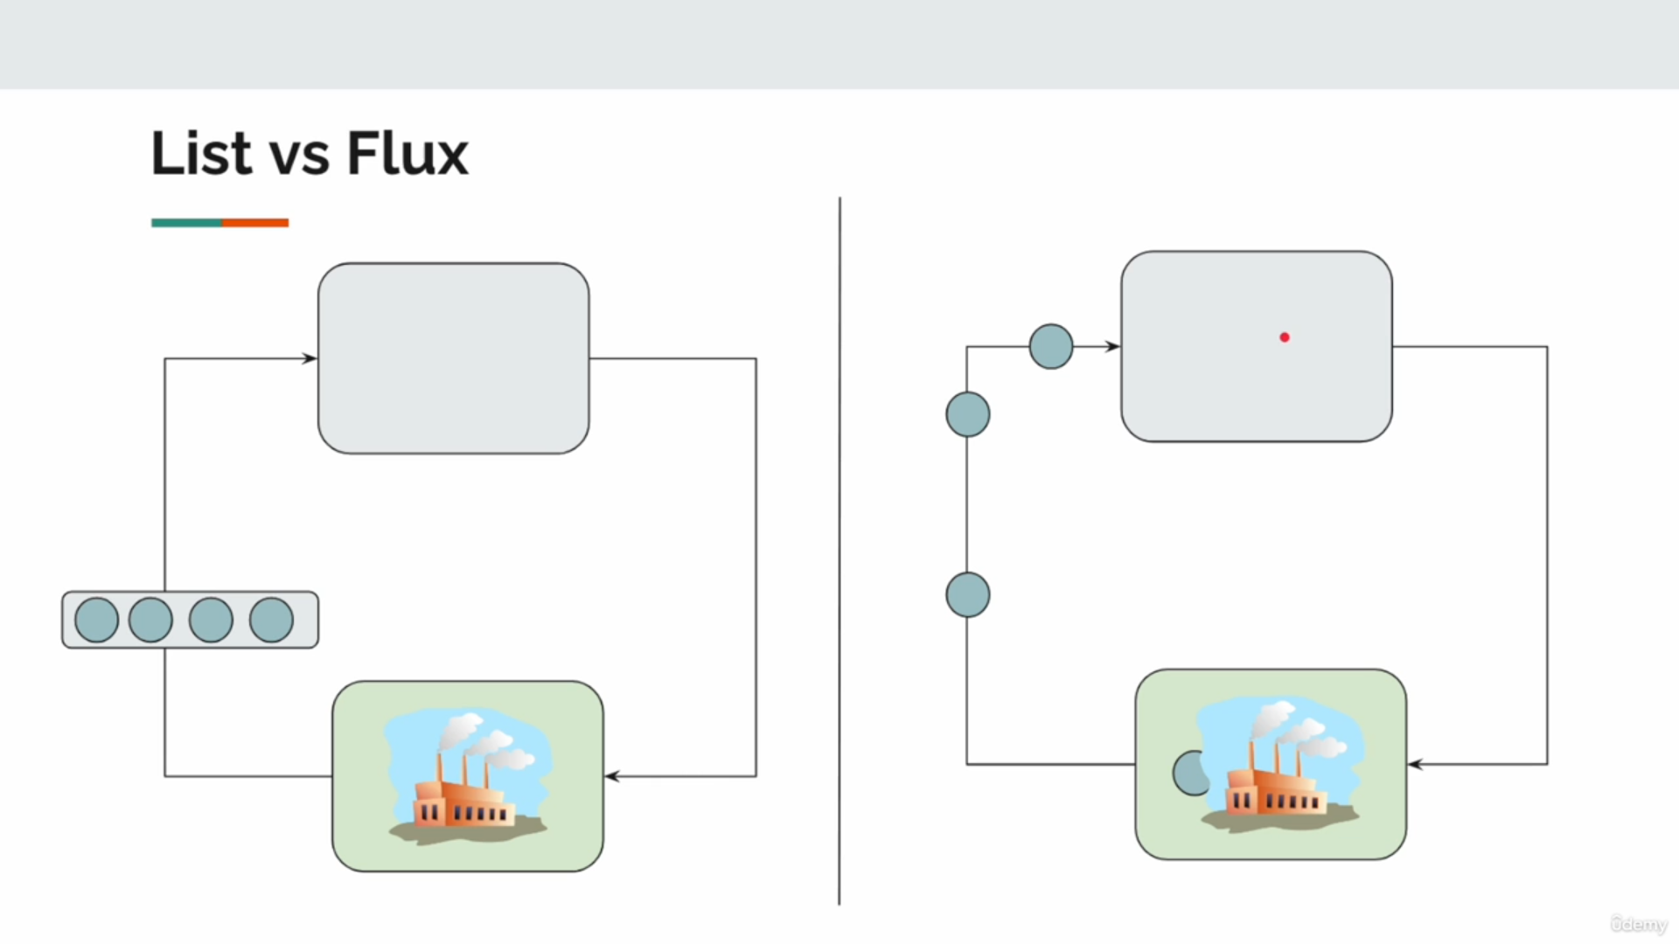

Comparison: Flux vs List
Aspect | List | Flux
Execution | Synchronous: Generates all items upfront. | Asynchronous: Emits items one by one.
Consumption | Blocks until the entire list is generated. | Processes items as they are emitted.
Memory Usage | Stores all items in memory. | Emits items reactively, reducing memory usage for large datasets.
Time to Process | Must wait for the entire list to be created. | Processing begins as soon as the first item is emitted.
Scalability | Limited by memory and CPU. | More scalable due to non-blocking and reactive nature.
Backpressure | No inherent backpressure support. | Supports backpressure, allowing flow control.

Why Flux is Better
- Reactive and Non-Blocking:
  - Flux emits data reactively, allowing subscribers to process items as soon as they are available.
  - Unlike List, Flux doesn’t block the thread until all data is ready.
- Efficient Resource Utilization:
  - Flux reduces memory usage by emitting items one at a time rather than holding all items in memory at once.
- Scalability:
  - Ideal for processing large data streams or real-time data feeds, where holding all data in memory isn’t feasible.
- Backpressure:
  - Flux supports backpressure, allowing subscribers to control how much data they consume, preventing overwhelm.
- Real-Time Processing:
  - Data can be processed in real-time, improving responsiveness.

When to Use

List
- Use List for small, static data sets where all items can be generated and stored in memory without concern.

Flux
- Use Flux for:
  - Large Data Sets:
    - When processing data streams that don’t fit into memory.
  - Real-Time Systems:
    - For systems requiring real-time data processing, such as WebSockets or live dashboards.
  - Asynchronous Tasks:
    - When integrating with non-blocking APIs or time-consuming operations (e.g., network calls).
  - Event-Driven Architectures:
    - When working with event streams or message brokers (e.g., Kafka, RabbitMQ).

Practical Use Cases for Flux
- Data Streams:
  - Processing log files, sensor data, or live data feeds reactively.
- Microservices Communication:
  - Streaming data between services in real-time.
- Pagination:
  - Loading large datasets from databases or APIs in chunks.
- Asynchronous I/O:
  - Fetching and processing data from non-blocking APIs (e.g., HTTP calls).
public class NameGenerator {
// Generate a list of names with the given count
public static List<String> getNamesList(int count) {
// Create a list using IntStream, generate a name for each index
return IntStream.rangeClosed(1, count)
.mapToObj(i -> generateName()) // Generate name for each element
.toList(); // Convert to List
}
// Generate a Flux of names with the given count
public static Flux<String> getNamesListFlux(int count) {
// Use Flux.range to emit a range of integers and map them to names
return Flux.range(1, count)
.map(i -> generateName()); // Generate name for each element
}
// Simulate name generation (e.g., fetching data from a service)
private static String generateName() {
try {
Util.sleepSeconds(1); // Simulate a delay for name generation
} catch (InterruptedException e) {
throw new RuntimeException(e); // Handle interruption
}
return Util.faker().name().fullName(); // Generate a random full name
}
}
public class FluxVsList {
public static void main(String[] args) {
// Generate names using the traditional List approach
var list = NameGenerator.getNamesList(10); // Generate 10 names
System.out.println(list); // Print all names at once after generation is complete
// Generate names using Flux
NameGenerator.getNamesListFlux(10)
.subscribe(Util.subscriber()); // Emit names reactively to the subscriber
}
}

List Approach
- Generates all 10 names synchronously and prints them at once:
[John Doe, Jane Smith, Alice Johnson, ...]

Flux Approach
- Emits names one by one as they are generated:
sub1 received: John Doe
sub1 received: Jane Smith
sub1 received: Alice Johnson
...
sub1 completed

- NameGenerator.getNamesList(int count):
  - Generates a list of count names using Java Streams.
  - The names are generated synchronously, with all names being created before they are returned as a list.
- NameGenerator.getNamesListFlux(int count):
  - Generates a Flux of count names reactively using Flux.range.
  - Names are emitted one by one as they are generated, allowing processing to begin before all names are ready.
- generateName():
  - Simulates a time-consuming name generation task (e.g., fetching names from an external service).
  - Introduces a 1-second delay per name for demonstration purposes.
- Main Class (FluxVsList):
  - Demonstrates the synchronous List approach and the asynchronous Flux approach for generating and consuming names.

- Flux is More Scalable:
- Suitable for large datasets and real-time applications.
- Non-Blocking Nature:
- Flux allows you to start processing data immediately, unlike List, which requires all data upfront.
- Reactive and Flexible:
- Flux integrates seamlessly with modern, reactive frameworks like Spring WebFlux.
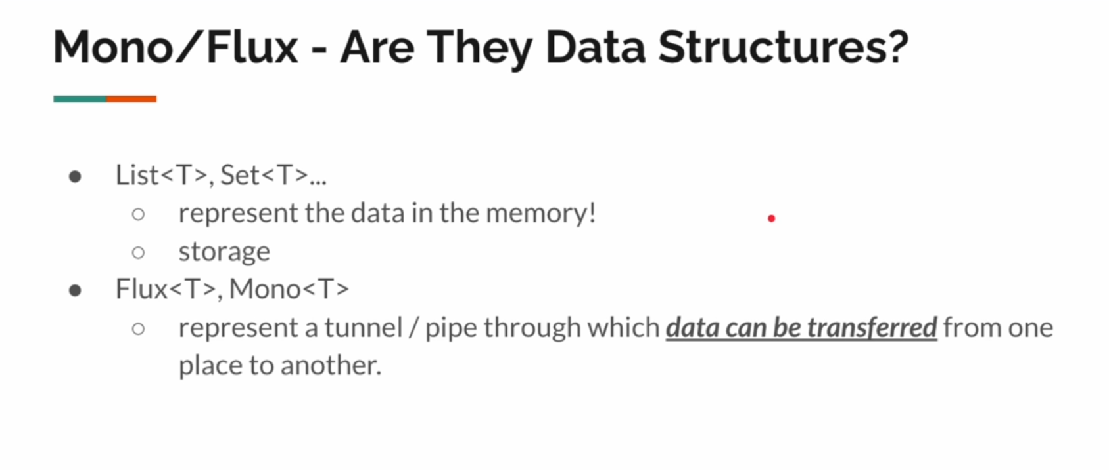

Flux Interval
Flux.interval is a factory method in Reactor that creates a Flux emitting sequential numbers (Long values) at a fixed time interval. The emissions start after an initial delay (optional) and continue indefinitely at regular intervals.

Usage of Flux.interval
- Periodic Tasks:
  - Emit values at regular intervals for periodic operations, such as fetching data or sending updates.
- Simulating Time-Based Events:
  - Simulate events that occur at fixed intervals, such as heartbeats or pings.
- Reactive Timing:
  - Combine with operators like map and flatMap to transform or trigger actions based on time.
- Testing:
  - Create time-based mock data streams for testing reactive pipelines.

Importance of Flux.interval
- Non-Blocking and Reactive:
  - Emits values asynchronously without blocking the main thread, enabling efficient resource usage.
- Time-Based Control:
  - Simplifies the creation of time-based event streams compared to traditional approaches (e.g., using Timer or ScheduledExecutorService).
- Scalable Timing:
  - Scales well with multiple intervals, as the emissions occur on a dedicated scheduler.
- Integration:
  - Works seamlessly with other reactive operators (map, filter, merge) to build complex, time-based pipelines.

When to Use Flux.interval
- Scheduling Periodic Actions:
  - For example, polling an API, sending periodic notifications, or refreshing a cache.
- Real-Time Data Streaming:
  - Emit real-time events (e.g., stock prices, sensor readings) at fixed intervals.
- Heartbeats and Monitoring:
  - Generate periodic "heartbeat" messages to monitor the health of a system.
- Simulating Data Streams:
  - Create mock time-based data for testing and development.
public class FluxInterval {
public static void main(String[] args) {
// Create a Flux that emits values at a fixed interval of 3 seconds
Flux.interval(Duration.ofSeconds(3))
// Transform the emitted value into a random full name using Faker library
.map(i -> Util.faker().name().fullName())
// Subscribe to the Flux to start receiving and processing data
.subscribe(Util.subscriber());
// Allow the main thread to sleep for 5 seconds to keep the application alive
// and allow Flux emissions to occur
try {
Util.sleepSeconds(5);
} catch (InterruptedException e) {
throw new RuntimeException(e);
}
}
}

- Flux.interval(Duration.ofSeconds(3)):
  - Creates a Flux that emits sequential Long values (0, 1, 2, ...) at regular intervals specified by the Duration.
  - In this case, it emits a new value every 3 seconds.
- .map(i -> Util.faker().name().fullName()):
  - Transforms each emitted value into a random full name using the Faker library.
  - The transformation does not depend on the emitted value (i), but it can if needed.
- .subscribe(Util.subscriber()):
  - Subscribes to the Flux to process the emitted names.
  - Without subscribing, the Flux would not start emitting values.
- Util.sleepSeconds(5):
  - Ensures the main thread stays alive long enough for the Flux.interval to emit a few values.
  - In a real-world reactive application, the program would remain reactive and not rely on thread blocking.

Assuming Util.faker().name().fullName() generates random names, the output will be:
sub1 received: John Doe
sub1 received: Jane Smith
sub1 received: Alice Johnson
...

The output will depend on how many names are emitted within the 5-second sleep duration. Since the interval is 3 seconds:
- The first name is emitted after 3 seconds.
- The second name may not be emitted due to the 5-second sleep limitation.

- Reactive and Non-Blocking:
  - Flux.interval emits values asynchronously, ideal for real-time applications.
- Flexible Timing:
  - Define custom intervals and transformations for dynamic use cases.
- Periodic Operations:
  - Simplifies scheduling tasks compared to traditional blocking methods.
Flux Empty-Error-defer
Flux.empty:
- Flux.empty is a factory method in Reactor that creates a Flux that completes immediately without emitting any items or errors.
- Use Case: Represents the absence of data, similar to an empty collection.
public class FluxEmptyExample {
public static void main(String[] args) {
// Create an empty Flux
Flux.empty()
.subscribe(
item -> System.out.println("Received: " + item), // onNext
err -> System.err.println("Error: " + err), // onError
() -> System.out.println("Completed!") // onComplete
);
}
}
When to Use:
- When no data needs to be emitted but the pipeline should still complete gracefully.
- Example: Returning an empty result for a valid request where no data exists.

Flux.error:
- Flux.error is a factory method that creates a Flux that terminates with a specified error without emitting any items.
- Use Case: Represents a failure or exceptional condition in a reactive pipeline.
public class FluxErrorExample {
public static void main(String[] args) {
// Create a Flux that emits an error
Flux.error(new RuntimeException("Something went wrong!"))
.subscribe(
item -> System.out.println("Received: " + item), // onNext
err -> System.err.println("Error: " + err), // onError
() -> System.out.println("Completed!") // onComplete
);
}
}

Output
Error: java.lang.RuntimeException: Something went wrong!
When to Use:
- To propagate an error downstream in the reactive pipeline.
- Example: Simulating an error during testing or handling invalid data conditions.

Flux.defer:
- Flux.defer is a factory method that creates a new Flux instance for every subscription by evaluating a supplier.
- Use Case: Defers the creation of the Flux until the moment of subscription, ensuring fresh computation for each subscriber.
public class FluxDeferExample {
public static void main(String[] args) {
// Create a Flux that generates a new value for each subscription
Flux<String> deferredFlux = Flux.defer(() -> {
System.out.println("Creating a new Flux...");
return Flux.just("Value generated at: " + System.currentTimeMillis());
});
// First subscription
deferredFlux.subscribe(value -> System.out.println("Subscriber 1 received: " + value));
// Wait for a moment before the second subscription
try {
Thread.sleep(1000);
} catch (InterruptedException e) {
throw new RuntimeException(e);
}
// Second subscription
deferredFlux.subscribe(value -> System.out.println("Subscriber 2 received: " + value));
}
}

Output

Creating a new Flux...
Subscriber 1 received: Value generated at: 1681234567890
Creating a new Flux...
Subscriber 2 received: Value generated at: 1681234568890
When to Use:
- When you want to ensure that each subscriber gets a fresh computation or data.
- Example: Fetching time-sensitive data or interacting with external resources like databases or APIs.

Importance
- Flux.empty:
  - Importance:
    - Indicates the absence of data in a clear and reactive way.
    - Ensures graceful completion of a reactive stream without emitting any items.
  - When to Use:
    - Representing an empty result (e.g., no matching records in a database query).
- Flux.error:
  - Importance:
    - Propagates errors in a structured manner, making error handling easier in reactive pipelines.
  - When to Use:
    - Simulating or propagating errors in a reactive flow.
- Flux.defer:
  - Importance:
    - Delays the creation of the Flux until subscription, ensuring fresh data for each subscriber.
  - When to Use:
    - For time-sensitive or dynamic data that should not be reused across multiple subscribers.
    - Interacting with resources that require re-initialization for each subscriber.

Comparison of Flux.empty, Flux.error, and Flux.defer
Aspect | Flux.empty | Flux.error | Flux.defer
Emits Items | No | No | Yes (based on the provided supplier).
Signals | onComplete | onError | Emits values, followed by onComplete.
Purpose | Represent absence of data. | Represent a failure. | Ensure fresh data or computation.
Key Use Case | Empty results or placeholders. | Error propagation or testing. | Dynamic or time-sensitive data streams.

Key Takeaways
- Flux.empty:
  - Use when there’s no data to emit but you want to complete the pipeline gracefully.
- Flux.error:
  - Use to propagate errors reactively in the pipeline.
- Flux.defer:
  - Use when you need fresh data or computation for every subscription.
Flux To Mono & Mono To Flux

When and Why to Use
- Flux to Mono:
  - Use when you only need the first element of a reactive stream.
  - Example:
    - Fetching a single record from a stream of results.
    - Processing only the first emitted event in a data stream.
- Mono to Flux:
  - Use when you need to treat a single value as a stream.
  - Example:
    - Converting a single result (e.g., a database query) into a stream for further processing.
    - Integrating Mono-based results into a pipeline that expects Flux.

Usage in Real-World Scenarios
- Flux to Mono:
  - API Calls:
    - When querying a paginated API but you only care about the first page or record.
  - Event Streams:
    - Handling only the first event in a reactive stream (e.g., first user login event).
- Mono to Flux:
  - Database Queries:
    - Converting a single database result (Mono) into a stream for further transformations.
  - Chaining Pipelines:
    - When combining a single value with a multi-item stream.

Importance
- Flexibility:
  - Enables seamless integration between Mono and Flux in reactive pipelines.
  - Allows transforming between single and multiple data streams as needed.
- Enhanced Usability:
  - Makes it easier to adapt APIs or data sources that use different reactive types.
- Reactive Composition:
  - Helps in composing complex reactive workflows by normalizing the data structure.
public class MonoFluxConversion {
public static void main(String[] args) {
// Convert a Flux to Mono
var flux = Flux.range(1, 10); // Create a Flux emitting integers 1 to 10
Mono.from(flux) // Convert Flux to Mono, emitting only the first element
.subscribe(Util.subscriber("Mono from Flux"));
// Demonstrate Mono to Flux conversion
monoToFlux();
}
private static void monoToFlux() {
// Convert a Mono to Flux
var mono = getUserName(1); // Fetch username for userId 1
save(Flux.from(mono)); // Convert Mono to Flux and save it
}
// Method to fetch a username based on userId
private static Mono<String> getUserName(int userId) {
// Return Mono based on userId
return switch (userId) {
case 1 -> Mono.just("John"); // Emit "John" for userId 1
case 2 -> Mono.just("Jane"); // Emit "Jane" for userId 2
case 3 -> Mono.empty(); // Emit no value for userId 3
default -> Mono.error(new RuntimeException("Invalid input")); // Emit an error for other userIds
};
}
// Method to process a Flux (save operation)
private static void save(Flux<String> flux) {
// Subscribe to the Flux to process the emitted values
flux.subscribe(Util.subscriber("Flux from Mono"));
}
}

public class CustomMonoFluxConversion {
public static void main(String[] args) {
// Create a Flux that emits multiple names
Flux<String> flux = Flux.just("Alice", "Bob", "Charlie");
// Convert Flux to Mono, emitting only the first element of the Flux
Mono.from(flux).subscribe(name -> System.out.println("Mono received: " + name));
// Create a Mono that emits a single name
Mono<String> mono = Mono.just("Dave");
// Convert Mono to Flux, making it behave like a Flux
Flux.from(mono).subscribe(name -> System.out.println("Flux received: " + name));
// Additional examples for Flux to Mono conversion
// Create a Flux with multiple names
var fluxExample = Flux.just("Alice", "Bob", "Charlie");
// Convert Flux to Mono, which will emit only the first element ("Alice")
Mono.from(fluxExample)
.subscribe(name -> System.out.println("Mono received: " + name)); // Print the first name
// Additional examples for Mono to Flux conversion
// Create a Mono with a single name
var monoExample = Mono.just("Dave");
// Convert Mono to Flux, now it behaves like a Flux
Flux.from(monoExample)
.subscribe(name -> System.out.println("Flux received: " + name)); // Print the single name from Flux
}
}
Flux to Mono
- Flux<String> flux = Flux.just("Alice", "Bob", "Charlie");
  - Creates a Flux that emits three names: "Alice", "Bob", "Charlie".
- Mono.from(flux)
  - Converts the Flux to a Mono, taking only the first element of the Flux ("Alice").
- .subscribe(name -> System.out.println("Mono received: " + name));
  - Subscribes to the Mono, printing the first element.
Output:
Mono received: Alice

Mono to Flux
- Mono<String> mono = Mono.just("Dave");
  - Creates a Mono that emits a single name: "Dave".
- Flux.from(mono)
  - Converts the Mono into a Flux, which now behaves like a multi-item publisher but emits only the single value from the Mono.
- .subscribe(name -> System.out.println("Flux received: " + name));
  - Subscribes to the Flux, printing the single emitted name.
Output:
Flux received: Dave

Additional Example: Flux to Mono
- Demonstrates the same concept with a new Flux object (fluxExample) emitting "Alice", "Bob", "Charlie".
- Only the first element, "Alice", is printed.
- Additional Example: Mono to Flux
- Demonstrates the same concept with a new Mono object (monoExample) emitting "Dave".
- Converts it into a Flux and prints the single emitted value.
Purpose of Conversion:
- Flux to Mono: Extracts the first element from a multi-item publisher.
- Mono to Flux: Treats a single value as a stream of one, allowing integration into reactive pipelines.
- Usage Scenarios:
- Flux to Mono: When you need only the first element from a collection or data stream.
- Mono to Flux: When combining single-value publishers with multi-item pipelines.
- Practical Applications:
- Flux to Mono:
  - Fetching the first result from a database or API.
- Mono to Flux:
  - Integrating a single result (e.g., user details) into a larger reactive pipeline.

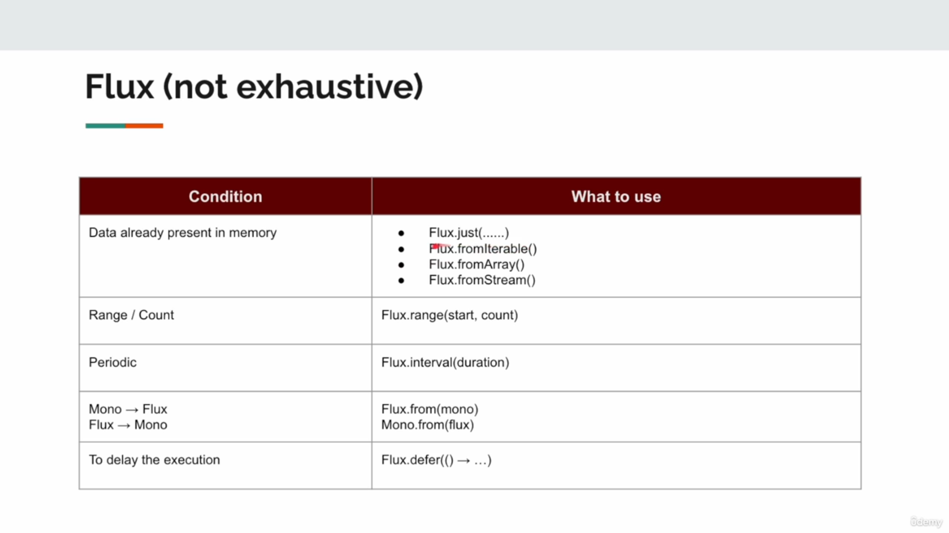
Flux - Emitting Items Programmatically

In the following lesson we will use Sink.
Sink is a tool in Project Reactor that lets you manually create and control reactive streams. It's like a special container where you can put data and control how it flows out.
Sink to emit events based on user actions, database changes, or other triggers in your system.
Here's a simple way to think about it:
- Imagine Sink as a pipe with a valve.
- You can put data into one end of the pipe.
- You control when and how the data flows out the other end.
This is useful in reactive programming because it lets you create streams of data that respond to events or changes in your application. Let's look at a basic example:
import reactor.core.publisher.Sinks;import reactor.core.publisher.Flux; public class SinkExample { public static void main(String[] args) { // Create a sink that can emit many elements Sinks.Many<String> sink = Sinks.many().multicast().onBackpressureBuffer(); // Get a Flux from the sink Flux<String> flux = sink.asFlux(); // Subscribe to the Flux flux.subscribe(data -> System.out.println("Subscriber 1 received: " + data)); flux.subscribe(data -> System.out.println("Subscriber 2 received: " + data)); // Emit some data sink.tryEmitNext("Hello"); sink.tryEmitNext("Reactive"); sink.tryEmitNext("World"); // Complete the sink sink.tryEmitComplete(); }}

In this example:
- We create a Sink that can emit many elements.
- We get a Flux from the Sink. This Flux is what we can subscribe to.
- We create two subscribers that will print the data they receive.
- We emit some data using the Sink.
- Finally, we complete the Sink.
When you run this, both subscribers will receive all the data we emit.This is a very basic example, but it shows how Sink can be used to create and control a stream of data. In a real application, you might use Sink to emit events based on user actions, database changes, or other triggers in your system.

Flux Create & Flux Sink
What is FluxSink?
- A FluxSink is a utility provided by Reactor for emitting items, handling errors, and signaling completion in a Flux.create pipeline.
- Capabilities:
- Emit Items: fluxSink.next(item)
- Signal Completion: fluxSink.complete()
- Signal Error: fluxSink.error(throwable)
- Why Use FluxSink?
- It provides a controlled way to bridge imperative code with reactive streams.
What is Flux.create?
- A method in Reactor that allows programmatic creation of a Flux using a custom logic block.
- Uses a FluxSink to emit items dynamically.
- Why Use Flux.create?
- For scenarios where the data source or emission logic is dynamic and doesn't fit into standard Flux factories (e.g., Flux.just, Flux.fromIterable).

Usage of Flux.create
- Dynamic Data Sources:
  - When data needs to be generated or emitted dynamically, such as reading data from a file, user input, or a network stream.
- Imperative to Reactive:
  - To convert imperative logic into a reactive pipeline.
- Custom Emission Logic:
  - When the emission logic involves loops, conditions, or external triggers.

When to Use
- Custom Data Emission:
  - When you have a unique emission logic (e.g., based on external conditions).
- Dynamic or Real-Time Data:
  - Use Flux.create for real-time data generation (e.g., continuous API calls, user interaction).
- Bridging Imperative and Reactive Worlds:
  - Useful for integrating imperative codebases into reactive systems.

Importance of Flux.create
- Flexibility:
  - Allows emitting items programmatically based on custom conditions or external triggers.
- Real-Time Data:
  - Suitable for scenarios where data generation is dynamic and cannot be predefined.
- Bridging Code Paradigms:
  - Enables the integration of imperative codebases with reactive systems.
FluxSink is a utility provided by Reactor as part of the Flux.create method. It acts as a bridge between imperative (non-reactive) code and the reactive world, allowing developers to emit items dynamically into a reactive Flux stream.

Key Features of FluxSink
- Dynamic Emission:
  - Emit items programmatically using fluxSink.next(item).
- Error Handling:
  - Signal an error in the stream using fluxSink.error(throwable).
- Completion:
  - Signal that the stream has completed using fluxSink.complete().
- Backpressure Control:
  - Provides strategies to handle backpressure using onRequest, onOverflow, and similar mechanisms.

Common Methods in FluxSink
Method | Description
next(T item) | Emit an item to the downstream subscriber.
complete() | Signal that the stream has completed.
error(Throwable t) | Signal that an error has occurred, terminating the stream.
onRequest(Consumer<Long>) | Allows custom logic to handle requests from downstream subscribers (e.g., managing backpressure).
onDispose(Runnable) | Perform a cleanup action when the sink is disposed.
onCancel(Runnable) | Perform a cleanup action when the sink is canceled.

How Does FluxSink Work?
- Producer:
  - You act as the producer, emitting items dynamically into the Flux using fluxSink.next().
- Subscriber:
  - Downstream subscribers receive the emitted items, errors, or completion signals.
- Backpressure:
  - FluxSink does not enforce backpressure by default, but it allows you to define custom strategies.

FluxSink vs Other Emitters
Aspect | FluxSink | Emitter (MonoSink/CompletableFuture)
Use Case | Dynamic, multi-item streams. | Single value or single completion.
Reactive Type | Multi-item (Flux). | Single-item (Mono).
Backpressure Support | Requires custom handling. | Not applicable (single emission).

When to Use FluxSink
- Custom Emission Logic:
  - When your logic involves loops, conditional checks, or event-driven triggers.
- Dynamic Data Sources:
  - Real-time streams where data cannot be pre-defined (e.g., WebSocket messages, random generation).
- Integrating Imperative Code:
  - Convert callback-based or event-driven code (e.g., listeners) into reactive streams.

Importance of FluxSink
- Flexibility:
  - Enables custom logic for emitting, handling, and managing reactive streams.
- Bridge Between Paradigms:
  - Converts imperative programming patterns into a reactive model.
- Dynamic Emission:
  - Handles unpredictable or real-time data generation scenarios efficiently.

/*
To create a flux & emit items programmatically
*/
public class FluxCreate {
public static void main(String[] args) {
// Create a Flux using the create() method
Flux.create(
// fluxSink.next("Hello");
// fluxSink.next("World");
// for (int i = 0; i < 10; i++) {
// fluxSink.next(Util.faker().country().name());
// }
/*
The `create` method allows us to programmatically emit items using a FluxSink.
A FluxSink is a bridge between imperative code and the reactive world.
Example Requirement:
- Emit random country names continuously.
- Stop emitting when the country name "Pakistan" appears.
- Emit a complete signal after emitting "Pakistan".
*/
fluxSink -> {
String country; // Variable to hold the emitted country name
do {
country = Util.faker().country().name(); // Generate a random country name
fluxSink.next(country); // Emit the country name
} while (!country.equalsIgnoreCase("Pakistan")); // Stop when "Pakistan" is generated
fluxSink.complete(); // Emit the complete signal
}
)
// Subscribe to the Flux to process the emitted country names
.subscribe(Util.subscriber());
}
}

Using Flux.create with a Separate Consumer Class for Complex Emission Logic
When dealing with complex emission logic that doesn't fit neatly into a lambda expression, creating a separate Consumer class for handling FluxSink operations is a better practice. This approach allows for better code organization, reusability, and readability.

public class NameGenerator implements Consumer<FluxSink<String>> {
private FluxSink<String> sink; // Holds the FluxSink to emit items
@Override
public void accept(FluxSink<String> stringFluxSink) {
// Initialize the FluxSink when Flux.create is called
this.sink = stringFluxSink;
}
// Method to generate names dynamically and emit them using the sink
public void generate() {
// Generate a random first name and emit it
this.sink.next(Util.faker().name().firstName());
}
// Method to emit a termination signal
public void complete() {
this.sink.complete(); // Notify subscribers that the stream is complete
}
// Method to emit an error signal
public void emitError(Exception e) {
this.sink.error(e); // Signal an error in the stream
}
}

public class FluxCreateRefactor {
public static void main(String[] args) {
// Create an instance of the NameGenerator
var generator = new NameGenerator();
// Use Flux.create to initialize the reactive stream using NameGenerator
var flux = Flux.create(generator);
// Subscribe to the Flux to process emitted names
flux.subscribe(Util.subscriber("NameSubscriber"));
// Simulate generating names dynamically
for (int i = 0; i < 10; i++) {
generator.generate(); // Emit a name
}
// Complete the stream after emitting all names
generator.complete();
// Example: Emitting an error (uncomment to test error handling)
// generator.emitError(new RuntimeException("Unexpected error occurred!"));
}
}

NameGenerator Class:
- Implements Consumer<FluxSink<String>>, which allows it to act as a consumer for the FluxSink.
- Purpose:
  - Handles the emission logic for the Flux.
  - Encapsulates complex logic for emitting items (generate), signaling completion (complete), and emitting errors (emitError).
- accept Method:
- Called when Flux.create initializes the Flux.
- Stores the FluxSink reference, enabling the NameGenerator to programmatically emit items.
- generate Method:
- Emits a random name to the FluxSink when called.
- This simulates dynamic or event-driven data generation.
- Flux.create(generator):
- Initializes a Flux using the NameGenerator instance as the Consumer of the FluxSink.
- The NameGenerator handles how and when items are emitted.
- Main Class (FluxCreateRefactor):
- Subscribes to the Flux, triggering the emission of names from NameGenerator.
- Uses a loop to simulate dynamic name generation.
- Completes the stream after emitting all names.

Why Use a Separate Consumer Class?
- Complex Logic:
  - When the emission logic involves multiple steps, conditions, or external dependencies, a separate class organizes the code better.
- Reusability:
  - The NameGenerator class can be reused across multiple Flux instances.
- Readability:
  - Separating emission logic from the Flux.create method improves the readability of your code.
- Testing:
  - A separate class allows you to test the emission logic independently.

Use Case: Real-Time Stock Price Updates
Imagine generating a stream of real-time stock price updates:
public class StockPriceGenerator implements Consumer<FluxSink<Double>> {
private FluxSink<Double> sink;
@Override
public void accept(FluxSink<Double> fluxSink) {
this.sink = fluxSink;
}
// Emit a random stock price
public void emitPrice() {
double price = 100 + (Math.random() * 20 - 10); // Random price between 90 and 110
sink.next(price);
}
// Signal the stream has completed
public void complete() {
sink.complete();
}
// Emit an error
public void emitError(Exception e) {
sink.error(e);
}
}

public class StockPriceStream {
public static void main(String[] args) {
var stockPriceGenerator = new StockPriceGenerator();
// Create a Flux using StockPriceGenerator
var flux = Flux.create(stockPriceGenerator);
// Subscribe to the stream
flux.subscribe(
price -> System.out.println("Received stock price: $" + price),
error -> System.err.println("Error occurred: " + error),
() -> System.out.println("Price stream completed!")
);
// Simulate emitting stock prices dynamically
for (int i = 0; i < 10; i++) {
stockPriceGenerator.emitPrice(); // Emit stock price
try {
Thread.sleep(500); // Simulate a delay in price updates
} catch (InterruptedException e) {
stockPriceGenerator.emitError(e); // Signal an error if interrupted
}
}
// Complete the stream after emitting all prices
stockPriceGenerator.complete();
}
}

Output:
Received stock price: $102.5
Received stock price: $98.3
Received stock price: $105.1
...
Price stream completed!

Key Benefits of Using Flux.create with a Consumer Class
- Dynamic Data Emission:
  - Handles real-time or event-driven scenarios like stock prices, user inputs, or sensor data.
- Improved Maintainability:
  - Encapsulates complex emission logic in a dedicated class for better organization.
- Extensibility:
  - Easily add new features like error handling, additional events, or conditional logic.

When to Use This Approach
- When dealing with dynamic or event-driven data sources.
- When emission logic is too complex for a lambda.
- When you need reusable and testable components for data emission.

Thread-Safety in FluxSink vs ArrayList
This example demonstrates why FluxSink is thread-safe while a regular ArrayList is not when used in multi-threaded scenarios. Below is the detailed explanation along with an updated version of your code with comments.
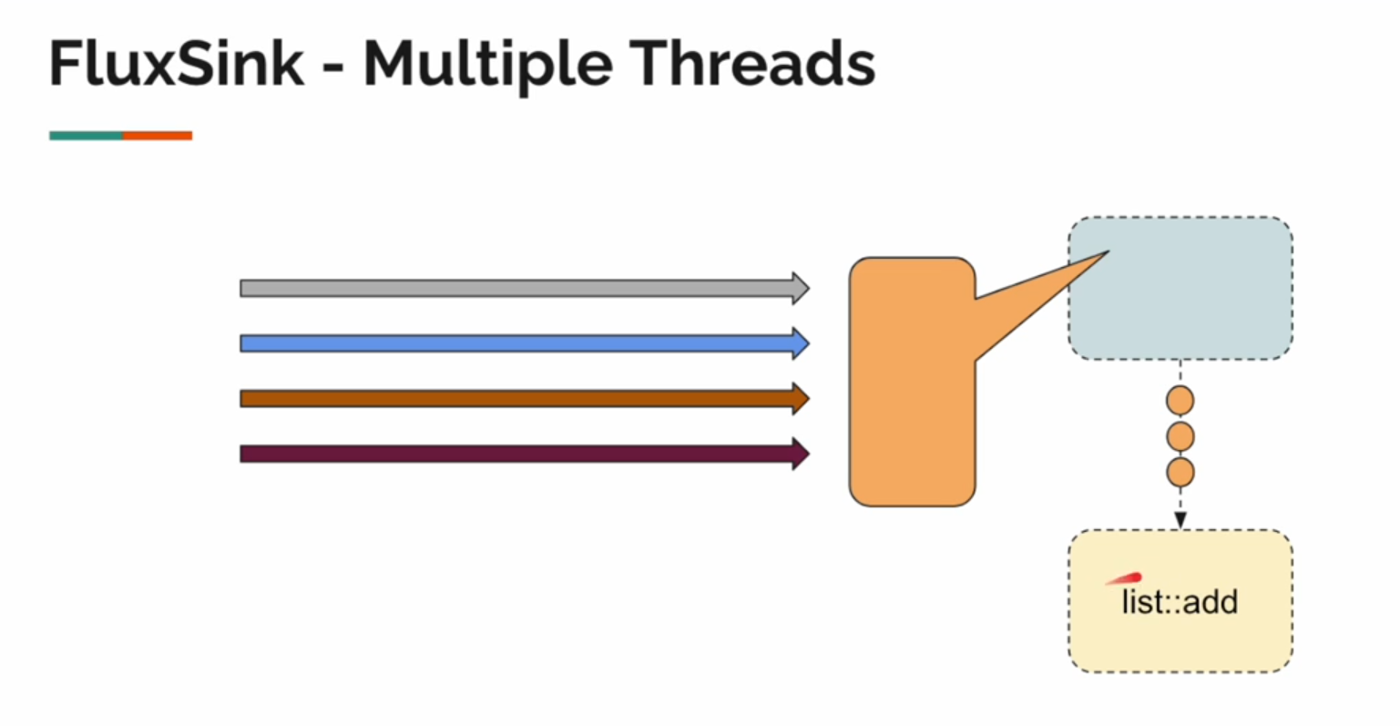
public class FluxSinkThreadSafetyExample {
public static final Logger logger = LoggerFactory.getLogger(FluxSinkThreadSafetyExample.class);
public static void main(String[] args) {
// Demonstrating a non-thread-safe operation with ArrayList
notThreadSafeExample();
// Demonstrating a thread-safe operation using FluxSink
fluxSinkThreadSafeExample();
}
// Example: Using ArrayList in a non-thread-safe manner
private static void notThreadSafeExample() {
var list = new ArrayList<Integer>(); // Non-thread-safe ArrayList
// Runnable task to add integers to the list
Runnable runnable = () -> {
for (int i = 0; i < 1000; i++) {
list.add(i); // Add integers to the list
}
};
// Launch 10 threads to execute the task concurrently
for (int i = 0; i < 10; i++) {
Thread.ofPlatform().start(runnable); // Start threads using Java 21's virtual threads
}
// Wait for all threads to complete execution
try {
Util.sleepSeconds(3);
} catch (InterruptedException e) {
throw new RuntimeException(e);
}
// Print the size of the list
logger.info("List size (non-thread-safe): {}", list.size());
}
// Example: Using FluxSink to handle thread-safety
private static void fluxSinkThreadSafeExample() {
var list = new ArrayList<String>(); // Non-thread-safe ArrayList to store emitted items
var nameGenerator = new NameGenerator(); // Name generator to emit names
var flux = Flux.create(nameGenerator); // Create a Flux using the name generator
// Subscribe to the Flux and add emitted names to the list
flux.subscribe(list::add);
// Runnable task to generate names
Runnable runnable = () -> {
for (int i = 0; i < 1000; i++) {
nameGenerator.generate(); // Emit a new name
}
};
// Launch 10 threads to execute the task concurrently
for (int i = 0; i < 10; i++) {
Thread.ofPlatform().start(runnable); // Start threads using Java 21's virtual threads
}
// Wait for all threads to complete execution
try {
Util.sleepSeconds(3);
} catch (InterruptedException e) {
throw new RuntimeException(e);
}
// Print the size of the list
logger.info("List size (thread-safe with FluxSink): {}", list.size());
}
}

Non-Thread-Safe Example
List size (non-thread-safe): 8765
Expected size: 10,000 (10 threads * 1,000 iterations).
- Actual size is smaller due to concurrent modifications and race conditions.

Thread-Safe Example with FluxSink
List size (thread-safe with FluxSink): 10000
The size matches the expected value because FluxSink handles concurrent emissions correctly.

Why ArrayList is Not Thread-Safe
- Race Conditions: ArrayList is not synchronized, meaning multiple threads modifying it simultaneously can corrupt its internal structure, leading to:
  - Missing elements.
  - Overlapping writes.
  - Incorrect size calculations.
- No Built-in Protection: The add() method of ArrayList directly modifies its internal array without checking for concurrent modifications.

Why FluxSink is Thread-Safe
- Reactive Streams Specification: FluxSink adheres to the reactive streams specification, which ensures thread safety and provides backpressure strategies.
- Internal Synchronization:
  - The operations (next, complete, error) are thread-safe and can handle concurrent emissions properly.
- Serialized Access:
  - FluxSink serializes the emissions, ensuring no overlapping modifications.

Key Differences: ArrayList vs FluxSink
Aspect | ArrayList | FluxSink
Thread Safety | Not thread-safe | Thread-safe
Concurrent Access | Leads to race conditions | Ensures serialized emissions
Synchronization | Needs manual synchronization | Built-in thread safety
Use Case | Static, single-threaded data | Dynamic, multi-threaded data streams
Error Handling | Manual handling required | Reactive error propagation

When to Use FluxSink
- Dynamic Data Emission:
  - When data is generated in real-time or from multiple sources (e.g., WebSocket messages, user inputs).
- Multi-Threaded Scenarios:
  - Use FluxSink to handle emissions from multiple threads safely.
- Bridging Imperative and Reactive Code:
  - Ideal for integrating non-reactive code (e.g., callbacks, event listeners) with reactive pipelines.

Key Takeaways
- FluxSink for Thread-Safe Emissions:
  - Handles concurrent emissions and ensures data consistency.
- Avoid Using Non-Thread-Safe Collections in Multi-Threaded Environments:
  - Replace ArrayList with thread-safe alternatives like CopyOnWriteArrayList if needed.
- Reactive Programming Benefits:
  - FluxSink allows dynamic, real-time, and thread-safe data generation, making it a powerful tool for reactive systems.

Understanding Downstream Demand with Flux.create
This code demonstrates how Flux.create produces items regardless of downstream demand, and the subscriber controls how much data it processes using backpressure mechanisms. Below is the updated version of your code with comments, followed by an explanation of the problem, usage, and key takeaways.

public class FluxCreateDownStreamDemand {
public static final Logger log = LoggerFactory.getLogger(FluxCreateDownStreamDemand.class);
public static void main(String[] args) throws InterruptedException {
var subscriber = new SubscriberImpl(); // Custom subscriber for handling backpressure
// Create a Flux that emits 10 names
Flux.<String>create(
fluxSink -> {
for (int i = 0; i < 10; i++) {
var name = Util.faker().name().fullName(); // Generate a random name
log.info("Emitting item {}", name); // Log the emitted item
fluxSink.next(name); // Emit the name to the FluxSink
}
fluxSink.complete(); // Signal completion after emitting all items
}
).subscribe(subscriber); // Subscribe the custom subscriber to this Flux
/*
* Problem: Even if the subscriber cancels immediately or doesn't request any items,
* the producer generates all the items upfront. This is the default behavior of `Flux.create`.
* The subscriber might not receive all the items if it cancels early or limits its requests.
*/
// Cancel the subscription immediately without requesting items
subscriber.getSubscription().cancel();
// Simulate delayed downstream requests
Util.sleepSeconds(2);
subscriber.getSubscription().request(2); // Request the first 2 items
Util.sleepSeconds(2);
subscriber.getSubscription().request(2); // Request 2 more items
Util.sleepSeconds(2);
subscriber.getSubscription().cancel(); // Cancel the subscription again
}
}

Flux.create Behavior:
  - By default, Flux.create produces all items immediately, irrespective of the downstream subscriber's demand.
  - Items are emitted to the FluxSink, and the subscriber decides how much of that data to consume.
- Backpressure Problem:
  - The producer generates all items upfront, but the subscriber might not request all of them.
  - This leads to wasted computation and resource usage if the subscriber cancels or limits its request.
- Subscriber Controls:
  - The custom SubscriberImpl allows you to manually request data using the subscription's request() method.
  - The subscriber can also cancel the subscription at any point, preventing further data processing.

How the Code Works
- Flux.create Implementation:
  - A Flux is created using Flux.create, which emits 10 randomly generated names to the FluxSink.
  - Each name is logged as it is emitted.
  - After emitting all 10 names, the complete() method signals that the stream is complete.
- Subscriber Actions:
  - The custom subscriber subscribes to the Flux.
  - The subscription is immediately canceled using subscriber.getSubscription().cancel(), so no items are processed by the subscriber.
  - The subscriber later requests items in chunks using request(), demonstrating how it controls downstream demand.
- Delays Between Requests:
  - The Util.sleepSeconds() calls simulate delays between requests, showing how the subscriber can request items at its own pace.

Output
Log Output (Example):
INFO - Emitting item John Doe
INFO - Emitting item Jane Smith
INFO - Emitting item Alice Johnson
...
INFO - Emitting item Michael Brown

All items are logged as emitted by the producer, regardless of whether the subscriber processes them.
Subscriber Output (Based on requests):
Subscriber received: John Doe
Subscriber received: Jane Smith
...
Subscriber completed

Only the items requested by the subscriber are processed. If canceled, no further items are processed.

Problem and Use Case

Problem:
- Uncontrolled Production:
  - By default, Flux.create generates all items upfront, which might lead to wasted computation if the subscriber cancels or processes only a limited number of items.

Use Case:
- This behavior is useful when:
  - The producer must generate all items irrespective of demand.
  - You are dealing with data that doesn't have high computational cost or is pre-generated.
- However, for expensive operations or large datasets, this behavior can lead to inefficiencies. For such cases, lazy production or controlled backpressure using Flux.push or Flux.generate is more suitable.

Key Concepts
- Backpressure:
  - Allows subscribers to control how much data they process at a time.
  - Prevents the subscriber from being overwhelmed by an unbounded stream of data.
- Subscription Control:
  - request(long n): Request n items from the producer.
  - cancel(): Stop receiving further items from the producer.
- Flux.create:
  - Produces items eagerly, emitting all items to the FluxSink upfront.

When to Use This Approach
- Pre-Generated Data:
  - When the producer generates data quickly or upfront, and the subscriber selectively processes it.
- Debugging:
  - For testing how subscribers handle backpressure and cancellation.
- Real-Time Streams:
  - When emitting real-time events or logs, but with controlled downstream consumption.

Key Takeaways
- Default Behavior of Flux.create:
  - Produces all items upfront, regardless of downstream demand.
- Backpressure:
  - Subscribers can limit data processing using request() and cancel().
- Optimization:
  - For expensive or dynamic data, consider using Flux.generate (lazy production) or Flux.push (event-driven emission).
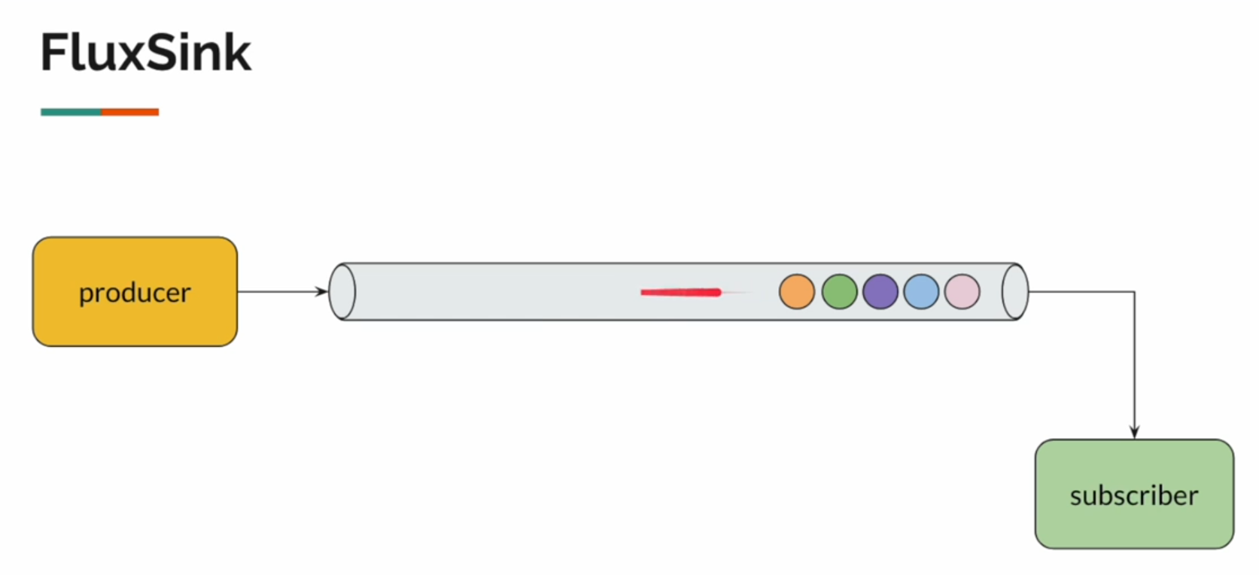
Why does Flux.create emit all items upfront and place them into a queue, even if the subscriber has not requested them? Can you explain how this queuing mechanism works, its impact on performance, and how it relates to backpressure in reactive streams?

How Flux.create Works Internally
- Emission to FluxSink:
  - When you use Flux.create, items are emitted into a queue (or buffer) maintained by Reactor.
  - This queue acts as a temporary storage for all the emitted items.
- Producer Behavior:
  - The producer (code inside fluxSink.next(...)) generates all the items upfront, one by one, and places them into the queue.
  - This happens regardless of whether the subscriber is actively consuming the items or not.
- Subscriber Behavior:
  - The subscriber requests items using subscription.request(n).
  - The queue then serves the requested number of items to the subscriber, maintaining a reactive and non-blocking flow.
- Queue Management:
  - If the subscriber requests fewer items than the producer emits, the remaining items stay in the queue until they are requested or the subscriber cancels.
  - If the subscriber cancels, any remaining items in the queue are discarded.

Why Does Flux.create Use a Queue?
- Reactive Backpressure:
  - The queue acts as a buffer between the producer (which emits items) and the subscriber (which consumes items).
  - This allows the subscriber to control the flow of data by requesting only the number of items it can handle at a time.
- Non-Blocking Behavior:
  - The producer can emit items as fast as it wants without waiting for the subscriber to process them.
  - The queue ensures that the subscriber processes items at its own pace without blocking the producer.
- Overflow Management:
  - Reactor uses strategies to manage queue overflow when the producer emits too many items, such as dropping items, buffering them, or signaling errors.

How Does the Queue Affect Performance?
- Pros:
  - Decouples Producer and Subscriber: The producer can emit items at its natural pace without being slowed down by the subscriber.
  - Smooth Data Flow: Ensures a smooth flow of data between producer and subscriber, even if they operate at different speeds.
- Cons:
  - Memory Usage: If the subscriber processes items slowly, the queue can grow large, consuming more memory.
  - Overproduction: Items might be produced unnecessarily if the subscriber cancels before consuming them.

When to Use Flux.create
- Real-Time Data Streams:
  - Use when data is generated dynamically and the producer emits items at a fast or unpredictable rate.
- Event-Driven Systems:
  - Ideal for systems where events (like user actions or API calls) are emitted continuously but consumed based on demand.
- Testing Backpressure:
  - Use Flux.create to simulate a producer emitting data faster than the subscriber can consume.

Key Takeaways
- Queue Mechanism:
  - Flux.create uses an internal queue to buffer emitted items.
  - The subscriber requests items from this queue based on its demand (request(n)).
- Producer Behavior:
  - The producer emits all items upfront, filling the queue even if the subscriber hasn’t requested them.
- Subscriber Behavior:
  - The subscriber consumes items from the queue based on its demand and can cancel at any time.
- Optimization:
  - For efficient resource usage, consider lazy production with Flux.generate or backpressure-friendly methods like Flux.push.

Why Does Flux.create Emit All Items Upfront?
- Producer Behavior in Flux.create:
  - The producer emits all items as soon as the fluxSink.next() is called inside the Flux.create block.
  - The emission is unbounded by default, meaning it does not wait for the subscriber to request items.
  - Queue:
    - These emitted items are placed into a queue internally by Reactor, ready for the subscriber to consume them based on demand.
Flux.create(fluxSink -> {
for (int i = 1; i <= 10; i++) {
System.out.println("Producing: " + i);
fluxSink.next(i); // Emit each item
}
fluxSink.complete(); // Signal completion
});
Here, the producer emits 10 items in a tight loop, adding them to the queue.
- Why a Queue Is Used:
  - Since the subscriber controls the flow of data using the request(n) mechanism, the queue acts as a buffer to temporarily store emitted items until the subscriber is ready to consume them.
  - Without a queue, the producer would have to synchronize with the subscriber, potentially causing inefficiencies and blocking.

How Does the Queuing Mechanism Work?
- Buffering in the Queue:
  - The FluxSink used by Flux.create emits items into a queue maintained by Reactor.
  - These items remain in the queue until the subscriber requests them.
Code Behavior:
Flux.create(fluxSink -> {
for (int i = 1; i <= 10; i++) {
fluxSink.next(i); // Emit item
}
fluxSink.complete(); // Signal completion
}).subscribe(new CustomSubscriber<>("Subscriber2", 3));
Here, the producer emits 10 items upfront, but the subscriber (Subscriber2) initially requests only 3 items.
- The first 3 items are delivered from the queue to the subscriber, and the remaining 7 items stay in the queue.
- Subscriber’s Role:
- The subscriber explicitly controls how many items it processes by calling request(n).
- The queue ensures that the subscriber receives only the requested number of items, even if the producer has emitted more.
Code Example:
CustomSubscriber<Integer> subscriber = new CustomSubscriber<>("Subscriber3", 5, 2);
The subscriber first requests 5 items, processes them, and then requests 2 more items.
  - Items from the queue are delivered in chunks as per these requests.

Impact on Performance

Advantages:
- Decouples Producer and Subscriber:
  - The producer can emit items at its natural pace, independently of the subscriber’s processing speed.
  - In the code, the producer emits items in a tight loop (for (int i = 1; i <= 10; i++)) without waiting for the subscriber.
- Smooth Data Flow:
  - The queue ensures that data flows smoothly between the producer and subscriber, even if they operate at different speeds.
  - The subscriber processes items at its own pace by requesting a specific number of items (request(n)).
- Non-Blocking Behavior:
  - The producer is not blocked by slow subscribers, as items are buffered in the queue until requested.

Disadvantages:
- Memory Usage:
  - If the producer emits a large number of items and the subscriber is slow to process them, the queue can grow, consuming significant memory.
  - For instance, if the subscriber only requests 2 items and then cancels, the remaining 8 items in the queue are wasted.
Code Example:
subscriber.cancel(); // Remaining items in the queue are discarded
Overproduction:
  - The producer might generate items unnecessarily if the subscriber cancels before consuming them all.
Code Behavior:
  - The producer emits 10 items upfront, but if the subscriber cancels after processing 5 items, the remaining 5 items are discarded.

How It Relates to Backpressure
- Subscriber Demand:
  - Backpressure in reactive streams allows subscribers to control how much data they can handle using request(n).
Example in Code:
subscriber.requestMore(5); // Subscriber requests additional 5 items
Queue Acts as Buffer:
- The queue in Flux.create serves as a buffer to handle backpressure:
  - Items are stored in the queue when emitted by the producer.
  - The subscriber consumes items from the queue based on its demand.
- Cancellation:
- The subscriber can cancel the subscription, preventing further processing and discarding items in the queue.
Code Behavior:
subscriber.cancel(); // Stops further processing and discards queued items

Key Takeaways
- Queue Mechanism:
  - Flux.create uses an internal queue to buffer items emitted by the producer until they are requested by the subscriber.
- Producer Behavior:
  - The producer emits all items upfront, filling the queue regardless of subscriber demand.
- Subscriber Behavior:
  - The subscriber processes items from the queue based on its demand (request(n)) and can cancel at any time.
- Performance Implications:
  - Pros:
    - Decouples producer and subscriber for smooth data flow.
    - Ensures non-blocking behavior.
  - Cons:
    - Risk of memory usage due to overproduction.
    - Wasted computation if the subscriber cancels.

Optimization Suggestions
- Lazy Production:
  - Use Flux.generate to emit items only when requested by the subscriber.
Example:
Flux.generate(sink -> sink.next(Util.faker().name().fullName()));
Backpressure-Friendly Methods:
- Consider using Flux.push for event-driven data emission to better handle backpressure.
Flux Create: Early Production vs On-Demand Emission with Backpressure

/**
* Demonstrates the default behavior of Flux.create where the producer emits all items upfront,
* regardless of downstream demand. Overproduction may occur if the subscriber doesn't request all items.
*/
private static void produceEarly() throws InterruptedException {
var subscriber = new SubscriberImpl(); // Create a custom subscriber
// Create a Flux that emits items upfront
Flux.<String>create(fluxSink -> {
for (int i = 0; i < 10; i++) { // Produce 10 items
var name = Util.faker().name().firstName(); // Generate a random name
log.info("generated: {}", name); // Log the emitted name
fluxSink.next(name); // Emit the name to the sink
}
fluxSink.complete(); // Signal the completion of the stream
}).subscribe(subscriber); // Subscribe the custom subscriber to this Flux
// Demonstrating subscriber behavior:
Util.sleepSeconds(2); // Delay for 2 seconds
subscriber.getSubscription().request(2); // Request 2 items from the subscription
Util.sleepSeconds(2); // Delay for 2 seconds
subscriber.getSubscription().request(2); // Request another 2 items
Util.sleepSeconds(2); // Delay for 2 seconds
subscriber.getSubscription().cancel(); // Cancel the subscription
subscriber.getSubscription().request(2); // Try requesting 2 more items (has no effect)
}
/**
* Demonstrates a more efficient approach where items are produced on demand.
* The producer emits items only when explicitly requested by the subscriber, respecting backpressure.
*/
private static void produceOnDemand() throws InterruptedException {
var subscriber = new SubscriberImpl(); // Create a custom subscriber
// Create a Flux that produces items on demand
Flux.<String>create(fluxSink -> {
// Define onRequest behavior to produce items based on downstream demand
fluxSink.onRequest(request -> {
for (int i = 0; i < request && !fluxSink.isCancelled(); i++) { // Emit items only when requested
var name = Util.faker().name().firstName(); // Generate a random name
log.info("generated: {}", name); // Log the emitted name
fluxSink.next(name); // Emit the name to the sink
}
});
}).subscribe(subscriber); // Subscribe the custom subscriber to this Flux
// Demonstrating subscriber behavior:
Util.sleepSeconds(2); // Delay for 2 seconds
subscriber.getSubscription().request(2); // Request 2 items from the subscription
Util.sleepSeconds(2); // Delay for 2 seconds
subscriber.getSubscription().request(2); // Request another 2 items
Util.sleepSeconds(2); // Delay for 2 seconds
subscriber.getSubscription().cancel(); // Cancel the subscription
subscriber.getSubscription().request(2); // Try requesting 2 more items (has no effect)
}

produceEarly
- Purpose: This method demonstrates the default behavior of Flux.create, where the producer generates all items upfront, irrespective of the subscriber's requests.
- Key Points:
  - Overproduction occurs because the producer emits all 10 items upfront.
  - The subscriber requests items in chunks of 2, but the excess items remain in the queue and are wasted if the subscription is canceled.
  - The queue can grow unnecessarily large if many items are emitted and not consumed.

produceOnDemand
- Purpose: This method demonstrates a more efficient approach using fluxSink.onRequest to produce items only when explicitly requested by the subscriber.
- Key Points:
  - Items are produced on-demand based on the number of items requested (request(n)).
  - No overproduction occurs, as the producer emits exactly the number of items requested by the subscriber.
  - The fluxSink.isCancelled() check ensures that items are not emitted after the subscription is canceled.

Key Takeaways
- produceEarly:
  - Suitable for scenarios where all items are pre-generated or must be emitted upfront.
  - Can lead to overproduction and wasted resources if the subscriber doesn't consume all items.
- produceOnDemand:
  - Ideal for scenarios where backpressure is important, such as large datasets or expensive computations.
  - Prevents overproduction and ensures efficient resource usage by emitting items only as requested.

Examples: Flux.generate and Flux.push
Flux.generate and Flux.push are alternatives to Flux.create, offering more control over item emission and backpressure handling.

1. Flux.generate
Purpose:
- Flux.generate emits items one at a time based on the subscriber's demand, avoiding overproduction and unnecessary queuing.
Key Features:
- Emits items lazily.
- Uses a stateful emission logic (optional).
- Ideal for scenarios where the producer should generate items only when requested by the subscriber.
public class FluxGenerateExample {
public static void main(String[] args) {
Flux.generate(
sink -> {
String name = Util.faker().name().fullName(); // Generate a random name
System.out.println("Producing: " + name);
sink.next(name); // Emit the name
if (name.equalsIgnoreCase("John Doe")) { // Stop condition
sink.complete(); // Signal completion
}
}
).subscribe(Util.subscriber("LazySubscriber")); // Subscriber processes items
}
}
Explanation:
- The producer emits one item at a time based on subscriber demand.
- The sink.next() method emits a single item, and sink.complete() terminates the stream.
Output (Sample):
Producing: Alice Smith
LazySubscriber received: Alice Smith
Producing: John Doe
LazySubscriber received: John Doe
LazySubscriber completed!
Advantages:
- No Overproduction: Items are emitted only when requested by the subscriber.
- No Wasted Memory: The queue doesn’t grow unnecessarily.

Example: Stateful Counter
public class FluxGenerateWithState {
public static void main(String[] args) {
Flux.generate(
() -> 1, // Initial state (counter starting at 1)
(state, sink) -> {
sink.next("Count: " + state); // Emit current state
if (state == 10) {
sink.complete(); // Stop when the counter reaches 10
}
return state + 1; // Increment the counter
}
).subscribe(Util.subscriber("StatefulSubscriber")); // Subscriber processes items
}
}
Output:
StatefulSubscriber received: Count: 1
StatefulSubscriber received: Count: 2
...
StatefulSubscriber received: Count: 10
StatefulSubscriber completed!
Advantages:
- Stateful Emission: Maintains state across emissions.
- Subscriber-Controlled: Emits items based on subscriber demand.

2. Flux.push
Purpose:
- Flux.push is used for event-driven data streams, where items are emitted from external events like user interactions or sensor data.
Key Features:
- Supports high-throughput, single-threaded event generation.
- Suitable for integrating imperative event sources with reactive streams.

Example: Event-Driven Emission
public class FluxPushExample {
public static void main(String[] args) {
Flux.push(sink -> {
for (int i = 1; i <= 5; i++) {
sink.next("Event " + i); // Emit an event
}
sink.complete(); // Signal completion
}).subscribe(Util.subscriber("EventSubscriber")); // Subscriber processes events
}
}
Output:
EventSubscriber received: Event 1
EventSubscriber received: Event 2
EventSubscriber received: Event 3
EventSubscriber received: Event 4
EventSubscriber received: Event 5
EventSubscriber completed!
Advantages:
- High-Throughput: Optimized for single-threaded, high-throughput scenarios.
- Efficient Emission: Avoids unnecessary queuing for event-driven data.

Example: External Event Listener
public class FluxPushEventListener {
public static void main(String[] args) {
var flux = Flux.push(sink -> {
Runnable eventEmitter = () -> {
for (int i = 1; i <= 10; i++) {
System.out.println("Emitting: Event " + i);
sink.next("Event " + i); // Emit external event
try {
Thread.sleep(500); // Simulate delay
} catch (InterruptedException e) {
sink.error(e); // Signal an error
}
}
sink.complete(); // Signal completion
};
new Thread(eventEmitter).start(); // Run the emitter in a separate thread
});
flux.subscribe(Util.subscriber("ExternalEventSubscriber")); // Subscribe to the Flux
}
}
Output:
Emitting: Event 1
ExternalEventSubscriber received: Event 1
Emitting: Event 2
ExternalEventSubscriber received: Event 2
...
ExternalEventSubscriber completed!
Advantages:
- Event-Driven Integration: Perfect for connecting external event sources to a reactive pipeline.
- Non-Blocking: Emits events asynchronously.

Comparison: Flux.create vs Flux.generate vs Flux.push
Aspect | Flux.create | Flux.generate | Flux.push
Emits Items | Programmatically emits items into a queue. | Emits one item at a time, lazily. | Emits items based on external event sources.
Backpressure Handling | No backpressure by default (eager emission). | Handles backpressure naturally (lazy). | No backpressure by default (event-driven).
Thread Safety | Thread-safe by design. | Thread-safe by design. | Single-threaded emission (optimized).
Use Case | Dynamic data streams requiring manual control. | Stateful or lazy item generation. | Event-driven systems (e.g., sensors, UI).

When to Use
- Flux.create:
  - Use for complex, programmatically emitted streams where multiple threads or external logic are involved.
  - Suitable for scenarios requiring explicit queuing or fine-grained control.
- Flux.generate:
  - Use for lazy, stateful streams that respond directly to subscriber demand.
  - Ideal for testing backpressure or producing items on-demand.
- Flux.push:
  - Use for high-throughput, event-driven streams where data comes from external sources.
  - Best for real-time systems like WebSocket messages, sensor readings, or user interactions.

Key Takeaways
- Avoid Overproduction:
  - Use Flux.generate to emit items lazily and only when requested.
- Optimize for Events:
  - Use Flux.push for integrating imperative event sources.
- Flexibility:
  - Use Flux.create for scenarios requiring maximum control over emissions.

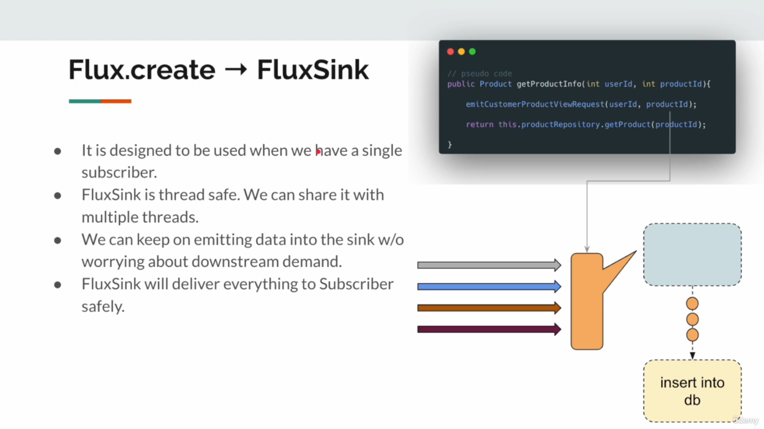

The image provides an explanation of Flux.create and its underlying FluxSink mechanism.
Designed for a Single Subscriber:
  - Flux.create with FluxSink is typically used when you have one subscriber at a time consuming the emitted items.
  - Unlike Flux.generate, it allows manual control over emissions, but you must ensure only one subscriber consumes the stream to avoid conflicts.
- Thread-Safe:
  - FluxSink is thread-safe, which means it can safely handle emissions from multiple threads simultaneously.
  - This is particularly useful in multi-threaded environments or when multiple threads emit events into the same stream.
- Emit Without Downstream Demand:
  - FluxSink allows emitting data regardless of downstream demand (e.g., how much the subscriber has requested).
  - However, you can use onRequest to synchronize emissions with demand and prevent overproduction, which is often necessary for efficient resource management.
- Reliable Delivery:
  - FluxSink ensures that all emitted data reaches the subscriber safely and in the correct order, as long as the subscription is active and has not been canceled.

Example Use Case in the Image
The pseudocode in the image represents a scenario where a product's details are fetched and the corresponding actions are emitted into a FluxSink. Here’s what it depicts:
- Emit Events:
  - A method (emitCustomerProductViewRequest) emits events (e.g., logging, analytics, etc.) into the FluxSink.
- Perform Operations:
  - While emitting events, another operation (e.g., fetching product details from a repository or database) can be performed simultaneously.
- Thread-Safe Handling:
  - Multiple threads emitting events into the same sink won’t cause thread safety issues.

Practical Explanation

Why Use FluxSink with Flux.create?
- Real-Time Data Streams:
  - When events are generated from external sources (e.g., user interactions, IoT devices, or external API responses).
  - Example: Logging real-time stock price changes or user actions.
- Custom Emission Logic:
  - You can control exactly how and when items are emitted based on specific business logic.
- Thread-Safe Emission:
  - Multiple threads emitting into the same sink is safe and avoids race conditions or data corruption.

How to Use It?
Code Example: Real-Time Database Insertions
Flux.create(fluxSink -> {
Runnable task = () -> {
for (int i = 1; i <= 10; i++) {
if (fluxSink.isCancelled()) return; // Stop emitting if subscription is canceled
String data = "Product " + i; // Generate data
System.out.println("Emitting: " + data);
fluxSink.next(data); // Emit data to the sink
}
fluxSink.complete(); // Complete the stream
};
// Run the task in a new thread
new Thread(task).start();
})
.subscribe(item -> {
System.out.println("Received: " + item); // Process received data
// Insert data into a database
});

Flexibility:
- FluxSink gives you full control over data emission, making it ideal for event-driven use cases.
- Thread Safety:
- Suitable for multi-threaded scenarios where multiple threads emit events into the same sink.
- Downstream Demand:
- You can synchronize emissions with downstream demand using onRequest to avoid overproduction and wasted resources.
Here are more examples and detailed clarifications on how FluxSink integrates into reactive applications:

Advanced Use Cases for FluxSink

1. Real-Time Sensor Data Streaming
Scenario:
- IoT devices or sensors continuously generate data that needs to be streamed to a subscriber in real-time.
Code Example:
public class RealTimeSensorData {
public static void main(String[] args) {
// Create a Flux for sensor data
Flux<String> sensorFlux = Flux.create(fluxSink -> {
Runnable task = () -> {
for (int i = 1; i <= 10; i++) {
if (fluxSink.isCancelled()) return; // Stop emitting if subscription is canceled
String sensorData = "SensorReading: " + i; // Simulated sensor reading
fluxSink.next(sensorData); // Emit data into the sink
try {
Thread.sleep(500); // Simulate delay between readings
} catch (InterruptedException e) {
fluxSink.error(e); // Handle interruption
}
}
fluxSink.complete(); // Signal completion
};
// Run the task in a separate thread
Executors.newSingleThreadExecutor().submit(task);
});
// Subscribe to the Flux and process the data
sensorFlux.subscribe(
data -> System.out.println("Received: " + data), // Handle each reading
err -> System.err.println("Error: " + err), // Handle errors
() -> System.out.println("Stream complete!") // Handle completion
);
}
}
Output (Sample):
Received: SensorReading: 1
Received: SensorReading: 2
Received: SensorReading: 3
...
Stream complete!
Key Points:
- Real-Time Streaming:
  - Simulates continuous data streaming from a sensor.
  - The subscriber receives data as it’s emitted.
- Thread-Safe Emission:
  - The producer emits data in a separate thread, and FluxSink ensures thread safety.
- Early Cancellation:
  - If the subscriber cancels, the producer stops emitting data immediately.

2. Event-Driven UI Updates
Scenario:
- A reactive system updates the user interface (UI) based on real-time events, like button clicks or notifications.
Code Example:
public class EventDrivenUI {
public static void main(String[] args) {
// Create a Flux for UI events
Flux<String> uiEventFlux = Flux.create(fluxSink -> {
Runnable task = () -> {
String[] events = {"Click", "Scroll", "Hover", "Resize", "Drag"};
for (String event : events) {
if (fluxSink.isCancelled()) return; // Stop emitting if canceled
fluxSink.next("UI Event: " + event); // Emit event
try {
Thread.sleep(300); // Simulate delay between events
} catch (InterruptedException e) {
fluxSink.error(e); // Handle interruption
}
}
fluxSink.complete(); // Signal completion
};
// Run the task in a separate thread
Executors.newSingleThreadExecutor().submit(task);
});
// Subscribe to the Flux to update the UI
uiEventFlux.subscribe(
event -> System.out.println("Processing: " + event), // Process each event
err -> System.err.println("Error: " + err), // Handle errors
() -> System.out.println("All events processed!") // Handle completion
);
}
}
Output (Sample):
Processing: UI Event: Click
Processing: UI Event: Scroll
Processing: UI Event: Hover
...
All events processed!
Key Points:
- Event-Driven:
  - Simulates handling UI events (e.g., clicks, scrolls) as they occur.
- Concurrency:
  - Events are generated in a separate thread and processed by the subscriber.
- Thread Safety:
  - FluxSink ensures the emitted events are safely delivered to the subscriber.

3. Dynamic API Request Handling
Scenario:
- Emit API requests dynamically based on real-time inputs (e.g., user actions, configuration changes).
Code Example:
public class DynamicApiRequests {
public static void main(String[] args) {
// Create a Flux for API requests
Flux<String> apiRequestFlux = Flux.create(fluxSink -> {
for (int i = 1; i <= 5; i++) {
if (fluxSink.isCancelled()) return; // Stop emitting if subscription is canceled
String apiRequest = "API Request #" + i; // Simulated API request
System.out.println("Emitting: " + apiRequest);
fluxSink.next(apiRequest); // Emit API request
try {
Thread.sleep(500); // Simulate delay between requests
} catch (InterruptedException e) {
fluxSink.error(e); // Handle interruption
}
}
fluxSink.complete(); // Signal completion
});
// Subscribe to the Flux and process the requests
apiRequestFlux.subscribe(
request -> System.out.println("Processing: " + request), // Handle each request
err -> System.err.println("Error: " + err), // Handle errors
() -> System.out.println("All requests processed!") // Handle completion
);
}
}
Output (Sample):
Emitting: API Request #1
Processing: API Request #1
Emitting: API Request #2
Processing: API Request #2
...
All requests processed!
Key Points:
- Dynamic Data Generation:
  - Simulates generating API requests in real-time based on inputs or configurations.
- Event Processing:
  - Each emitted request is processed by the subscriber.

Clarification: Why Is FluxSink Thread-Safe?
- Internal Synchronization:
  - FluxSink uses internal thread-safety mechanisms (like locks) to ensure that multiple threads emitting data do not corrupt the state.
- Safe Delivery:
  - Even if multiple threads emit items, FluxSink ensures the items are queued and delivered in the correct order to the subscriber.
- Single Subscriber:
  - While FluxSink itself is thread-safe, it assumes there is only one subscriber at a time consuming the emitted items.

Advantages of Using FluxSink
- Full Control Over Emission:
  - You can programmatically decide when and what to emit, unlike other factory methods like Flux.just or Flux.range.
- Dynamic or Real-Time Data:
  - Ideal for scenarios where data is generated in real-time, such as events, logs, or external inputs.
- Thread-Safe for Concurrency:
  - Multiple threads can emit data safely without the risk of race conditions or data corruption.
- Flexible Event Handling:
  - Can emit events or data dynamically in response to external triggers (e.g., user actions, sensor readings).

When to Use FluxSink
- Event-Driven Systems:
  - Ideal for streaming events like user interactions, notifications, or sensor data.
- Real-Time Data Processing:
  - Use for processing dynamic, real-time data where the producer generates items at an unpredictable rate.
- Custom Emission Logic:
  - When you need fine-grained control over how and when items are emitted.
- Thread-Safe Multi-Threaded Emission:
  - Use when multiple threads emit data into the same stream.

Take, Takewhile, TakeUntil Operators

Operator | Behavior | Condition | Stopping Criteria
take(N) | Emits the first N elements of the Flux. | No condition. Fixed count. | Stops after emitting N items.
takeWhile | Emits items while a condition is true. | Condition-based (Predicate). | Stops as soon as the condition fails.
takeUntil | Emits items until a condition becomes true. | Condition-based (Predicate). | Stops as soon as the condition is met.

Detailed Explanation of Each Operator

1. take(N)
- Description:
  - The take operator allows you to limit the number of items emitted from a Flux. It emits the first N items and then cancels the subscription.
- Usage:
  - Use when you want to limit the number of items to a fixed count.
- Importance:
  - Useful for performance optimization when you only need a subset of the data.
- When to Use:
  - When consuming data streams where you know the exact number of items required.
Example Behavior: For a range from 1 to 10:
- take(3) → 1, 2, 3.

2. takeWhile
- Description:
  - The takeWhile operator emits items as long as a condition is true. As soon as the condition is false, the stream stops.
- Usage:
  - Use when you want to conditionally consume items from a stream based on a dynamic check.
- Importance:
  - Optimizes data consumption by stopping early based on conditions.
- When to Use:
  - When processing real-time or infinite streams and you need to stop as soon as a condition fails.
Example Behavior: For a range from 1 to 10:
- takeWhile(i -> i < 5) → 1, 2, 3, 4.

3. takeUntil
- Description:
  - The takeUntil operator emits items until a condition becomes true. Once the condition is met, the stream stops immediately.
- Usage:
  - Use when you need to stop emitting as soon as a condition is satisfied.
- Importance:
  - Useful for detecting a trigger condition or stopping when specific criteria are reached.
- When to Use:
  - When processing real-time data and you need to stop when an event occurs.
Example Behavior: For a range from 1 to 10:
- takeUntil(i -> i < 5) → Stops immediately at the first value i < 5, i.e., 1.

public class TakeOperator {
public static void main(String[] args) {
// Demonstrate the "take" operator
take();
// Demonstrate the "takeWhile" operator
takeWhile();
// Demonstrate the "takeUntil" operator
takeUntil();
}
/**
* The take operator takes only the first N elements emitted by the Flux
* regardless of any condition.
*/
private static void take() {
Flux.range(1, 10) // Creates a Flux emitting integers from 1 to 10
.log("take") // Logs the Flux operations for debugging
.take(3) // Emits only the first 3 items
.log("sub") // Logs the downstream subscription behavior
.subscribe(Util.subscriber("TakeOperator")); // Subscribes to the Flux
}
/**
* The takeWhile operator takes items while a condition is true.
* It stops as soon as the condition is not met.
*/
private static void takeWhile() {
Flux.range(1, 10) // Creates a Flux emitting integers from 1 to 10
.log("take") // Logs the Flux operations for debugging
.takeWhile(i -> i < 5) // Emits items while 'i < 5' is true
.log("sub") // Logs the downstream subscription behavior
.subscribe(Util.subscriber("TakeWhileOperator")); // Subscribes to the Flux
}
/**
* The takeUntil operator takes items until a condition becomes true.
* It stops emitting as soon as the condition is met.
*/
private static void takeUntil() {
Flux.range(1, 10) // Creates a Flux emitting integers from 1 to 10
.log("take") // Logs the Flux operations for debugging
.takeUntil(i -> i < 5) // Stops emitting as soon as 'i < 5' is met
.log("sub") // Logs the downstream subscription behavior
.subscribe(Util.subscriber("TakeUntilOperator")); // Subscribes to the Flux
}
}
take:
- Fixed, predictable number of items.
- Efficient when you know the exact number of elements you need.
takeWhile:
- Condition-based; stops as soon as the condition is false.
- Best for processing streams where data validity depends on a condition.
takeUntil:
- Stops as soon as the condition is true.
- Useful for stopping data streams dynamically when a trigger occurs.

Output Example
For take(3):
take -> | onSubscribe([Synchronous Fuseable])
take -> | request(unbounded)
take -> | onNext(1)
take -> | onNext(2)
take -> | onNext(3)
take -> | cancel()
sub -> | onComplete()
For takeWhile(i -> i < 5):
take -> | onSubscribe([Synchronous Fuseable])
take -> | onNext(1)
take -> | onNext(2)
take -> | onNext(3)
take -> | onNext(4)
take -> | onNext(5)
take -> | cancel()
sub -> | onComplete()
For takeUntil(i -> i < 5):
take -> | onSubscribe([Synchronous Fuseable])
take -> | onNext(1)
take -> | cancel()
sub -> | onComplete()

Usage Scenarios
- take(N):
  - Example: You want to process only the first 100 items from a large data stream.
  - Real-World: Paginated responses or fetching limited rows in APIs.
- takeWhile:
  - Example: Process sensor data until the temperature exceeds a threshold.
  - Real-World: Processing stock prices while prices are below a maximum limit.
- takeUntil:
  - Example: Stop a data stream as soon as a specific event occurs, such as an error condition or threshold crossing.
  - Real-World: Stop processing as soon as a flag (e.g., a "stop" signal) is raised.

Visual Diagrams for Each Operator

1. take(N)
- Description: Emits only the first N items from the Flux, then cancels the subscription.
- Behavior:
Flux.range(1, 10).take(3)
Flow:
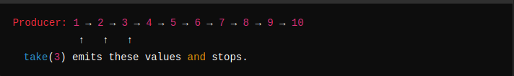
Diagram:
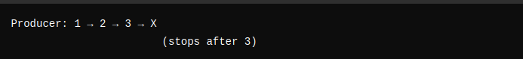

When to Use:
  - When you need a fixed number of items.
  - Example: Fetch the first 10 records from a large data set.

2. takeWhile(Predicate)
- Description: Emits items while the condition is true. As soon as the condition fails, the Flux cancels the stream.
- Behavior:

Flux.range(1, 10).takeWhile(i -> i < 5)

Flow:

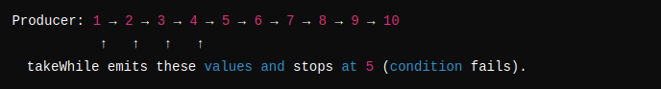

Diagram:

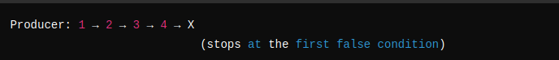

When to Use:
  - When you want to stop early based on a condition.
  - Example: Process a stream of stock prices until the price exceeds a threshold.

3. takeUntil(Predicate)
- Description: Emits items until the condition becomes true. The first time the condition is true, the Flux stops immediately.
- Behavior:
Flux.range(1, 10).takeUntil(i -> i < 5)

Flow:

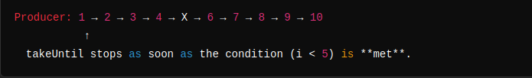

Diagram:

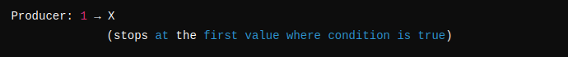
When to Use:
  - When you want to stop as soon as a trigger condition occurs.
  - Example: Stop processing sensor data when an error condition or stop signal occurs.

Differences Between take, takeWhile, and takeUntil
Aspect | take(N) | takeWhile(Predicate) | takeUntil(Predicate)
Behavior | Emits a fixed number of items. | Emits items while the condition is true. | Emits items until the condition becomes true.
Stopping Rule | Stops after N items. | Stops when the condition fails. | Stops when the condition is first met.
Condition Type | No condition, fixed count. | Condition-based (Predicate). | Condition-based (Predicate).
Usage | Limiting the number of items. | Stopping early based on a condition. | Triggering stop on a specific event.

Practical Real-Life Examples

take(N) Example
- Scenario: Fetch the first 10 records from a database API.

Flux.range(1, 1000) // Simulate 1000 records
.take(10) // Take only the first 10 records
.subscribe(System.out::println);
Output:
1
2
3
4
5
6
7
8
9
10

takeWhile Example
- Scenario: Process stock prices until a threshold is exceeded.
Flux.just(100, 101, 102, 110, 115, 120)
.takeWhile(price -> price < 110) // Stop when price >= 110
.subscribe(price -> System.out.println("Processing: " + price));
Output:
Processing: 100
Processing: 101
Processing: 102

takeUntil Example
- Scenario: Stop processing when an error condition is met.
Flux.just(100, 101, 102, 99, 120)
.takeUntil(price -> price < 100) // Stop when price < 100
.subscribe(price -> System.out.println("Processing: " + price));
Output:
Processing: 100
Processing: 101
Processing: 102
The stream stops immediately when price < 100.

Why Are These Operators Important?
- Resource Optimization:
  - Avoid unnecessary computation and emissions by stopping early when conditions are met.
- Backpressure Management:
  - Prevent overwhelming downstream consumers with excessive data.
- Dynamic Stopping:
  - Useful for real-time systems where data streams need to stop based on conditions.
- Error Prevention:
  - Helps avoid processing invalid data or crossing predefined limits.

Choosing the Right Operator
- Use take(N):
  - When you know exactly how many items you need.
  - Example: Fetch a fixed number of records from a database.
- Use takeWhile:
  - When you want to stop based on a condition that is continuously checked.
  - Example: Process data while it is valid (e.g., stock prices below a limit).
- Use takeUntil:
  - When you want to stop as soon as a specific event or condition occurs.
  - Example: Stop processing when an alert or threshold condition is reached.

Flux Generate

Definition of Flux.generate
- Flux.generate is a programmatic generator that synchronously emits items one at a time based on downstream demand (from the subscriber).
- It repeatedly invokes a lambda function to generate a single item per call to synchronousSink.next().
- It stops when:
  - The complete() method is invoked.
  - The error(Throwable) method is invoked.
  - The subscriber cancels the stream.

Definition of SynchronousSink
- SynchronousSink is an object provided by Flux.generate to emit at most one value in each invocation.
- It is used to:
  - Emit one value using synchronousSink.next(value).
  - Signal completion using synchronousSink.complete().
  - Signal an error using synchronousSink.error(Throwable).

public class FluxGenerate {
private static final Logger logger = LoggerFactory.getLogger(FluxGenerate.class);
public static void main(String[] args) {
/**
* Flux.generate:
* - Allows the programmatic generation of a Flux stream where a single item
* can be emitted at a time using SynchronousSink.
* - The lambda function is repeatedly invoked based on downstream demand.
* - Stops emitting items when:
* 1. `complete()` is called
* 2. `error(Throwable)` is called
* 3. The subscriber cancels the stream
*/
Flux.generate(synchronousSink -> {
logger.info("invoked"); // Log each invocation of the lambda
synchronousSink.next("hello"); // Emit a single item: "hello"
// Invalid: You cannot emit more than one value in a single invocation.
synchronousSink.next(2); // This will throw an error because only one value is allowed.
synchronousSink.complete(); // Signal completion to stop the stream
})
.take(5) // Request only the first 5 items from the generated Flux
.subscribe(Util.subscriber("FluxGenerate")); // Subscribe with a custom subscriber
}
}

Working of Flux.generate
- Lambda Execution:
  - The lambda function passed to Flux.generate is repeatedly invoked to emit one item at a time.
  - The lambda receives a SynchronousSink object, which is used to:
    - Emit a value using next(value).
    - Signal completion using complete().
    - Signal an error using error(Throwable).
- Downstream Demand:
  - The lambda is executed only when the subscriber requests data (request(n)).
  - Each invocation of the lambda allows emitting only one value.
- Stopping Conditions:
  - The stream stops if:
    - complete() is called.
    - error(Throwable) is called.
    - The subscriber cancels the subscription.
- Backpressure:
  - Unlike Flux.create, Flux.generate respects backpressure. It only invokes the lambda when there’s downstream demand.

Key Differences: Flux.create vs Flux.generate
Aspect | Flux.create | Flux.generate
Emit Behavior | Emit multiple items per invocation | Emit only one item per invocation
Backpressure | Ignores backpressure by default | Respects backpressure
Synchronous/Asynchronous | Supports asynchronous emission | Only synchronous emission
Thread Safety | Thread-safe and can use multiple threads | Single-threaded only
Control | Complete control over emissions | Emits one value based on demand

Practical Use Cases of Flux.generate
- Finite Generation:
  - When you need to emit a sequence of items one at a time.
  - Example: Generating numbers or records based on a fixed algorithm.
- Dynamic Data Generation:
  - Generate dynamic data on-demand (e.g., computation results or generated strings).
- Simulating Iterative Workflows:
  - When processing must occur step-by-step based on requests from the subscriber.
- Backpressure-Friendly Data Generation:
  - Use Flux.generate when you want to ensure that your producer respects backpressure and emits only the requested items.

Emitting Random Names
Here’s a valid example that respects the one value per invocation rule of Flux.generate:
public class FluxGenerateExample {
private static final Logger logger = LoggerFactory.getLogger(FluxGenerateExample.class);
public static void main(String[] args) {
Flux.generate(synchronousSink -> {
// Generate and emit a random name
String name = Util.faker().name().fullName();
logger.info("Generated name: {}", name);
synchronousSink.next(name); // Emit the name
if (name.startsWith("A")) { // Stop condition: name starts with 'A'
synchronousSink.complete();
}
})
.take(5) // Request at most 5 items
.subscribe(Util.subscriber("RandomNames"));
}
}
Emission:
  - A random name is generated and emitted for each invocation of the lambda function.
- Stopping Condition:
  - The stream stops when a name starting with "A" is generated, or the subscriber cancels.
- Backpressure:
  - The lambda is called only when the subscriber requests more data.

Flux.generate:
  - Emits items synchronously, one at a time.
  - Respects downstream demand (backpressure).
- SynchronousSink:
  - Provides control to emit exactly one item per invocation.
  - Allows signaling completion or error.
- When to Use Flux.generate:
  - When you need to generate data programmatically based on demand.
  - When the data source is finite or conditionally emitted.
- Why Not Use Flux.create Here?:
  - Flux.create is more flexible but can overproduce data and requires manual backpressure handling.
  - Flux.generate is simpler and enforces backpressure, making it ideal for synchronous data generation.

Difference Between Flux.create and Flux.generate
Aspect | Flux.create | Flux.generate
Emit Behavior | Allows emitting multiple values per invocation. | Allows emitting only one value per invocation.
Backpressure | Ignores backpressure by default but can handle it using onRequest. | Respects backpressure and emits based on downstream demand.
Thread Safety | Thread-safe. Can be used with multiple threads for parallel data emission. | Not thread-safe. Works on a single thread and does not allow multiple threads.
Emission Control | Complete control over emitting values and when to complete/error. | Limited to emitting one value at a time; synchronousSink manages single emission per call.
Synchronous/Asynchronous | Supports asynchronous emissions. Can emit items from multiple threads. | Supports only synchronous emissions; items are emitted one at a time.
Usage Complexity | More complex because the developer must handle backpressure manually or use onRequest. | Simpler to use since backpressure is inherently respected.
Best Use Case | Ideal for event-driven systems, such as multiple threads emitting data in real-time. | Ideal for finite, programmatically generated streams with controlled emission.
Stopping Conditions | Stops when fluxSink.complete() or fluxSink.error() is called. | Stops when synchronousSink.complete() or synchronousSink.error() is called.
Flexibility | High flexibility for creating streams dynamically. | Less flexible but suitable for structured and sequential data generation.
Performance | Can have higher overhead when multiple threads emit concurrently. | Lightweight and efficient due to its single-threaded design.
Downstream Demand | Can emit items even if no downstream demand exists. | Emits items only when explicitly requested by the downstream subscriber.
Handling Cancellation | Allows cancellation but does not inherently stop the producer unless handled manually. | Automatically stops further invocations when the subscriber cancels.

When to Use Flux.create
Use Flux.create when:
- Event-Driven Systems:
  - You need to emit data dynamically in real-time, often driven by external events.
  - Example: Button clicks, sensor readings, or log events.
- Multi-Threaded Emission:
  - You want to emit items concurrently from multiple threads. Flux.create is thread-safe.
- Custom Backpressure Handling:
  - You need fine-grained control over emissions, including managing backpressure manually via onRequest.
Example Use Case:
Flux.create(fluxSink -> {
Runnable task = () -> {
for (int i = 0; i < 10; i++) {
fluxSink.next("Event: " + i); // Emit events
}
fluxSink.complete();
};
new Thread(task).start();
})
.subscribe(System.out::println);
Output:
Event: 0
Event: 1
Event: 2
...

When to Use Flux.generate
Use Flux.generate when:
- Finite Programmatic Data Generation:
  - You want to generate items programmatically in a structured manner.
- Backpressure-Friendly:
  - You need emissions to respect downstream demand automatically.
- Single-Threaded Emission:
  - The generation logic works synchronously, and you don't require thread safety.
Example Use Case:
Flux.generate(synchronousSink -> {
String name = Util.faker().name().firstName();
System.out.println("Generated: " + name);
synchronousSink.next(name); // Emit one value at a time
if (name.startsWith("A")) synchronousSink.complete(); // Stop if condition met
})
.take(5)
.subscribe(System.out::println);
Output:
Generated: John
John
Generated: Alice
Alice
Generated: Alex
Alex

Aspect | Flux.create | Flux.generate
Flexibility | Best for asynchronous or multi-threaded data emission. | Best for synchronous, controlled data generation.
Backpressure | Developer must handle backpressure manually. | Automatically respects backpressure.
Emissions | Can emit multiple items per invocation. | Emits exactly one item per invocation.
Concurrency | Thread-safe, can work with multiple threads. | Single-threaded; not thread-safe.
Complexity | Slightly more complex due to manual control. | Simpler due to its structured emission logic.

Real-World Examples
Scenario | Flux.create | Flux.generate
Event-Driven Systems | Sensor data, button clicks, or real-time logs. | Not ideal, as it only emits one value per call.
Programmatically Generated Data | Not efficient for single-item emissions. | Perfect for sequential data generation.
Multi-Threaded Systems | Emitting data from multiple threads safely. | Not thread-safe, so not suitable.
Finite Streams | Can be used but requires manual handling. | Designed for finite, synchronous streams.

Conclusion
- Use Flux.create when:
  - You need dynamic, event-driven data streams.
  - Your application involves multi-threaded data emission.
  - You require full control over emission behavior and backpressure.
- Use Flux.generate when:
  - You want a simple, backpressure-friendly, synchronous data generator.
  - You are emitting finite, programmatically generated items.
  - The generation logic does not require thread safety or multi-threading.

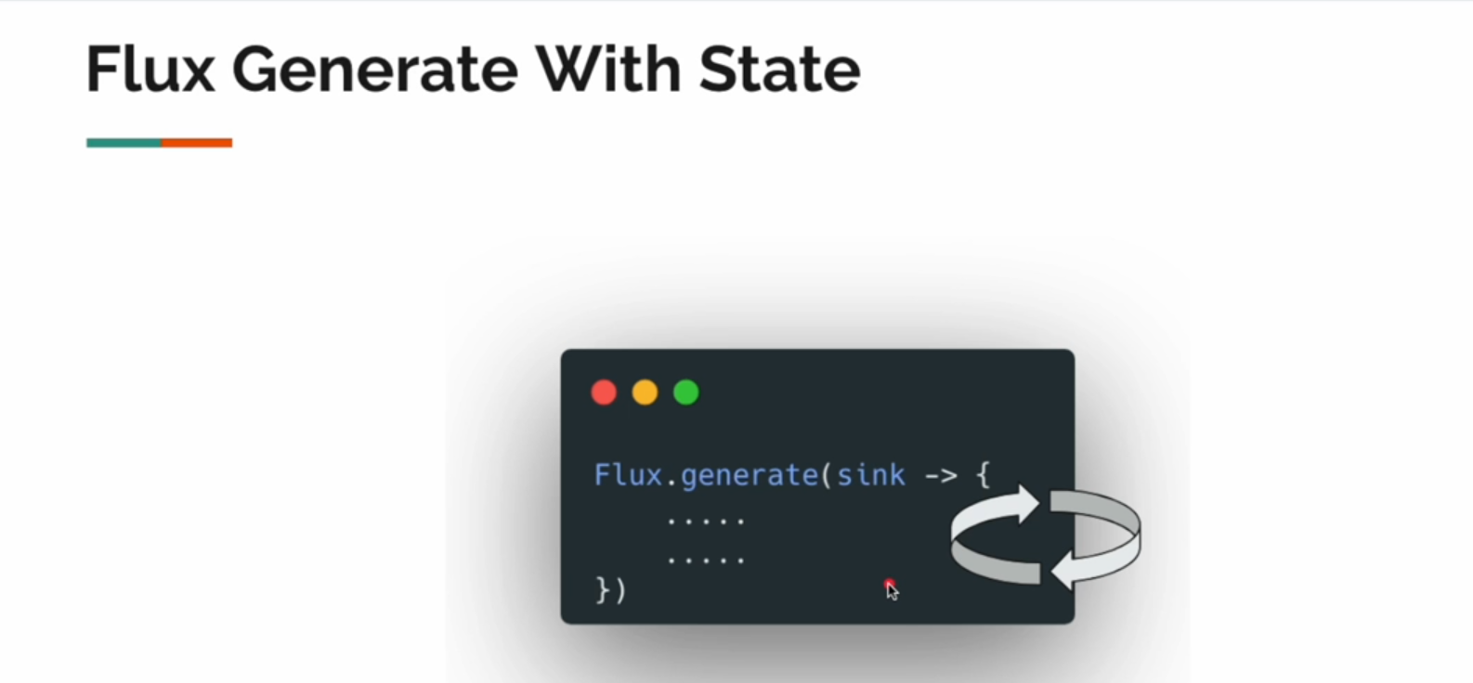

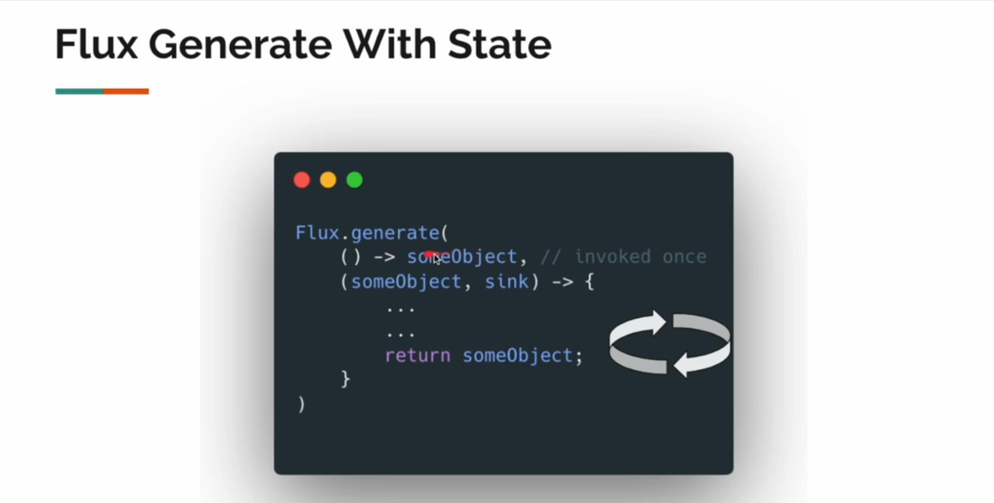

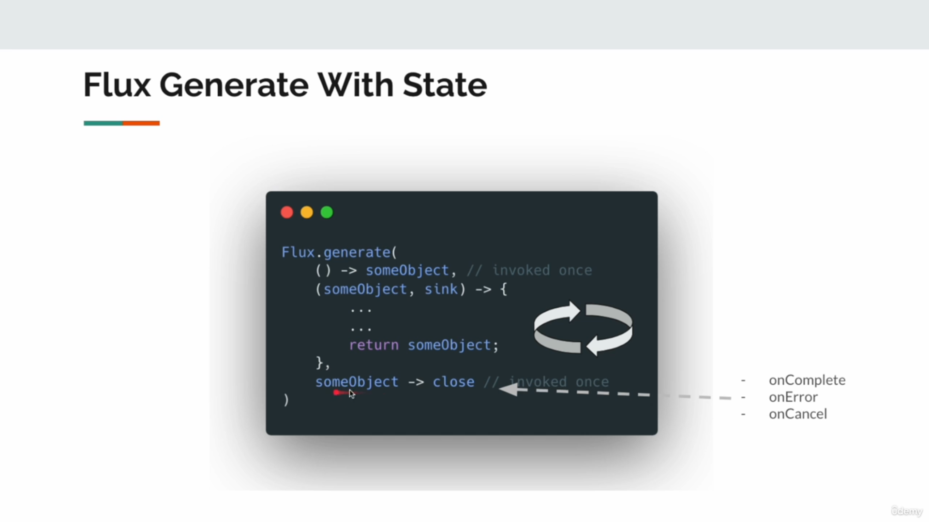
Syntax

Flux.generate(
() -> someObject, // Initial state (invoked once)
(someObject, sink) -> { // Invoked repeatedly based on downstream demand
...
return someObject; // Updated state returned after each invocation
},
someObject -> close // Cleanup operation invoked once on completion, error, or cancellation
);

() -> someObject:
  - This initializes the state (like a counter, object, or any resource).
  - It is invoked once when the stream starts.
- (someObject, sink) -> { ... }:
  - A lambda function invoked repeatedly to emit items based on downstream demand.
  - someObject: Represents the current state.
  - sink: A SynchronousSink to emit:
    - sink.next(value): Emits a value.
    - sink.complete(): Signals stream completion.
    - sink.error(Throwable): Signals an error.
- someObject -> close:
  - A cleanup operation that is invoked once when the stream terminates:
    - On completion (sink.complete()).
    - On error (sink.error()).
    - On cancellation by the subscriber.

Flow of Execution
- Initialization:
  - The someObject state is initialized once.
- Generation:
  - The (state, sink) function is repeatedly invoked for each downstream request.
  - The current state (someObject) can be updated after each invocation and is passed to the next iteration.
- Stopping:
  - The stream stops when:
    - sink.complete() is called.
    - An error occurs.
    - The subscriber cancels the subscription.
- Cleanup:
  - After termination, the cleanup function (someObject -> close) is invoked once to release resources.

Flux.generate Stateless?
Yes, Flux.generate is stateless by design. This means that each invocation of the lambda function provided to Flux.generate does not remember any state from the previous invocation.
- The lambda function receives a SynchronousSink, which allows you to emit exactly one item per invocation.
- However, since the lambda is invoked repeatedly for each requested item, it does not maintain any state across calls.

Why Is Flux.generate Stateless?
The design is intentional to make Flux.generate:
- Simple:
  - Flux.generate focuses on generating one value per invocation. By keeping it stateless, the developer has full control over what to emit.
- Lightweight:
  - Stateless generation avoids unnecessary overhead, making it efficient for synchronous item emission.
- Backpressure-Aware:
  - Since it emits items one at a time based on downstream demand, statelessness keeps it predictable.

The Problem with Statelessness
While being stateless makes Flux.generate simple and lightweight, it causes a problem when you need to maintain state across emissions. For example:
- Sequential Logic: If you need to emit items based on the previous state, such as incrementing numbers or processing a list step-by-step.
- Counters or Accumulators: Keeping track of an index, count, or cumulative sum is not possible in a pure stateless function.

Practical Example of Statelessness Issue
Let’s say you want to emit numbers starting from 1 and increment them on each invocation. In Flux.generate, you cannot do this directly because there is no built-in state management.
Flux.generate(sink -> {
int i = 1; // This will reset on every invocation
sink.next(i);
});
In this case:
- The int i is local to the lambda function and is reinitialized to 1 on every call.
- You will end up emitting 1 repeatedly, and the increment logic will not work.

Solution: Using a State Variable
To solve the statelessness issue, Flux.generate provides an overloaded version that allows you to use a state variable. This helps maintain state between invocations.

Stateful Flux.generate Example
The correct approach is to use the generate(initialState, BiFunction) variant of Flux.generate:
public class FluxGenerateWithState {
private static final Logger logger = LoggerFactory.getLogger(FluxGenerateWithState.class);
public static void main(String[] args) {
// Example: Generate numbers starting from 1
Flux.generate(
() -> 1, // Initial state: Starting value
(state, sink) -> {
logger.info("Emitting: {}", state);
sink.next(state); // Emit the current state
if (state == 10) { // Stop when state reaches 10
sink.complete();
}
return state + 1; // Increment state for the next invocation
}
).subscribe(value -> logger.info("Received: {}", value));
}
}
() -> 1:
  - This is the initial state, here set to 1.
- (state, sink) -> { ... }:
  - The state parameter holds the current state value that you can modify and return for the next invocation.
  - In this case:
    - Emit the current state using sink.next(state).
    - Return state + 1 to increment the state for the next emission.
- Stopping Condition:
  - Use sink.complete() to stop emitting values when the desired condition is met.
- Thread-Safe:
  - This works on a single thread, ensuring state consistency without additional synchronization.

Output of the Example
Emitting: 1
Received: 1
Emitting: 2
Received: 2
Emitting: 3
Received: 3
...
Emitting: 10
Received: 10

dvantages of Stateful Flux.generate
- State Persistence:
  - Allows you to keep track of values between invocations (e.g., counters, indexes, sums).
- Simplicity:
  - Cleaner and more intuitive when working with sequences or streams that require stateful logic.
- Backpressure Management:
  - Stateful generation still respects downstream demand and emits items one at a time.

When to Use Flux.generate (Stateless vs Stateful)
Use Case | Stateless Flux.generate | Stateful Flux.generate
Simple Data Generation | Emit fixed or constant values (e.g., "Hello") | Not needed
Sequential Data Generation | Not possible without state | Use state to emit incrementing or sequential data
Counters or Iterative Logic | Not possible | Use state to maintain counters or indexes
Backpressure-Friendly Logic | Supported | Supported
Custom Stopping Conditions | Supported with manual logic | Supported with state condition checks

Key Takeaways
- Statelessness:
  - By default, Flux.generate is stateless. It emits one value at a time and does not remember previous emissions.
- Problem:
  - Statelessness makes it impossible to keep track of counters, indexes, or any form of sequential state.
- Solution:
  - Use the stateful variant of Flux.generate with initialState and BiFunction to maintain state across invocations.
- When to Use:
  - Use stateless Flux.generate for fixed or simple logic.
  - Use stateful Flux.generate for sequences, counters, or when maintaining state is required.

- What does this example do?
- How Flux.generate works here and why it's stateful.
- The stateless version of this example.
- Why Flux.generate is stateless by default, and how state management is provided in your example.

public class GenerateWithStateInCountry {
public static void main(String[] args) {
Flux.generate(
() -> 0, // Initial state (counter = 0)
(counter, sink) -> { // Lambda invoked per emission
var country = Util.faker().country().name(); // Generate a random country
sink.next(country); // Emit the country name
counter++; // Increment the counter
// Stop emitting if 10 items are emitted or "Canada" is encountered
if (counter == 10 || country.equalsIgnoreCase("canada")) {
sink.complete(); // Signal completion
}
return counter; // Return updated state for the next invocation
}
).subscribe(Util.subscriber());
}
}
Output Behavior:
- The Flux.generate emits one value (a random country) per downstream request.
- A counter state tracks how many items have been emitted.
- The stream stops when either:
  - 10 items are emitted, or
  - "Canada" is generated.

2. Why Is This Example Stateful?
- The state here is managed using the counter (0 → 1 → 2... etc.).
- Flux.generate provides an initial state (0 in this case) and allows you to update it across invocations using the return value of the lambda.
- The counter persists across lambda invocations, enabling it to track emissions between calls.

3. Stateless
In a stateless version, we do not rely on state variables (e.g., counters) to track progress. Instead, we focus purely on emitting items independently for each invocation.
Here’s the modified stateless version:
public class GenerateStateless {
public static void main(String[] args) {
Flux.generate(sink -> {
// Generate a random country
var country = Util.faker().country().name();
sink.next(country); // Emit the country name
// Stop when "Canada" is encountered
if (country.equalsIgnoreCase("Canada")) {
sink.complete();
}
})
.take(10) // Take only the first 10 items (instead of using a counter)
.subscribe(Util.subscriber());
}
}

Explanation of the Stateless Version
- No State Initialization:
  - Unlike the stateful version, there is no () -> 0 initial state.
- No State Persistence:
  - The lambda function does not track a counter across invocations. Each invocation of the lambda is stateless and independent.
- Stopping Conditions:
  - Instead of using a counter, the take(10) operator limits the emissions to 10 items.
  - sink.complete() stops the stream when the condition (country.equalsIgnoreCase("Canada")) is satisfied.
- Why It’s Stateless:
  - Each lambda invocation generates and emits a value independently.
  - No state is shared or passed between invocations.

Comparison: Stateful vs Stateless
Aspect | Stateful Version | Stateless Version
State Management | Uses a counter to track emissions. | No state variable; each invocation is independent.
Stopping Condition | Stops when counter == 10 or "Canada" is found. | Stops using take(10) and "Canada" check.
Complexity | Slightly more complex due to state handling. | Simpler and cleaner without state.
Control Over Emission | Complete control over emission with state. | Relies on external operators like take().

4. Why Flux.generate Is Stateless by Default
Flux.generate is designed to emit only one value per invocation. By default, it does not provide a mechanism to persist state across invocations because:
- Simplicity:
  - Stateless behavior ensures that Flux.generate remains lightweight and simple for developers to use.
- Backpressure:
  - Statelessness makes it easier to respect downstream demand and emit items synchronously as requested.
- Explicit State Management:
  - If state persistence is needed (e.g., counters, accumulators), Flux.generate offers a stateful overload where you initialize and update the state explicitly:
Flux.generate(() -> initialState, (state, sink) -> { ... });

The Problem With Stateless Flux.generate
The issue with statelessness arises when you need to maintain context or track progress across invocations. For example:
- Emitting incremental numbers (1, 2, 3, ...).
- Keeping a running total of emitted values (sum, count, etc.).
- Tracking how many items have been emitted or processing an iterative sequence.

- Stateless:
  - By default, Flux.generate is stateless. Each invocation emits one value and forgets the previous invocation.
- Stateful:
  - Use the stateful variant Flux.generate(initialState, BiFunction) when you need to maintain state.
- Problems With Statelessness:
  - You cannot track progress, counters, or sequences across lambda invocations without additional operators or state handling.
- When to Use Stateless:
  - Use a stateless approach when you can rely on external operators like take(N) for stopping conditions.
- When to Use Stateful:
  - Use the stateful version when you need explicit control over emissions and need to track state like counters or accumulators.

Example: Counting Emitted Numbers Using Flux.generate

1. Stateful Example: Emit Incrementing Numbers with State Management
In this example, we want to emit a series of numbers starting from 1 and stop when the count reaches 10. Since Flux.generate is stateless by default, we must explicitly manage state.
public class StatefulFluxGenerateExample {
private static final Logger logger = LoggerFactory.getLogger(StatefulFluxGenerateExample.class);
public static void main(String[] args) {
Flux.generate(
() -> 1, // Initial state: Start counting from 1
(state, sink) -> {
logger.info("Emitting: {}", state); // Log the current state (count)
sink.next(state); // Emit the current state
if (state >= 10) { // Stop condition: when state reaches 10
sink.complete(); // Signal completion
}
return state + 1; // Increment the state for the next invocation
}
)
.subscribe(
value -> logger.info("Subscriber received: {}", value), // Process each value
err -> logger.error("Error occurred", err), // Handle errors
() -> logger.info("Stream complete!") // Handle stream completion
);
}
}

Explanation:
- State Initialization:
  - () -> 1: This initializes the state to 1 (the starting number for counting).
- State Progression:
  - return state + 1: Each invocation increments the state (i.e., the counter).
- Emitting Values:
  - sink.next(state): Emits the current value of the state.
- Stopping Condition:
  - if (state >= 10): Stops the stream when the count reaches 10.
  - sink.complete(): Signals that the stream has completed.
- Subscriber Behavior:
  - The subscriber receives each emitted value until the stream completes.

Output:
Emitting: 1
Subscriber received: 1
Emitting: 2
Subscriber received: 2
Emitting: 3
Subscriber received: 3
...
Emitting: 10
Subscriber received: 10
Stream complete!

2. Stateless Example Using Flux.range
If you do not need explicit state tracking, you can use Flux.range, which is inherently stateful under the hood.
public class StatelessFluxRangeExample {
private static final Logger logger = LoggerFactory.getLogger(StatelessFluxRangeExample.class);
public static void main(String[] args) {
Flux.range(1, 10) // Emit numbers 1 to 10
.subscribe(
value -> logger.info("Subscriber received: {}", value), // Process each value
err -> logger.error("Error occurred", err), // Handle errors
() -> logger.info("Stream complete!") // Handle stream completion
);
}
}

Explanation:
- No State Management:
  - Flux.range(1, 10) emits numbers from 1 to 10 without requiring explicit state handling.
- Simpler Syntax:
  - No need for state initialization or progression logic.
- Output:
Subscriber received: 1
Subscriber received: 2
...
Subscriber received: 10
Stream complete!

Comparison of Stateful Flux.generate vs Stateless Flux.range
Aspect | Stateful Flux.generate | Stateless Flux.range
State Management | Explicitly managed using initialState and BiFunction. | No explicit state management needed.
Use Case | Dynamic or conditional emission of values. | Sequential emission of a range of values.
Complexity | More complex due to manual state updates. | Simpler to use and understand.
Flexibility | Allows custom logic for state progression. | Limited to a fixed range of numbers.
Performance | Slightly slower due to state handling. | Highly optimized for performance.
Stopping Condition | Custom stopping logic (if condition). | Predefined number of emissions.

3. Key Problem With Statelessness
If you try to implement sequential logic (e.g., counters, accumulators) using the stateless version of Flux.generate, it won't work because there’s no persistence of state between invocations.

Example of the Problem:
Flux.generate(sink -> {
int counter = 1; // Reinitialized every time
sink.next(counter);
if (counter == 10) {
sink.complete();
}
});

Issue:
- int counter = 1 is local to the lambda function.
- It gets reset to 1 on each invocation, so the emitted value will always be 1.
Fix:
- Use the stateful overload of Flux.generate to maintain and update state across invocations.

4. When to Use Each
Scenario | Use Flux.generate | Use Flux.range
Dynamic State Updates | When you need stateful logic (e.g., counters, accumulators). | Not suitable for dynamic updates.
Simple Sequential Range | Can be used, but unnecessarily complex. | Perfect for emitting a fixed range.
Conditional Emissions | Custom stopping conditions (e.g., stop on "Canada"). | Not possible with Flux.range.
Backpressure Support | Respects backpressure inherently. | Respects backpressure inherently.
Performance | Slightly more overhead due to manual logic. | Highly optimized for fixed ranges.

Conclusion
- Stateful Flux.generate:
  - Use when you need explicit control over state (e.g., counters, dynamic progression).
- Stateless Flux.generate:
  - Use when items can be emitted independently, or when you rely on operators like take() for stopping logic.
- Flux.range:
  - Use for simple, sequential emissions without custom logic.
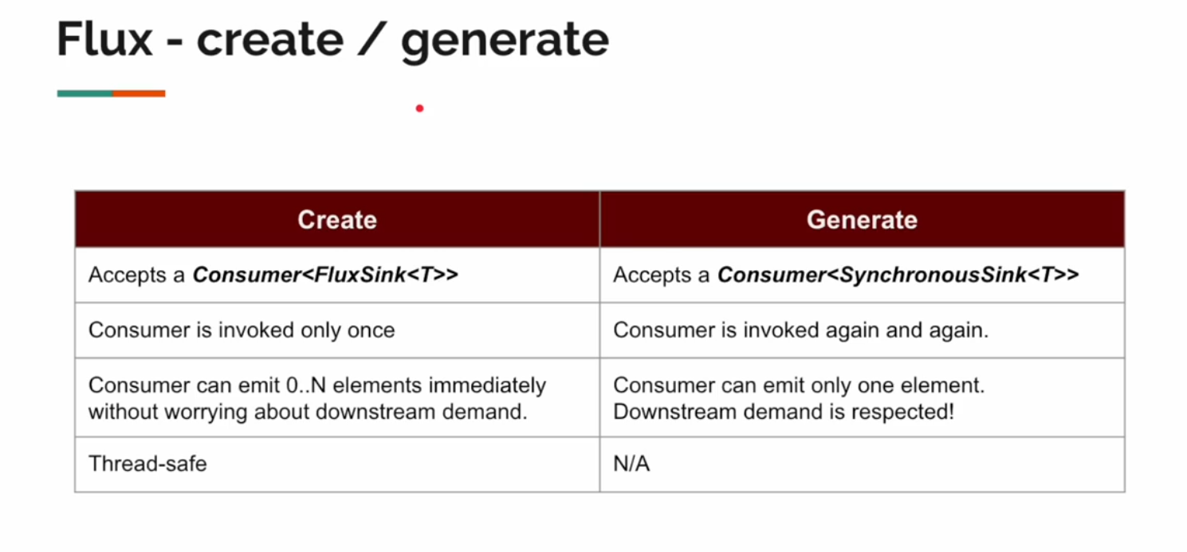
Operators

Operators in reactive programming (such as those provided by Reactor's Flux and Mono) are functions that transform, filter, or manipulate data streams in a reactive pipeline. They form the core building blocks for reactive stream processing and help developers compose, control, and observe data flows.

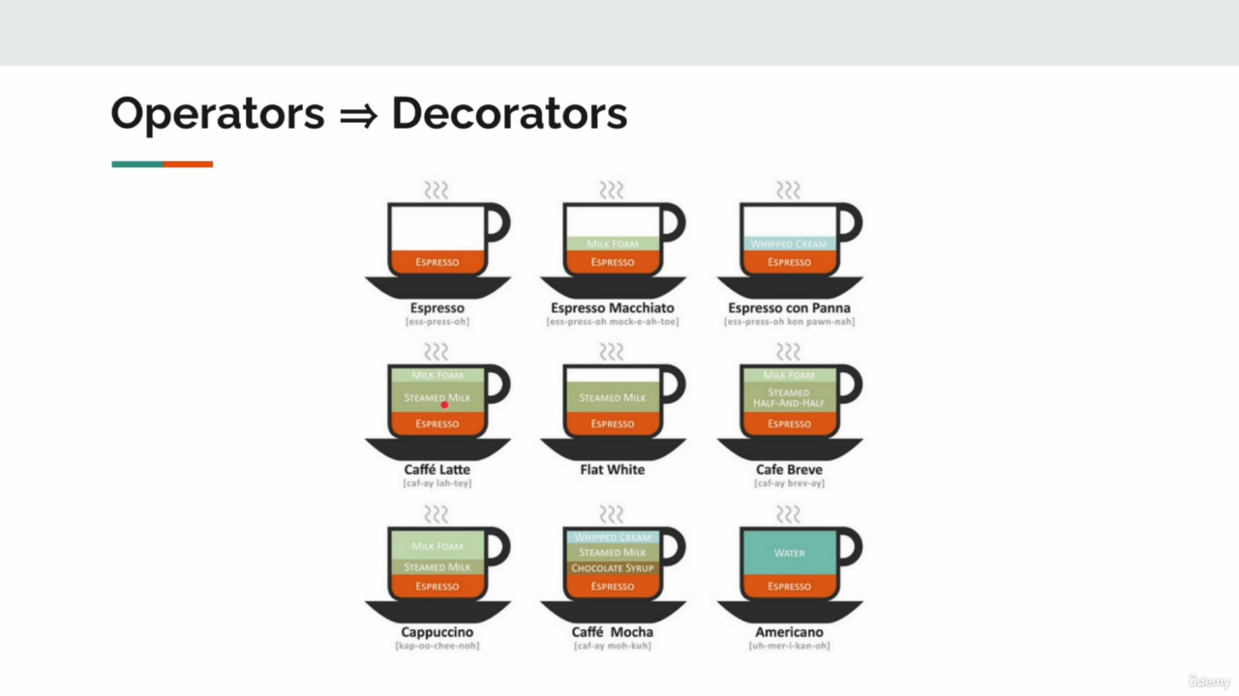

Types of Operators

1. Transformation Operators
- Purpose: Transform each emitted item from one form to another.
- Examples:
  - map: Transforms each item by applying a function.
  - flatMap: Flattens nested data streams by transforming items into Flux or Mono.

2. Filtering Operators
- Purpose: Select specific elements from the stream based on conditions.
- Examples:
  - filter: Allows items that satisfy a condition.
  - take: Emits only the first N items.
  - takeWhile: Emits items until a condition becomes false.
  - takeUntil: Emits items until a condition triggers an event.

3. Control Flow Operators
- Purpose: Control how items flow between producer and subscriber.
- Examples:
  - log: Logs all interactions in the reactive pipeline.
  - onErrorResume: Handles errors and continues with fallback data.
  - onComplete: Signals stream completion.

4. Combining Operators
- Purpose: Combine multiple streams into one.
- Examples:
  - merge: Merges multiple streams concurrently.
  - zip: Combines streams element-by-element.

5. Backpressure Operators
- Purpose: Manage how fast items are emitted vs consumed.
- Examples:
  - buffer: Collects items into a buffer before emitting.
  - limitRate: Controls the rate of emissions.

Reactive Pipeline and Operators

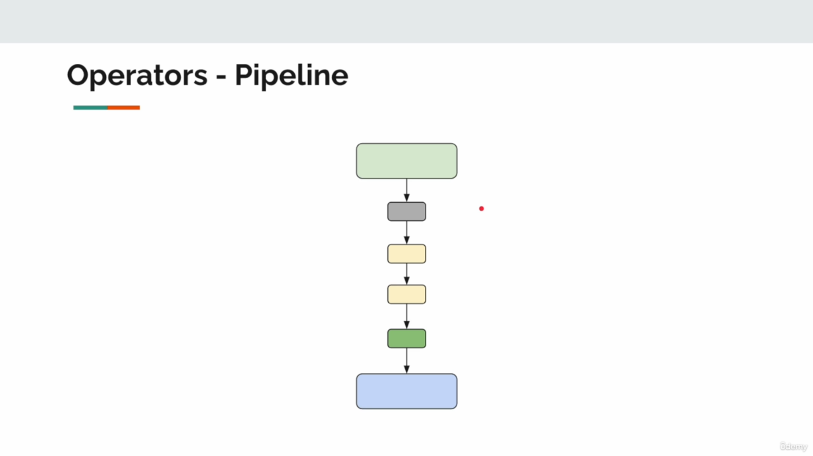

A reactive pipeline is a series of operators applied to a stream of data. It transforms the data step by step and connects the producer (source) to the subscriber (consumer).
Example:
Flux.range(1, 10) // Source emits numbers from 1 to 10
.filter(i -> i % 2 == 0) // Allow only even numbers
.map(i -> "Number: " + i) // Transform to String format
.log() // Log interactions for debugging
.take(3) // Take the first 3 items
.subscribe(System.out::println); // Consume and print

Output:
Number: 2
Number: 4
Number: 6

Explanation:
- The source emits numbers 1-10.
- filter selects only even numbers.
- map transforms them into a formatted string.
- log helps track pipeline activity.
- take(3) stops after 3 items are emitted.

Why Operators Are Important
- Declarative Programming:
  - Operators allow composing pipelines to express logic declaratively instead of imperatively.
- Non-Blocking:
  - Operators work in a non-blocking manner, enabling efficient resource usage in reactive systems.
- Flexibility:
  - Operators provide granular control over streams, like transformation, filtering, and handling errors.
- Scalability:
  - They enable large-scale data processing and backpressure handling, ensuring smooth interactions between fast producers and slow consumers.

When to Use Operators
- filter: When you need to exclude items that do not match certain criteria.
- map: To transform data elements.
- takeWhile / takeUntil: To limit the number of emitted elements based on conditions.
- log: For debugging reactive streams.
- buffer: To group items into chunks before further processing.

Operators are the backbone of reactive programming, enabling developers to build efficient, flexible, and declarative data pipelines. They allow you to transform, filter, and control the flow of data between a source and its subscribers.

Handle Operator
The handle operator in Project Reactor is a versatile operator that allows you to:
- Perform custom logic on each item in a stream.
- Decide whether to emit, transform, or filter items.
- Optionally emit errors or complete the stream programmatically.
It combines the capabilities of:
- filter: Decides whether to emit an item.
- map: Transforms the item before emitting.

Purpose of the handle Operator
The primary purpose of the handle operator is:
- To provide a low-level way to interact with data streams.
- To allow conditional filtering, transformation, and custom error handling in a single operator.

Usage
You use the handle operator when:
- You need complex logic to decide what to do with each emitted item.
- You want to filter, transform, or error out items conditionally.
- Combining filter and map separately would require multiple steps or repetitive code.

When to Use the handle Operator
- Dynamic Logic: When simple filter or map operators are insufficient, and you need to write custom logic.
- Error Handling: If certain items in the stream should cause the stream to emit an error.
- Selective Filtering and Transformation: You want to filter out some items, transform others, and emit errors for specific inputs in one operator.
/*
Handle behaves like a combination of filter and map operators.
Behavior Description:
- For item `1`: Convert it to `-2` and emit.
- For item `4`: Do not send it downstream (filter out).
- For item `7`: Emit an error and stop processing.
- For everything else: Emit the item as it is.
*/
public class HandleOperator {
public static void main(String[] args) {
Flux.range(1, 10) // Generate a stream of integers from 1 to 10
.filter(i -> i != 7) // (Optional) Early filter to exclude '7'
.handle((item, sink) -> { // Handle operator provides custom logic
switch (item) {
case 1 -> sink.next(-2); // Transform 1 to -2 and emit
case 4 -> { /* Do nothing => filter out */ } // Skip item 4
case 7 -> sink.error(new RuntimeException("Error")); // Throw an error for item 7
default -> sink.next(item); // Emit the item as it is
}
})
.cast(Integer.class) // Cast items to Integer type for type safety
.subscribe(Util.subscriber()); // Subscribe with a custom subscriber
}
}

Output:
Received: -2
Received: 2
Received: 3
Received: 5
Received: 6
Received: 8
Received: 9
Received: 10
Item 1 is converted to -2.
- Item 4 is filtered out (not emitted).
- Item 7 is excluded by filter (no error thrown due to early filtering).
- All other items pass through as is.
- Input:
  - The Flux.range(1, 10) generates a sequence of numbers from 1 to 10.
- filter Operator:
  - Optional, but here it excludes the number 7 before handle processes items.
- handle Logic:
  - sink.next(value): Emits a transformed or original value downstream.
  - sink.error(exception): Terminates the stream with an error.
  - Skipping sink.next filters out the item (like filter).
- Output:
  - Items are selectively transformed or filtered.
  - Errors can be emitted for specific conditions.

Why Is handle Important?
- It is a single operator that provides full control over emitted data.
- Reduces the need for chaining multiple operators like map and filter.
- Supports complex business logic directly within the stream pipeline.
- Useful for real-world scenarios like data validation, transformation, and error handling.
Flux<String> userInput = Flux.just("Alice", "", "John", "invalid", "Mike");
userInput
.handle((name, sink) -> {
if (name.isEmpty()) {
sink.error(new IllegalArgumentException("Name cannot be empty")); // Emit an error
} else if (name.equals("invalid")) {
// Skip "invalid" names
} else {
sink.next(name.toUpperCase()); // Transform valid names to uppercase
}
})
.subscribe(
name -> System.out.println("Processed: " + name),
err -> System.err.println("Error: " + err.getMessage()),
() -> System.out.println("Processing complete!")
);
Output:
Processed: ALICE
Error: Name cannot be empty
Processed: JOHN
Processed: MIKE

Definition: The handle operator allows custom filtering, transformation, and error emission.
- Usage: When simple operators like filter and map are not sufficient for dynamic logic.
- Importance: It combines filtering, mapping, and error handling into a single operator.
- Real-World Use: Ideal for validation, transformation, and custom business logic in data streams.

Do Hooks / Callback
Do Hooks (or callbacks) are special operators in Project Reactor that allow you to tap into the lifecycle of a reactive stream. They observe or log actions without modifying the data flowing through the stream.

urpose of Do Hooks
The purpose of do hooks is to:
- Log and Debug:
  - Observe lifecycle events (e.g., onNext, onComplete, onError, onSubscribe) for debugging purposes.
- Add Side Effects:
  - Perform tasks such as logging, auditing, or cleanup without changing the data stream.
- Track Stream Behavior:
  - Monitor how data flows through the stream and identify bottlenecks or issues.

Lifecycle of a Reactive Stream
The typical lifecycle of a stream includes:
- Subscription:
  - The subscriber subscribes to the stream (doOnSubscribe runs).
- Item Requests:
  - The subscriber requests items (doOnRequest runs).
- Data Flow:
  - Items are emitted (doOnNext runs for each item).
- Completion or Error:
  - If the stream completes successfully, doOnComplete runs.
  - If an error occurs, doOnError runs.
- Termination:
  - The doOnTerminate runs regardless of success or error.
- Cleanup:
  - Final actions like logging or cleanup (doFinally runs).

Importance and When to Use Do Hooks
- Debugging:
  - Use hooks like doOnNext, doOnSubscribe, and doFinally to log events and troubleshoot stream behavior.
- Auditing and Logging:
  - Implement audit trails or log critical events without modifying the data stream.
- Performance Monitoring:
  - Track requests and emitted items to identify bottlenecks.
- Cleanup and Resource Management:
  - Use doFinally or doOnTerminate to close resources or clean up after the stream completes.
- Testing and Validation:
  - Observe stream events to ensure the stream behaves as expected in different scenarios.

Key Hooks and Their Usage
Hook | Purpose
doFirst | Executes before anything else, in reverse order of declaration.
doOnSubscribe | Runs when a subscription starts.
doOnRequest | Logs requests made by subscribers for backpressure debugging.
doOnNext | Executes for every emitted item. Useful for inspecting data.
doOnComplete | Executes when the stream completes successfully.
doOnTerminate | Runs when the stream ends (either success or error).
doOnError | Runs when an error occurs in the stream.
doOnCancel | Executes when the subscription is canceled.
doOnDiscard | Logs discarded items (useful for backpressure scenarios).
doFinally | Runs at the end of the stream lifecycle (completion, error, or cancel).

public class DoCallbacks {
// Logger to track the lifecycle of the reactive stream
private static final Logger log = LoggerFactory.getLogger(Lec03DoCallbacks.class);
public static void main(String[] args) {
// Create a Flux programmatically using Flux.create
Flux.<Integer>create(fluxSink -> {
log.info("producer begins"); // Log when the producer starts
for (int i = 0; i < 4; i++) {
fluxSink.next(i); // Emit items 0 to 3
}
fluxSink.complete(); // Signal the stream's completion
log.info("producer ends"); // Log when the producer ends
})
// ----------------- Lifecycle Hooks/Callbacks -----------------
// doFirst: Executes callbacks BEFORE anything else in the pipeline (in reverse order of declaration)
.doFirst(() -> log.info("doFirst-1")) // Runs 2nd
.doFirst(() -> log.info("doFirst-2")) // Runs 1st
// doOnSubscribe: Executes when a subscription is made to the stream
.doOnSubscribe(subscription -> log.info("doOnSubscribe-1: {}", subscription))
.doOnSubscribe(subscription -> log.info("doOnSubscribe-2: {}", subscription))
// doOnRequest: Executes when the subscriber requests items
.doOnRequest(request -> log.info("doOnRequest-1: {}", request))
.doOnRequest(request -> log.info("doOnRequest-2: {}", request))
// doOnNext: Executes for each emitted item in the stream
.doOnNext(item -> log.info("doOnNext-1: {}", item))
.doOnNext(item -> log.info("doOnNext-2: {}", item))
// doOnComplete: Executes when the stream completes successfully
.doOnComplete(() -> log.info("doOnComplete-1"))
.doOnComplete(() -> log.info("doOnComplete-2"))
// doOnTerminate: Executes when the stream ends (either by completion or error)
.doOnTerminate(() -> log.info("doOnTerminate-1"))
.doOnTerminate(() -> log.info("doOnTerminate-2"))
// doOnError: Executes when an error occurs
.doOnError(error -> log.info("doOnError-1: {}", error.getMessage()))
.doOnError(error -> log.info("doOnError-2: {}", error.getMessage()))
// doOnCancel: Executes when the subscriber cancels the subscription
.doOnCancel(() -> log.info("doOnCancel-1"))
.doOnCancel(() -> log.info("doOnCancel-2"))
// doOnDiscard: Executes when items are discarded due to cancellation or backpressure
.doOnDiscard(Object.class, o -> log.info("doOnDiscard-1: {}", o))
.doOnDiscard(Object.class, o -> log.info("doOnDiscard-2: {}", o))
// doFinally: Executes at the very end of the stream lifecycle
.doFinally(signal -> log.info("doFinally-1: {}", signal))
.doFinally(signal -> log.info("doFinally-2: {}", signal))
// Subscribe to the Flux to trigger the callbacks and lifecycle hooks
.subscribe(Util.subscriber("subscriber"));
}
}

Output and Explanation
When this program runs, the following lifecycle events and callbacks occur (in order):
- doFirst:
  - These callbacks run before anything else in the pipeline, in reverse order of declaration.
- doOnSubscribe:
  - Executes when the subscription starts (i.e., the stream is subscribed).
- doOnRequest:
  - Logs whenever the subscriber requests items (useful for backpressure debugging).
- doOnNext:
  - Executes for every item emitted by the producer.
- doOnComplete:
  - Executes when the stream completes successfully (i.e., all items have been emitted).
- doOnTerminate:
  - Runs when the stream terminates, either by completion or error.
- doFinally:
  - Executes after everything, regardless of success, error, or cancellation.
- doOnError (if applicable):
  - Runs if an error occurs.
- doOnCancel (if applicable):
  - Runs if the subscriber cancels the subscription.
- doOnDiscard:
  - Runs when items are discarded due to cancellation or backpressure.

Logging Stream Events

Flux.range(1, 5)
.doOnSubscribe(subscription -> System.out.println("Subscribed!"))
.doOnRequest(request -> System.out.println("Requested: " + request))
.doOnNext(item -> System.out.println("Processing: " + item))
.doOnComplete(() -> System.out.println("Stream Completed!"))
.doOnTerminate(() -> System.out.println("Stream Terminated"))
.subscribe();

Output:
Subscribed!
Requested: 256
Processing: 1
Processing: 2
Processing: 3
Processing: 4
Processing: 5
Stream Completed!
Stream Terminated

Definition: Do hooks are lifecycle callbacks that observe and log events during the stream lifecycle.
- Usage: Debugging, logging, auditing, and monitoring stream events.
- Importance: Provides insights into stream behavior without altering data flow.
- Lifecycle: Subscription → Data Flow → Completion/Error → Cleanup.

Overview of All do Hooks in Project Reactor
In Project Reactor, do hooks (also known as lifecycle callbacks) provide a way to observe, log, and act at different stages of a reactive stream's lifecycle. They are useful for debugging, monitoring, auditing, and adding non-intrusive side effects to a stream.

Why Use do Hooks?
- Debugging: Track the flow of data, requests, and errors.
- Monitoring: Observe lifecycle events like subscription, termination, or cancellation.
- Auditing: Log important actions without modifying the data stream.
- Side Effects: Perform non-functional operations like cleanup, resource management, or status tracking.

List of All do Hooks with Explanation
Hook | Description
doFirst | Runs before anything else in the pipeline. Executed in reverse order.
doOnSubscribe | Executes when a subscription is created (subscriber subscribes).
doOnRequest | Executes when the subscriber requests items (for backpressure handling).
doOnNext | Executes when each item is emitted from the stream.
doOnComplete | Runs when the stream completes successfully (no errors).
doOnTerminate | Runs when the stream terminates by success or error.
doOnError | Executes when an error occurs in the stream.
doOnCancel | Executes when the subscriber cancels the subscription.
doOnDiscard | Runs when items are discarded due to backpressure or cancellation.
doFinally | Runs at the end of the stream, regardless of success, error, or cancel.

Life Cycle of a Reactive Stream with do Hooks
The typical lifecycle of a reactive stream includes:
- Subscription: A subscriber subscribes to the stream (doOnSubscribe).
- Item Requests: The subscriber requests data (doOnRequest).
- Data Flow:
  - Items are emitted (doOnNext).
  - Side effects or checks occur (doOnNext, doOnDiscard).
- Completion or Error:
  - Stream completes successfully (doOnComplete).
  - An error terminates the stream (doOnError).
- Termination:
  - Cleanup tasks run (doOnTerminate, doFinally).
- Cancellation: If the subscriber cancels, doOnCancel runs.

Detailed Explanation with Practical Examples

1. doFirst
- Executes before anything else in the stream pipeline.
- Hooks run in reverse declaration order.
Flux.just(1, 2, 3)
.doFirst(() -> System.out.println("doFirst-1")) // Runs second
.doFirst(() -> System.out.println("doFirst-2")) // Runs first
.subscribe(System.out::println);

Output:
doFirst-2
doFirst-1
1
2
3

2. doOnSubscribe
- Executes when a subscription is made to the stream.
Flux.just(1, 2, 3)
.doOnSubscribe(subscription -> System.out.println("Subscription started"))
.subscribe(System.out::println);
Output:
Subscription started
1
2
3

3. doOnRequest
- Logs when the subscriber requests a specific number of items.
Flux.range(1, 5)
.doOnRequest(request -> System.out.println("Requested: " + request))
.subscribe(System.out::println);
Output:
Requested: 256
1
2
3
4
5
(Default request for an unbounded subscriber is Long.MAX_VALUE or 256 for bounded environments.)

4. doOnNext
- Executes for each item emitted.
Flux.range(1, 3)
.doOnNext(i -> System.out.println("Processing item: " + i))
.subscribe(System.out::println);

Output:

Processing item: 1
1
Processing item: 2
2
Processing item: 3
3

5. doOnComplete
- Runs when the stream completes successfully.
Flux.range(1, 3)
.doOnComplete(() -> System.out.println("Stream completed!"))
.subscribe(System.out::println);

Output:
Output:
1
2
3
Stream completed!

6. doOnTerminate
- Executes when the stream terminates (either successfully or with an error).
Flux.range(1, 3)
.doOnTerminate(() -> System.out.println("Stream terminated"))
.subscribe(System.out::println);

Output:
1
2
3
Stream terminated

7. doOnError
- Executes when an error occurs in the stream.
Flux.just(1, 2, 3)
.map(i -> {
if (i == 2) throw new RuntimeException("Error on 2");
return i;
})
.doOnError(error -> System.out.println("Error: " + error.getMessage()))
.subscribe(System.out::println);

Output:

1
Error: Error on 2

8. doOnCancel
- Executes when the subscriber cancels the subscription.
Flux.range(1, 10)
.doOnCancel(() -> System.out.println("Subscription canceled"))
.take(3) // Cancels after 3 items
.subscribe(System.out::println);

Output:

1
2
3
Subscription canceled

9. doOnDiscard
- Logs when items are discarded (due to cancellation or backpressure).
Flux.range(1, 5)
.doOnDiscard(Integer.class, i -> System.out.println("Discarded: " + i))
.take(3)
.subscribe(System.out::println);

Output:

1
2
3
Discarded: 4
Discarded: 5

10. doFinally
- Executes at the end of the stream lifecycle, regardless of success, error, or cancellation.
Flux.range(1, 5)
.doFinally(signal -> System.out.println("Signal: " + signal))
.take(3) // Cancels after 3 items
.subscribe(System.out::println);

Output:

1
2
3
Signal: cancel

Summary of Use Cases
Use Case | Hook to Use
Debugging subscription flow | doOnSubscribe
Logging emitted items | doOnNext
Monitoring stream termination | doOnTerminate
Handling errors | doOnError
Cleanup after stream ends | doFinally
Logging discarded items | doOnDiscard
Handling stream cancellation | doOnCancel

When to Use do Hooks?
- Debugging: To understand stream behavior, including requests, emissions, and cancellations.
- Monitoring: For performance monitoring, logging, or auditing.
- Side Effects: To trigger non-intrusive actions without modifying the data.
- Backpressure Management: Use doOnRequest for tracking item requests.

Key Takeaways
- do hooks are non-intrusive and observe the stream lifecycle.
- They help in debugging, monitoring, and side-effect management.
- Each hook serves a specific purpose at a different lifecycle stage.
- Use them wisely to ensure clarity and proper stream debugging.

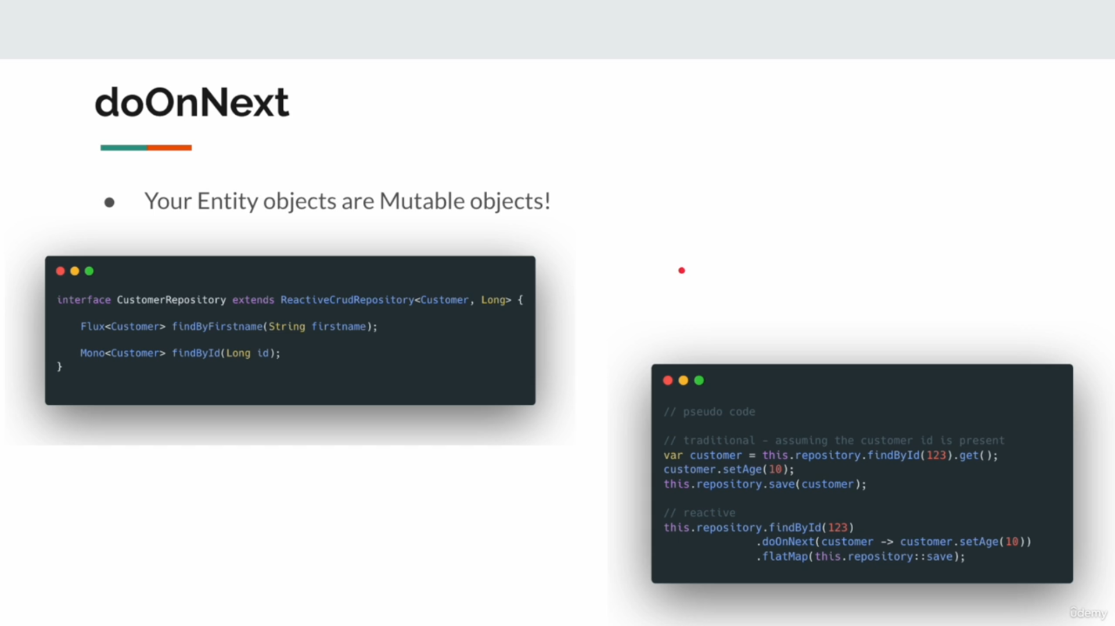

Delay Operator
The delayElements operator introduces a fixed delay between each item emitted by a Flux. This delay does not impact the total number of emitted items but slows down their emission based on the specified duration.

delayElements
The delayElements(Duration) operator in Project Reactor:
- Introduces a delay for each item emitted by a Flux.
- Duration specifies how long the delay should be (e.g., 1 second).
- Delayed elements are emitted sequentially in a non-blocking fashion.

Purpose of delayElements
- To simulate time gaps between the emission of items in a reactive stream.
- To throttle data processing without overloading downstream consumers.
- To mimic real-time data flow or time-based delays in event-driven systems.

Usage of delayElements
- Testing: Simulate delays in data processing to test time-dependent components.
- Throttling: Ensure downstream systems are not overwhelmed by slowing down emissions.
- Real-Time Simulation: Imitate periodic data emissions (e.g., sensor readings, events).
- Rate-Limiting: Control how frequently items are emitted in a controlled time interval.

When to Use delayElements
- To control the flow of data: If a downstream subscriber processes data slowly, delayElements introduces manageable delays.
- Simulating Real-Time Behavior: For scenarios like periodic updates or streaming data.
- Testing Async Systems: To verify how an application handles delayed data flow.
- Rate-Limiting APIs: When interacting with APIs that require throttling requests.

Example Use Cases
- Simulating Event Stream:
  - When simulating sensor readings or event logs that arrive at fixed intervals.
- Testing UI Components:
  - Ensuring UI components can process streamed data in a timed manner.
- Throttling Data:
  - If a backend service cannot handle bursts of requests, delayElements can regulate the emission speed.

Key Notes
- Non-Blocking: The delay does not block the thread. It uses a scheduler internally.
- Thread-Safe: Items are emitted sequentially.
- Performance: Use with caution for high-frequency streams; delays could accumulate and affect latency.

/**
* Delay Elements
*/
public class DelayOperator {
public static void main(String[] args) {
// Flux emits integers from 1 to 10
Flux.range(1, 10)
.log() // Logs the flow of the Flux for debugging
.delayElements(Duration.ofSeconds(1)) // Introduces a delay of 1 second for each emitted item
.subscribe(Util.subscriber()); // Subscribes to the Flux and processes the items
// Sleep the main thread to allow time for the delayed emission to complete
try {
Util.sleepSeconds(12); // Main thread sleeps for 12 seconds to wait for all emissions
} catch (InterruptedException e) {
throw new RuntimeException(e); // Handle interruption exception
}
}
}
Output
INFO: | onSubscribe([Fuseable] FluxRange)
INFO: | request(unbounded)
INFO: | onNext(1)
1
INFO: | onNext(2) --> delayed by 1 second
2
INFO: | onNext(3) --> delayed by 1 second
3
...
INFO: | onComplete()

public static void main1(String[] args) {
System.out.println("Starting delayed stream...");
Flux.range(1, 5) // Emit 1 to 5
.delayElements(Duration.ofSeconds(2)) // Delay each item by 2 seconds
.doOnNext(i -> System.out.println("Emitting: " + i)) // Debug log for each emission
.doOnComplete(() -> System.out.println("Stream completed!")) // Log when stream completes
.subscribe(); // Subscribe to the Flux
// Keep the main thread alive for enough time to process the stream
try {
Util.sleepSeconds(12); // Sleep for 12 seconds to allow delays to finish
} catch (InterruptedException e) {
throw new RuntimeException(e);
}
}

delayElements introduces a delay between emitted elements of a Flux.
- It helps to simulate real-time delays, throttle data flow, and test asynchronous systems.
- Non-blocking delays ensure efficient resource utilization.
- Use it for cases like event simulation, rate-limiting, and testing periodic emissions.

Subscriber Operator
The subscriber operator in Project Reactor refers to the behavior of the subscribe() method. It:
- Initiates the stream processing.
- Acts as the consumer that receives items emitted by the publisher (Flux or Mono).
- Allows the subscriber to observe and interact with the reactive stream through doOn hooks like:
  - doOnNext (on each emitted item),
  - doOnComplete (on stream completion),
  - doOnError (on stream errors).

public class SubscriberOperator {
private static final Logger log = LoggerFactory.getLogger(SubscriberOperator.class);
public static void main(String[] args) {
// Flux.range generates a stream of integers from 1 to 10
Flux.range(1, 10)
// doOnNext hook is triggered whenever an item is emitted
.doOnNext(i -> log.info("received: {}", i)) // Logs each emitted item
// doOnComplete hook is executed when the Flux completes successfully
.doOnComplete(() -> log.info("completed")) // Logs when the stream completes
// doOnError hook is triggered when an error occurs in the stream
.doOnError(err -> log.error("error", err)) // Logs errors in the stream
// subscribe method starts the stream processing
.subscribe(); // Starts the stream but does nothing with emitted items
}
}

Program Output

INFO: received: 1
INFO: received: 2
INFO: received: 3
...
INFO: received: 10
INFO: completed

doOnNext: Logs each emitted item.
- doOnComplete: Indicates that the stream has completed successfully.
- doOnError: Logs any error if the stream fails (not seen in this case since no error occurs).

Purpose of Subscriber Operator
The subscriber operator (subscribe) serves the following purposes:
- Triggering the Stream:
  - Reactive streams are lazy, and the stream only starts when a subscriber subscribes.
- Consuming Emitted Data:
  - A subscriber consumes the data emitted by the publisher.
- Observing Lifecycle Events:
  - Side effects like logging, cleanup, or monitoring are performed using doOn hooks.
- Error Handling:
  - Allows developers to observe and handle errors gracefully.

Usage of subscribe() and doOn Hooks
- subscribe():
  - Starts the reactive stream.
  - Defines how to process emitted data, handle errors, or observe completion.
- doOnNext:
  - Logs or performs a side effect on each emitted item before the subscriber processes it.
- doOnComplete:
  - Executes when the stream completes successfully, useful for cleanups or status logs.
- doOnError:
  - Observes errors and allows for debugging or corrective actions.

Importance of Subscriber Operator
- Lazy Execution: Reactive streams only execute when subscribe() is called, ensuring efficient resource usage.
- Monitoring and Debugging: doOn hooks help trace the data flow and lifecycle events of a stream.
- Error Handling: Observing and handling errors without breaking the application flow.
- Side Effects: Add non-functional behaviors like logging, cleanup, or audit trails without impacting the main stream logic.

When to Use Subscriber Operator
- To Initiate the Stream:
  - Without subscribe(), the stream will not emit items, as streams are lazy.
- For Logging and Debugging:
  - Use doOnNext, doOnComplete, and doOnError to monitor data flow and lifecycle events.
- Error Observability:
  - Handle errors effectively with doOnError for better reliability.
- Side Effects:
  - Add side effects like saving to a database, cleaning up resources, or logging actions.

The Idea Behind Subscriber Operator
The idea behind the subscriber operator is to:
- Decouple data emission (producer) and data consumption (subscriber).
- Provide a mechanism to:
  - Observe the stream lifecycle using hooks (doOnNext, doOnComplete, doOnError).
  - Take appropriate actions without modifying the main logic.
- Allow backpressure handling by defining request behavior (not used in this example).
public static void main1(String[] args) {
Flux.range(1, 10)
.doOnNext(i -> log.info("received: {}", i))
.doOnComplete(() -> log.info("completed"))
.doOnError(err -> log.error("error", err))
// Custom logic for the subscriber
.subscribe(
item -> log.info("Processing item: {}", item), // OnNext logic
err -> log.error("Error occurred: {}", err.getMessage()), // OnError logic
() -> log.info("All items processed successfully") // OnComplete logic
);
}

Output:

INFO: received: 1
INFO: Processing item: 1
INFO: received: 2
INFO: Processing item: 2
...
INFO: received: 10
INFO: Processing item: 10
INFO: completed
INFO: All items processed successfully

The subscribe() method is necessary to start stream execution.
- doOn hooks allow monitoring of different stages of the stream lifecycle:
  - doOnNext: When an item is emitted.
  - doOnComplete: When the stream completes successfully.
  - doOnError: When an error occurs.
- These hooks are non-intrusive, meaning they do not alter the emitted data but perform side effects like logging.

Error Handling in Reactive Streams

Error Handling in Reactive Streams: onErrorReturn, onErrorResume, and onErrorMap
In reactive programming with Project Reactor, error handling ensures that fault-tolerance and graceful recovery are achieved when exceptions occur. Below, I'll explain onErrorResume and onErrorMap, their purpose, when to use them, and their practical usage in multiple services.

The onErrorReturn operator in Project Reactor:
- Provides a fallback value to emit when an error occurs.
- Optionally allows specifying the type of exception to match.

Purpose of onErrorReturn
- To handle errors in a reactive pipeline without propagating them downstream.
- To ensure the stream can provide default values and graceful completion even in error scenarios.
- To avoid breaking subscribers when exceptions occur.

Usage of onErrorReturn
- General Fallback:
  - Use onErrorReturn to return a single fallback value when any error occurs.
- Type-Specific Fallback:
  - Handle different exception types differently with targeted fallback values.
- Graceful Recovery:
  - Avoid abrupt termination of streams by replacing errors with valid fallback data.

When to Use onErrorReturn
- Handling Known Errors:
  - When you expect certain errors (e.g., NullPointerException, ArithmeticException), provide fallback values to handle them.
- Providing Defaults:
  - Replace invalid or erroneous data with default values.
- Graceful Recovery:
  - Ensure the reactive stream does not terminate unexpectedly, allowing subscribers to consume fallback data instead.
- Simplified Error Management:
  - In simple scenarios, onErrorReturn provides an easy way to handle errors without complex recovery logic.

Importance of Error Handling
- Robustness:
  - Error handling ensures the application is resilient and does not crash due to unhandled exceptions.
- Graceful Degradation:
  - Provides fallback values or alternative flows when errors occur.
- Improved User Experience:
  - Avoids abrupt failures in applications (e.g., showing an error message to users instead of breaking the system).
- Stream Continuation:
  - Allows reactive streams to continue emitting values even when an intermediate error occurs.

The Idea Behind It
The idea behind onErrorReturn is:
- Decoupling: Errors can be replaced with fallback data, ensuring subscribers receive valid data.
- Resilience: Errors do not terminate the stream unexpectedly.
- Simplicity: Provides an easy mechanism to handle errors without custom logic or retries.

/**
* Demonstrates error handling using onErrorReturn in a reactive pipeline.
* Its also work with Mono
*/
public class ErrorHandling {
// Logger instance for logging events in the reactive stream
public static final Logger logger = LoggerFactory.getLogger(ErrorHandling.class);
public static void main(String[] args) {
Flux.range(1, 10) // Generate a range of numbers from 1 to 10
.map(i -> i == 5 ? 5 / 0 : i) // Intentional error when i == 5 (division by zero)
/*
* onErrorReturn: Handles errors by providing fallback values.
* 1. General error fallback value.
* 2. Specific fallback values for particular exception types.
*/
.onErrorReturn(-1) // Fallback value for any type of exception
.onErrorReturn(IllegalArgumentException.class, -2) // Specific fallback for IllegalArgumentException
.onErrorReturn(ArithmeticException.class, -3) // Specific fallback for ArithmeticException
// Subscribe to the stream to consume emitted values
.subscribe(Util.subscriber()); // Custom subscriber for consuming and logging data
}
}

Flux.range(1, 10): Generates numbers from 1 to 10.
- map Transformation:
- Transforms each number emitted by the Flux.
- An intentional error (5/0) is introduced when i == 5, causing an ArithmeticException.
- onErrorReturn:
- General Fallback: onErrorReturn(-1) provides a fallback value -1 for any type of exception.
- Specific Fallbacks:
  - onErrorReturn(IllegalArgumentException.class, -2) handles IllegalArgumentException with a fallback of -2.
  - onErrorReturn(ArithmeticException.class, -3) handles ArithmeticException with a fallback of -3.
- Subscriber:
- Consumes the values emitted by the Flux and logs them.
- After encountering an error, the fallback value is emitted instead of terminating the stream.
Output

INFO: received: 1
INFO: received: 2
INFO: received: 3
INFO: received: 4
INFO: received: -3
INFO: completed

Numbers 1 to 4 are emitted successfully.
- At i == 5, a division by zero occurs, triggering an ArithmeticException.
- onErrorReturn(ArithmeticException.class, -3) catches the error and emits -3.
- The stream completes gracefully without terminating abruptly.

Multiple Error Types
public static void main1(String[] args) {
Flux.range(1, 6)
.map(i -> {
if (i == 3) throw new IllegalArgumentException("Invalid argument");
if (i == 5) throw new ArithmeticException("Division by zero");
return i;
})
.onErrorReturn(IllegalArgumentException.class, -2) // Handles IllegalArgumentException
.onErrorReturn(ArithmeticException.class, -3) // Handles ArithmeticException
.onErrorReturn(-1) // General fallback for other errors
.subscribe(
data -> System.out.println("Received: " + data),
error -> System.err.println("Error: " + error),
() -> System.out.println("Stream Completed!")
);
}

onErrorReturn provides fallback values when errors occur, ensuring streams recover gracefully.
- It can handle general exceptions or specific exception types.
- It ensures the stream does not terminate unexpectedly, providing resilience and reliability.
- Ideal for simple fallback error-handling strategies without complex logic.

1. onErrorResume

Definition:
onErrorResume is used to recover from an error by switching to a new publisher. Instead of terminating the stream on an error, it allows you to return an alternative Publisher (e.g., another Mono or Flux).

Purpose:
- To recover dynamically from errors by switching to a fallback or alternative reactive stream.
- Useful when you need to return alternative data or fetch data from a different service.

Usage:
- Single Fallback:
  - Use when you need to switch to a fallback reactive stream.
- Dynamic Recovery:
  - Allows you to decide how to recover based on the error type.
- Multiple Services:
  - If one service fails (e.g., primary database or external API), you can switch to another service (e.g., secondary cache or a backup endpoint).

public class OnErrorResumeExample {
public static void main(String[] args) {
getDataFromPrimaryService()
.onErrorResume(error -> {
System.out.println("Primary service failed, switching to fallback...");
return getDataFromBackupService();
})
.subscribe(data -> System.out.println("Received: " + data),
error -> System.err.println("Stream failed: " + error),
() -> System.out.println("Stream completed!"));
}
// Simulate primary service that throws an error
private static Mono<String> getDataFromPrimaryService() {
return Mono.error(new RuntimeException("Primary service is down!"));
}
// Simulate fallback service
private static Mono<String> getDataFromBackupService() {
return Mono.just("Fallback data from backup service");
}
}

Output:

Primary service failed, switching to fallback...
Received: Fallback data from backup service
Stream completed!

When to Use onErrorResume:
- Service Failover: If one microservice or external API fails, switch to a fallback service or cached data.
- Data Source Recovery: When a primary data source (e.g., database) is unavailable, switch to a backup.
- Dynamic Fallback Logic: When fallback depends on the error type or the error message.

2. onErrorMap

Definition:
onErrorMap is used to transform an error into a different exception. It allows you to modify or wrap the error for more meaningful context before propagating it downstream.

Purpose:
- To transform low-level errors into domain-specific exceptions.
- Useful for providing clearer error messages or wrapping exceptions with custom types.
- Important in multi-service systems where you need consistent error representation.

Usage:
- Error Transformation:
  - Convert low-level exceptions (e.g., RuntimeException) into more descriptive domain exceptions.
- Error Reporting:
  - Add context or debugging information before passing the error downstream.
- Service Context:
  - If a microservice throws cryptic exceptions, onErrorMap can wrap it into application-specific exceptions.

Example: Using onErrorMap
public class OnErrorMapExample {
public static void main(String[] args) {
Mono.just("user123")
.flatMap(OnErrorMapExample::getUserDetails)
.onErrorMap(error -> new CustomServiceException("Service failed", error))
.subscribe(
data -> System.out.println("Received: " + data),
error -> System.err.println("Error: " + error)
);
}
// Simulated method to fetch user details
private static Mono<String> getUserDetails(String userId) {
return Mono.error(new IllegalArgumentException("Invalid user ID"));
}
// Custom exception class for better context
static class CustomServiceException extends RuntimeException {
public CustomServiceException(String message, Throwable cause) {
super(message, cause);
}
}
}

Output:

Error: CustomServiceException: Service failed

When to Use onErrorMap:
- Consistent Error Handling: Wrap raw exceptions into domain-specific exceptions.
- Microservices Communication: Provide meaningful errors to downstream consumers.
- Debugging: Add context or metadata to errors for easier troubleshooting.

Key Differences
Feature | onErrorReturn | onErrorResume | onErrorMap
Behavior | Provides a fallback value | Switches to another stream | Transforms the error
Recovery Type | Static value | Dynamic Publisher | Wraps or converts exceptions
Use Case | Simple fallback handling | Service failover/recovery | Error transformation
Impact | Graceful termination | Stream continuation | Error clarity & context

Usage in Multiple Services
- onErrorReturn:
  - Use for simple fallback values when an error occurs.
  - Example: If a service fails, return "Default value".
- onErrorResume:
  - Use when you need to switch to another service or backup source dynamically.
  - Example: If Service A fails, fetch data from Service B.
- onErrorMap:
  - Use to standardize error handling across multiple services.
  - Example: Wrap all service-specific exceptions into a custom exception, like CustomServiceException.

Combining All Three
public class MultiServiceErrorHandling {
public static void main(String[] args) {
getDataFromServiceA()
.onErrorResume(error -> {
System.out.println("Service A failed, switching to Service B...");
return getDataFromServiceB();
})
.onErrorReturn("Fallback value") // General fallback
.onErrorMap(error -> new RuntimeException("Final transformation: " + error.getMessage()))
.subscribe(
data -> System.out.println("Received: " + data),
error -> System.err.println("Error: " + error)
);
}
private static Mono<String> getDataFromServiceA() {
return Mono.error(new RuntimeException("Service A is down"));
}
private static Mono<String> getDataFromServiceB() {
return Mono.error(new IllegalArgumentException("Service B failed"));
}
}

Output:

Service A failed, switching to Service B...
Received: Fallback value

onErrorReturn: Use for simple, static fallback values.
- onErrorResume: Use for dynamic service failover or recovery logic.
- onErrorMap: Use for consistent error handling by transforming raw errors.
Together, these operators ensure robust error handling across services, improving system resilience and providing better error clarity to downstream consumers.

Understanding Error Handling in Reactor
This class demonstrates various error-handling mechanisms in Project Reactor using Flux and Mono. Below is the breakdown of each method, along with detailed explanations, comments, usage scenarios, and importance.
public class ErrorHandlingInReactiveStream {
private static final Logger log = LoggerFactory.getLogger(ErrorHandlingInReactiveStream.class);
public static void main(String[] args) {
// Call different error-handling methods to observe behavior
onErrorContinue(); // Skip error and continue processing
onErrorComplete(); // Stop processing on error and complete
onErrorReturn(); // Return fallback values for specific or any errors
onErrorResume(); // Switch to fallback publishers in case of errors
}
// 1. Skip the error and continue processing
private static void onErrorContinue() {
Flux.range(1, 10)
.map(i -> i == 5 ? 5 / 0 : i) // Intentional error for element 5
.onErrorContinue((ex, obj) -> log.error("==> Skipping: {}", obj, ex))
.subscribe(Util.subscriber("onErrorContinue"));
}
/*
* Explanation:
* - The `onErrorContinue` operator ignores the error and continues emitting subsequent items.
* - The error, along with the faulty item, is logged using a callback.
* Usage:
* - Use when some items can cause errors, but you want to continue processing other items.
* - For example, when validating or processing a large list of data.
*/
// 2. In case of an error, stop and emit 'complete'
private static void onErrorComplete() {
Mono.just(1)
.onErrorComplete() // Completes the stream silently if an error occurs
.subscribe(Util.subscriber("onErrorComplete"));
}
/*
* Explanation:
* - `onErrorComplete` terminates the stream quietly when an error occurs without propagating the error.
* Usage:
* - Use when errors are irrelevant, and completion is enough.
* - Suitable for optional or non-critical operations.
*/
// 3. Return a hardcoded value or fallback value in case of an error
private static void onErrorReturn() {
Mono.just(5)
.map(i -> i == 5 ? 5 / 0 : i) // Intentional error when i = 5
.onErrorReturn(IllegalArgumentException.class, -1) // Handle specific exception
.onErrorReturn(ArithmeticException.class, -2) // Handle arithmetic exception
.onErrorReturn(-3) // Fallback for any other error
.subscribe(Util.subscriber("onErrorReturn"));
}
/*
* Explanation:
* - `onErrorReturn` returns a fallback value based on:
* 1. Specific exception types (e.g., ArithmeticException).
* 2. A general fallback value for any other error.
* Usage:
* - Use when you want to return a default value in case of errors.
* - Useful for providing graceful degradation for non-critical operations.
*/
// 4. Use another publisher as a fallback in case of an error
private static void onErrorResume() {
Mono.error(new RuntimeException("oops"))
.onErrorResume(ArithmeticException.class, ex -> fallback1()) // Switch to fallback1 for ArithmeticException
.onErrorResume(ex -> fallback2()) // Switch to fallback2 for any other error
.onErrorReturn(-5) // Fallback value as a final resort
.subscribe(Util.subscriber("onErrorResume"));
}
/*
* Explanation:
* - `onErrorResume` switches to another publisher when an error occurs.
* - You can specify recovery publishers dynamically based on the error type or condition.
* Usage:
* - Use when you want to recover by switching to another data source or fallback logic.
* - Useful for failover mechanisms in microservices or multi-service systems.
*/
// Fallback publisher returning a random integer between 10 and 100
private static Mono<Integer> fallback1() {
return Mono.fromSupplier(() -> Util.faker().random().nextInt(10, 100));
}
// Fallback publisher returning a random integer between 100 and 1000
private static Mono<Integer> fallback2() {
return Mono.fromSupplier(() -> Util.faker().random().nextInt(100, 1000));
}
}

Error-Handling Operators Overview
Operator | Behavior | Usage
onErrorContinue | Ignores errors and continues processing other items. | When you want to process a list of items and skip faulty ones.
onErrorComplete | Completes the stream silently on encountering an error. | When errors are non-critical, and completion is sufficient.
onErrorReturn | Returns a fallback value when an error occurs. | When you need a simple recovery with a default fallback value.
onErrorResume | Switches to a fallback publisher dynamically on an error. | When recovery involves alternative data sources or publishers.

Purpose of Error Handling
- Graceful Degradation: Allow systems to fail gracefully without crashing.
- Fault Tolerance: Prevent errors from propagating and disrupting the reactive pipeline.
- Alternative Recovery: Switch to fallback logic when services or processes fail.
- Better Debugging: Provide meaningful logs and callbacks for error analysis.

When to Use These Operators in Multiple Services
- onErrorResume:
  - Failover: If a primary service fails, switch to a backup service.
  - Example: If Service A fails, fetch data from Service B.
- onErrorContinue:
  - Partial Data Processing: Process a large dataset while skipping faulty records.
  - Example: Processing a list of customers where some entries are invalid.
- onErrorReturn:
  - Default Fallback Value: Use a predefined fallback value when a critical service fails.
  - Example: If a product price API fails, return a default price value.
- onErrorComplete:
  - Silent Completion: Ignore errors for optional services or when errors are irrelevant.
  - Example: Optional logging or analytics streams where errors are non-critical.

Default If Empty
The defaultIfEmpty operator provides a fallback value if the reactive stream emits no items (i.e., an empty stream). It is useful when working with conditional flows where a stream may not produce any results.The defaultIfEmpty operator in Project Reactor:
- Emits a specified fallback value if the upstream publisher (e.g., Mono or Flux) completes without emitting any items.
- Acts as a safety mechanism to handle empty streams.

Purpose of defaultIfEmpty
- To provide a default fallback value when the stream emits no data.
- To ensure that subscribers always receive at least one value, even if the stream is empty.
- To simplify handling of optional values in a reactive pipeline.

When to Use defaultIfEmpty
- Fallback for Empty Streams:
  - Use when you expect a stream may emit no data, and you need to provide a fallback value.
- Optional Data Handling:
  - In cases where data retrieval may return empty results (e.g., querying a database for a user ID that doesn't exist).
- Conditional Logic:
  - Combine defaultIfEmpty with filtering or other conditional operations to ensure a predictable output.
- Avoiding Null Values:
  - Ensures subscribers receive a fallback value instead of null, improving reliability.
/**
* Similer to error handling empty
*/
public class DefaultIfEmpty {
public static void main(String[] args) {
// Example 1: Mono emits no value (empty stream)
Mono.empty() // Creates an empty Mono
.defaultIfEmpty("fallback") // Provides a fallback value when no items are emitted
.subscribe(Util.subscriber("MonoEmpty")); // Subscribes and prints the value or fallback
// Example 2: Mono emits a value (non-empty stream)
Mono.just("Musab") // Mono with a non-empty value
.defaultIfEmpty("fallback") // This fallback will not be used since Mono emits "Musab"
.subscribe(Util.subscriber("MonoWithValue")); // Subscribes and prints the emitted value
// Example 3: Flux emits no value after filtering
Flux.range(1, 10) // Generates numbers 1 to 10
.filter(i -> i > 11) // Filters all values since no value is > 11
.defaultIfEmpty(1) // Provides a fallback value (1) when no items are emitted
.subscribe(Util.subscriber("FluxDefaultIfEmpty")); // Subscribes and prints fallback
}
}

1. Handling Empty Results in a Database Query
Mono<String> user = findUserById("123"); // Simulate a user search
user.defaultIfEmpty("User Not Found")
.subscribe(System.out::println);
If no user is found, the stream completes with "User Not Found".

2. Providing a Default Value for a Filtered Flux
Flux.range(1, 10)
.filter(i -> i > 10) // No numbers > 10
.defaultIfEmpty(0) // Fallback value
.subscribe(System.out::println);
Output:
0

3. Avoiding Errors in Optional Processing
Mono.justOrEmpty(Optional.empty()) // Simulate an empty optional
.defaultIfEmpty("Default Value")
.subscribe(System.out::println);

Output:

Default Value

Importance of defaultIfEmpty
- Fallback Mechanism:
  - Ensures that subscribers always receive meaningful data, even for empty streams.
- Improves Reliability:
  - Avoids null values, which can cause NullPointerException in downstream processing.
- Simplifies Code:
  - Reduces the need for manual checks for empty or missing data.
- Error-Free Optional Handling:
  - Works seamlessly with Mono.justOrEmpty or optional data sources.

Summary
- defaultIfEmpty provides a fallback value when the stream emits no data.
- It ensures predictable output and improves reliability for empty streams.
- Ideal for handling optional values, filtering results, and providing default values when a stream completes without emitting items.

Switch If Empty
The switchIfEmpty operator provides an alternative publisher when the upstream stream (Mono/Flux) emits no items. It is useful when you want to provide a fallback reactive stream instead of emitting a default value (as in defaultIfEmpty).

- The switchIfEmpty operator switches to an alternative publisher (Flux/Mono) if the upstream stream emits no items.
- Unlike defaultIfEmpty, which provides a single fallback value, switchIfEmpty replaces the empty stream with an entirely new reactive stream.

Purpose of switchIfEmpty
- To recover dynamically from empty streams by switching to an alternative source of data.
- To provide a fallback stream that can emit multiple values, unlike defaultIfEmpty, which provides a single fallback.

When to Use switchIfEmpty
- Dynamic Fallback Logic:
  - When you want to replace an empty stream with another data source.
- Multiple Service Failover:
  - If a primary data source (e.g., database, API) returns no results, switch to a secondary data source.
- Real-Time Data Recovery:
  - Use to provide fallback real-time streams or cache values when primary data is unavailable.

Usage Comparison: defaultIfEmpty vs. switchIfEmpty
Feature | defaultIfEmpty | switchIfEmpty
Fallback | Emits a single fallback value | Switches to a new publisher
Items Emitted | Always one fallback value | Emits multiple items from the fallback stream
Use Case | Static fallback value | Dynamic data recovery with another stream

public class SwitchIfEmpty {
public static final Logger logger = LoggerFactory.getLogger(SwitchIfEmpty.class);
public static void main(String[] args) {
Flux.range(1, 10) // Generates a sequence of numbers from 1 to 10
.filter(i -> i > 11) // Filters numbers, but none satisfy the condition (>11)
.switchIfEmpty(fallback()) // Switches to the fallback Flux when no items are emitted
.subscribe(Util.subscriber("SwitchIfEmptySubscriber")); // Subscribes to process and print items
}
// Fallback publisher: Emits numbers starting from 100, for 3 items
private static Flux<Integer> fallback() {
return Flux.range(100, 3); // Generates numbers: 100, 101, 102
}
}

Flux.range(1, 10):
- Generates numbers from 1 to 10.
- filter(i -> i > 11):
- Filters numbers greater than 11.
- Since no numbers meet this condition, the stream emits no items (becomes empty).
- switchIfEmpty(fallback()):
- Switches to the fallback stream (Flux.range(100, 3)) when the original stream is empty.
- The fallback stream emits 100, 101, 102.
- subscribe:
- Processes the fallback stream and prints each emitted item.

Output

SwitchIfEmptySubscriber: Received: 100
SwitchIfEmptySubscriber: Received: 101
SwitchIfEmptySubscriber: Received: 102
SwitchIfEmptySubscriber: Completed

Imagine querying two APIs:
- API A: Primary data source.
- API B: Fallback data source.
public class SwitchIfEmptyExample {
public static void main(String[] args) {
getDataFromPrimaryService()
.switchIfEmpty(getDataFromBackupService()) // Switch to backup if primary emits no data
.subscribe(data -> System.out.println("Received: " + data),
error -> System.err.println("Error: " + error),
() -> System.out.println("Stream Completed!"));
}
// Primary service returns an empty stream
private static Flux<String> getDataFromPrimaryService() {
return Flux.empty(); // Simulate no data returned
}
// Backup service emits fallback data
private static Flux<String> getDataFromBackupService() {
return Flux.just("Backup Data 1", "Backup Data 2", "Backup Data 3");
}
}

Output:

Received: Backup Data 1
Received: Backup Data 2
Received: Backup Data 3
Stream Completed!

Key Benefits of switchIfEmpty
- Dynamic Fallback:
  - Allows replacing an empty stream with another publisher that emits meaningful data.
- Flexibility:
  - Unlike defaultIfEmpty, it can emit multiple values from a fallback source.
- Reliability:
  - Ensures that subscribers always receive some data, even when the main source emits nothing.
- Multiple Service Handling:
  - Helps implement failover mechanisms where you switch to secondary or backup data sources.

Summary
- switchIfEmpty is used to switch to a fallback reactive stream when the upstream publisher emits no items.
- It is more flexible than defaultIfEmpty because it allows emitting multiple fallback values.
- Use Case: Failover to a backup data source, dynamic recovery from empty streams, or providing alternative results in real-time systems.

Using switchIfEmpty for Database Failover (Redis and PostgreSQL)
In a real-world application, data retrieval often involves primary and backup databases. If the primary database (e.g., PostgreSQL) fails to return any results, you can use switchIfEmpty to fallback to an alternative database (e.g., Redis cache).

Scenario
- Primary Database: PostgreSQL
  - Fetch data from PostgreSQL as the main source.
  - If no data is found, the stream will be empty.
- Fallback Database: Redis
  - If PostgreSQL returns an empty result, switch to Redis to fetch cached data.
This ensures high availability and fault tolerance in case of data unavailability.

Code Implementation
Here is a complete example demonstrating switchIfEmpty for DB failover between PostgreSQL and Redis:

Simulated DB Services
public class DatabaseService {
// Simulated method to fetch user data from PostgreSQL
public static Mono<String> fetchFromPostgres(String userId) {
System.out.println("Fetching from PostgreSQL...");
// Simulate no data found for userId "123"
return userId.equals("123") ? Mono.empty() : Mono.just("UserData from PostgreSQL");
}
// Simulated method to fetch user data from Redis
public static Mono<String> fetchFromRedis(String userId) {
System.out.println("Fetching from Redis Cache...");
return Mono.just("CachedUserData from Redis");
}
}

Service Layer with Failover Logic
Here we integrate switchIfEmpty to use Redis as a fallback when PostgreSQL returns no data.
public class SwitchIfEmptyDatabaseExample {
public static void main(String[] args) {
String userId = "123"; // Simulated user ID input
DatabaseService.fetchFromPostgres(userId) // Try fetching from PostgreSQL
.switchIfEmpty(DatabaseService.fetchFromRedis(userId)) // Fallback to Redis if empty
.subscribe(
data -> System.out.println("Received: " + data), // OnNext
error -> System.err.println("Error: " + error), // OnError
() -> System.out.println("Stream Completed!") // OnComplete
);
// Another example: userId exists in PostgreSQL
userId = "456";
DatabaseService.fetchFromPostgres(userId)
.switchIfEmpty(DatabaseService.fetchFromRedis(userId)) // Fallback to Redis
.subscribe(
data -> System.out.println("Received: " + data),
error -> System.err.println("Error: " + error),
() -> System.out.println("Stream Completed!")
);
}
}

Code Explanation
- fetchFromPostgres:
  - Simulates a call to the PostgreSQL database.
  - If no data exists (e.g., Mono.empty()), the stream switches to Redis.
- fetchFromRedis:
  - Simulates retrieving cached data from Redis.
- switchIfEmpty:
  - Checks if the PostgreSQL stream is empty.
  - If empty, it switches to the Redis fallback stream.
- Subscribe:
  - Subscribes to the resulting Mono and prints the received data or handles any errors.

Output
When userId = "123" (not found in PostgreSQL):
Fetching from PostgreSQL...
Fetching from Redis Cache...
Received: CachedUserData from Redis
Stream Completed!

When userId = "456" (found in PostgreSQL):
Fetching from PostgreSQL...
Received: UserData from PostgreSQL
Stream Completed!

Key Points
- Primary DB (PostgreSQL):
  - First attempt to fetch data.
- Fallback DB (Redis):
  - If the primary DB emits an empty stream (Mono.empty()), switchIfEmpty switches to Redis.
- Resiliency:
  - Ensures that the application can gracefully handle cases where the primary database has no data.
- Seamless Fallback:
  - No disruption for downstream services or users.

Usage of switchIfEmpty in Multi-DB Systems
- Failover Mechanism:
  - Use a fallback data source (e.g., Redis) if the primary DB has no data.
- Caching Strategy:
  - Retrieve fresh data from the database and fallback to cached data for better performance.
- High Availability:
  - Ensures that the application remains operational even if a primary database has issues.
- Read Performance:
  - Redis can serve as a fast read-through cache for frequently accessed data.

Comparison: defaultIfEmpty vs switchIfEmpty
Feature | defaultIfEmpty | switchIfEmpty
Fallback | Provides a single value fallback. | Switches to another Publisher.
Flexibility | Emits only one item. | Emits multiple items.
Use Case | Static fallback values. | Dynamic fallback data sources.
Multi-Service Usage | Not suitable for other services. | Ideal for switching databases, APIs, etc.

Conclusion
- switchIfEmpty is a powerful operator for multi-database failover scenarios.
- It ensures that fallback data (e.g., Redis cache) can seamlessly replace empty results from a primary source (e.g., PostgreSQL).
- This approach is ideal for resilient systems where high availability and data consistency are critical.

Combining switchIfEmpty with Error Handling and Retries in Multi-Database Systems
In a resilient system, failover mechanisms like switchIfEmpty are often combined with error handling (onErrorResume, onErrorReturn) and retries (retry, retryBackoff) to ensure system availability and reliability. Let's expand on this by building a scenario where we use:
- switchIfEmpty: Switch to a fallback database (Redis) when the primary (PostgreSQL) has no data.
- onErrorResume: Handle any errors (e.g., connection failure) by switching to a fallback source.
- retry: Retry the operation in case of transient failures.

Scenario: Multi-DB System with Error Handling and Retries
We are simulating a system where:
- Primary Database: PostgreSQL is the main source of truth.
- Fallback Database: Redis acts as the fallback data source.
- If PostgreSQL fails, we retry the operation a few times. If still unsuccessful, we switch to Redis.
- If Redis also fails, we log the error and return a default value.

Full Code Implementation

Service Layer: Simulating Databases
public class DatabaseService {
// Simulated method to fetch user data from PostgreSQL
public static Mono<String> fetchFromPostgres(String userId) {
System.out.println("Fetching from PostgreSQL...");
return Mono.defer(() -> {
if (userId.equals("123")) {
return Mono.empty(); // Simulate no data found
} else if (userId.equals("error")) {
return Mono.error(new RuntimeException("PostgreSQL connection failed"));
}
return Mono.just("Data from PostgreSQL for userId: " + userId);
});
}
// Simulated method to fetch user data from Redis
public static Mono<String> fetchFromRedis(String userId) {
System.out.println("Fetching from Redis Cache...");
return Mono.defer(() -> {
if (userId.equals("error")) {
return Mono.error(new RuntimeException("Redis connection failed"));
}
return Mono.just("Cached Data from Redis for userId: " + userId);
});
}
// Default fallback data
public static Mono<String> fallbackData() {
return Mono.just("Default Fallback Data");
}
}

Service Logic: Combining switchIfEmpty, onErrorResume, and Retry
public class ResilientService {
public static void main(String[] args) {
String userId = "error"; // Simulate a failure scenario
DatabaseService.fetchFromPostgres(userId)
// Retry operation up to 3 times in case of failure
.retryWhen(Retry.backoff(3, Duration.ofSeconds(1))
.doBeforeRetry(signal -> System.out.println("Retrying... Attempt: " + signal.totalRetriesInARow())))
// Switch to Redis cache if PostgreSQL returns no data
.switchIfEmpty(DatabaseService.fetchFromRedis(userId))
// Fallback to default data if Redis also fails
.onErrorResume(error -> {
System.out.println("Error encountered: " + error.getMessage());
return DatabaseService.fallbackData();
})
.subscribe(
data -> System.out.println("Received: " + data), // OnNext
error -> System.err.println("Final Error: " + error), // OnError
() -> System.out.println("Stream Completed!") // OnComplete
);
}
}

Code Explanation
- fetchFromPostgres:
  - Simulates data retrieval from PostgreSQL. It:
    - Returns an empty stream for userId = "123".
    - Throws an error for userId = "error".
- Retry Mechanism:
  - retryWhen retries the PostgreSQL query 3 times with an exponential backoff.
  - Retries are logged before each retry attempt.
- switchIfEmpty:
  - If PostgreSQL emits an empty stream, the fallback source (fetchFromRedis) is used.
- onErrorResume:
  - If Redis fails (throws an error), we fallback to a default hardcoded value.
- subscribe:
  - Consumes the final output after retries, failover, and error recovery.

Output Scenarios

Scenario 1: PostgreSQL Returns Data
Input: userId = "456"
Output:
Fetching from PostgreSQL...
Received: Data from PostgreSQL for userId: 456
Stream Completed!

Scenario 2: PostgreSQL is Empty, Redis Returns Data
Input: userId = "123"
Output:
Fetching from PostgreSQL...
Fetching from Redis Cache...
Received: Cached Data from Redis for userId: 123
Stream Completed!

Scenario 3: PostgreSQL Fails, Redis Fails, Default Fallback
Input: userId = "error"
Output:
Fetching from PostgreSQL...
Retrying... Attempt: 1
Fetching from PostgreSQL...
Retrying... Attempt: 2
Fetching from PostgreSQL...
Retrying... Attempt: 3
Fetching from PostgreSQL...
Fetching from Redis Cache...
Error encountered: Redis connection failed
Received: Default Fallback Data
Stream Completed!

Error Handling Flow
- Retry on Transient Errors:
  - If PostgreSQL fails, the system retries the operation 3 times using retryWhen.
- Switch to Redis on Empty Results:
  - If PostgreSQL emits no data (Mono.empty()), the system switches to Redis using switchIfEmpty.
- Fallback to Default Data:
  - If both PostgreSQL and Redis fail, onErrorResume ensures a default value is returned.

When to Use This Approach
- High Availability:
  - Ensures seamless failover between multiple services/databases.
- Resilient Systems:
  - Combines retries, fallback logic, and error handling for fault tolerance.
- Cache-as-Fallback:
  - Use Redis or other in-memory databases as a fallback when primary databases fail.
- Microservices:
  - In distributed systems, gracefully switch between services to ensure reliability.

Key Operators Used
Operator | Purpose
switchIfEmpty | Switches to a fallback publisher when the upstream emits no items.
onErrorResume | Recovers from errors by switching to a fallback publisher or value.
retryWhen | Retries operations with custom retry logic (e.g., exponential backoff).
onErrorReturn | Provides a simple fallback value in case of errors.

Summary
- switchIfEmpty: Used for fallback streams when primary sources emit no data.
- retryWhen: Retries failed operations to handle transient errors.
- onErrorResume: Ensures graceful recovery from irrecoverable errors.
- This approach ensures robust error handling, seamless failover, and graceful degradation.

Time Out Operator
The timeout operator in Project Reactor imposes a time limit on the execution of a reactive stream. If the stream fails to produce a value within the specified time, it throws a TimeoutException. The onErrorReturn or fallback can be used to handle this scenario and provide a recovery mechanism.

public class TimeOut {
public static void main(String[] args) {
// 1. Simple timeout with a fallback value using onErrorReturn
getProductName()
.timeout(Duration.ofSeconds(1)) // Timeout after 1 second
.onErrorReturn("fallback") // Return "fallback" if timeout occurs
.subscribe(Util.subscriber("Timeout 1"));
// 2. Timeout with an alternative publisher (fallback method)
getProductName()
.timeout(Duration.ofSeconds(1), fallback()) // Switch to fallback publisher on timeout
.onErrorReturn("fallback") // If fallback also fails, return "fallback"
.subscribe(Util.subscriber("Timeout with Fallback"));
// 3. Timeout with faster stream (less than the timeout duration)
getProductNameInMillis()
.timeout(Duration.ofSeconds(1)) // Timeout after 1 second
.onErrorReturn("fallback") // Fallback value on timeout
.subscribe(Util.subscriber("No Timeout"));
// Keep the main thread alive to observe the results
try {
Util.sleepSeconds(5);
} catch (InterruptedException e) {
throw new RuntimeException(e);
}
}
// Simulate a delayed product name retrieval (3 seconds delay)
private static Mono<String> getProductName() {
return Mono.fromSupplier(() -> "Service " + Util.faker().commerce().productName())
.delayElement(Duration.ofSeconds(3)); // Simulated delay
}
// Simulate a fallback method that produces a product name
private static Mono<String> fallback() {
return Mono.fromSupplier(() -> "fallback- " + Util.faker().commerce().productName())
.delayElement(Duration.ofSeconds(3)); // Simulated delay
}
// Simulate a fast product name retrieval (900ms delay)
private static Mono<String> getProductNameInMillis() {
return Mono.fromSupplier(() -> Util.faker().commerce().productName())
.delayElement(Duration.ofMillis(900)); // Fast response
}
}

Output (Step-by-Step)
- Case 1: getProductName() with Timeout and Fallback Value
  - timeout(Duration.ofSeconds(1)): The stream delays 3 seconds, so it times out.
  - onErrorReturn("fallback"): Provides the fallback value "fallback".
Output:
Timeout 1: Received: fallback
Timeout 1: Completed

Case 2: getProductName() with Timeout and Fallback Publisher
- timeout(Duration.ofSeconds(1), fallback()): Switches to the fallback publisher on timeout.
- fallback() delays another 3 seconds, and eventually emits the fallback value.
Output:
Timeout with Fallback: Received: fallback- [product name]
Timeout with Fallback: Completed

Case 3: getProductNameInMillis() (Fast Stream)
- timeout(Duration.ofSeconds(1)): The stream completes in 900ms, which is within the timeout.
- The actual value from the stream is emitted.
Output:
No Timeout: Received: [product name]
No Timeout: Completed

timeout(Duration):
  - Sets a time limit for the reactive stream to produce a value.
  - If the timeout is breached, a TimeoutException is thrown.
- timeout(Duration, fallbackPublisher):
  - Switches to the fallback publisher if the timeout is breached.
  - The fallback publisher can emit alternative values.
- onErrorReturn:
  - Provides a static fallback value when an error (like TimeoutException) occurs.

Purpose of timeout
- Service Availability:
  - Ensures the system does not wait indefinitely for a delayed or stuck stream.
- Performance Management:
  - Protects applications from slow services, ensuring responsiveness.
- Failover Mechanisms:
  - Switches to fallback services when timeouts occur.
- Resource Management:
  - Frees resources by timing out unresponsive operations.

When to Use timeout
- API Timeouts:
  - When calling external APIs, set timeouts to avoid long waits caused by network delays.
- Database Operations:
  - Apply timeouts to database queries that may hang due to locking or slow execution.
- Service Failover:
  - If a primary service is slow, switch to a fallback service.
- Real-Time Applications:
  - In scenarios like live dashboards, ensure data is fetched within specific time constraints.
- Rate-Limiting Slow Producers:
  - Prevent slow reactive streams from consuming too many system resources.

Comparison of Scenarios
Scenario | Behavior
Timeout + onErrorReturn | Emits a static fallback value on timeout.
Timeout + Fallback Publisher | Switches to an alternative stream on timeout.
Fast Stream + Timeout | Emits data normally if completed before timeout.

timeout ensures that slow or stuck streams do not affect application responsiveness.
- Use onErrorReturn for static fallback values or timeout(Duration, fallbackPublisher) for dynamic fallback streams.
- Combine timeout with retry and onErrorResume for robust error-handling strategies.
- Useful in service-to-service communication, database queries, and real-time applications.

timeout with Multiple Timeouts and Fallbacks
This program demonstrates timeout handling with a fallback publisher, showcasing how multiple timeouts can be used in a reactive stream pipeline.
The closest timeout operator in the chain (closer to the subscriber) takes precedence and determines the behavior. We will also explain how to manage fallback streams and add detailed comments.
/*
* Demonstrates the usage of timeout, fallback, and multiple timeout operators in Project Reactor.
* Key Features:
* 1. `timeout` operator generates a timeout error if the upstream takes longer than the specified duration.
* 2. If a timeout occurs, we can handle it using a fallback publisher.
* 3. Multiple timeouts can exist in the chain; the one closest to the subscriber takes precedence.
*/
public class MultipleTimeout {
// Logger for observing the lifecycle and behavior
private static final Logger log = LoggerFactory.getLogger(MultipleTimeout.class);
public static void main(String[] args) {
// Call the product service with timeout and fallback handling
getProductName()
.timeout(Duration.ofSeconds(1), fallback()) // If it exceeds 1 second, switch to fallback
.timeout(Duration.ofMillis(500)) // Additional timeout closer to the subscriber
.subscribe(Util.subscriber("MultipleTimeouts"));
// Keep the main thread alive to allow for delayed responses
try {
Util.sleepSeconds(5);
} catch (InterruptedException e) {
throw new RuntimeException(e);
}
}
/*
* Simulated product name service
* - Introduces an artificial delay of 1900ms (1.9 seconds) to mimic a slow service.
*/
private static Mono<String> getProductName() {
return Mono.fromSupplier(() -> {
log.info("Calling primary product service...");
return "service-" + Util.faker().commerce().productName();
}).delayElement(Duration.ofMillis(1900)); // Simulated delay
}
/*
* Fallback service to handle timeout scenarios
* - Returns a fallback value after a shorter delay (300ms).
* - The `doFirst` hook logs an action when this publisher is triggered.
*/
private static Mono<String> fallback() {
return Mono.fromSupplier(() -> {
log.info("Calling fallback service...");
return "fallback-" + Util.faker().commerce().productName();
})
.delayElement(Duration.ofMillis(300)) // Simulated delay for fallback response
.doFirst(() -> log.info("Fallback publisher initiated")); // Logs before the fallback runs
}
}

timeout(Duration):
  - If the upstream operation (e.g., Mono or Flux) does not emit data within the specified Duration, a TimeoutException is generated.
  - The operation stops immediately, and the stream enters the error state.
- timeout(Duration, fallbackPublisher):
  - If a timeout occurs, this version of timeout switches to an alternative publisher (e.g., a fallback service).
  - The fallback publisher can emit a different result instead of failing the stream.
- Multiple Timeouts:
  - When multiple timeout operators are chained, the closest timeout operator to the subscriber takes effect.
  - Timeouts closer to the subscriber can override upstream timeouts, ensuring more fine-grained control.
- doFirst():
  - A lifecycle callback that executes as soon as the fallback publisher is triggered.

Flow of the Program
- Primary Service (getProductName()):
  - Simulates a product name service with an artificial delay of 1900ms (1.9 seconds).
- Timeout 1 (timeout(Duration.ofSeconds(1), fallback())):
  - If the primary service takes more than 1 second, it switches to the fallback service.
- Timeout 2 (timeout(Duration.ofMillis(500))):
  - This timeout is closer to the subscriber and takes precedence.
  - If the upstream service (including the fallback) takes more than 500ms, the stream throws a TimeoutException.
- Fallback Service (fallback()):
  - Provides an alternative response if the first timeout occurs.
  - Includes a 300ms delay to simulate processing time.
- Subscriber:
  - Logs the result emitted by the stream, whether from the primary service, fallback, or an error due to the closest timeout.

Program Output
Expected Behavior:
- The primary service delays for 1900ms.
- The first timeout occurs at 1000ms, triggering the fallback publisher.
- The fallback publisher takes 300ms to emit data.
- However, the second timeout (500ms) occurs, and the entire stream fails with a TimeoutException.
Output:
[INFO] Calling primary product service...
[INFO] Fallback publisher initiated
[INFO] Calling fallback service...
[ERROR] MultipleTimeouts: Error: reactor.core.Exceptions$ReactiveException: java.util.concurrent.TimeoutException

Why Does the Second Timeout Take Effect?
- Operator Precedence: The timeout operator closest to the subscriber takes precedence.
- In this case:
  - The first timeout (1 second) triggers the fallback.
  - However, the second timeout (500ms) observes the combined delays of the fallback and cancels the stream.

Purpose of Multiple Timeouts
- Fine-Grained Control:
  - Different stages of a stream can have different timeout thresholds.
  - Closest timeouts override earlier timeouts, giving precise control over how long to wait for responses.
- Failover Mechanism:
  - If a slow service times out, use a fallback service, but also impose a strict limit on the fallback itself.
- Resource Management:
  - Prevent excessive wait times for slow publishers, saving resources in time-sensitive applications.
- Layered Timeouts:
  - Useful in distributed systems where services have varying response time SLAs.

Comparison of Timeouts
Timeout Operator | Behavior
timeout(Duration) | Produces a TimeoutException if the upstream delays beyond the duration.
timeout(Duration, fallback) | Switches to an alternative publisher on timeout instead of failing.
Multiple Timeouts (Layered) | Closest timeout operator to the subscriber takes precedence.

Practical Use Cases
- API Calls:
  - Impose timeouts on primary API calls and failover to cached or default responses.
  - Use additional stricter timeouts to prevent long fallback delays.
- Microservices Failover:
  - Primary database or service timeout → Switch to a fallback service → Strict timeout for fallback.
- Complex Data Pipelines:
  - Apply timeouts at different stages of a pipeline, ensuring no step delays the entire processing.
- Resource Efficiency:
  - Avoid holding resources (e.g., threads) for slow services or responses.

Summary
- timeout(Duration): Enforces a time limit for the stream.
- timeout(Duration, fallback): Provides failover to a fallback publisher on timeout.
- Multiple Timeouts: The closest timeout operator to the subscriber takes effect.
- Key Usage:
  - Control response times in API calls.
  - Implement failover mechanisms.
  - Ensure time-sensitive applications remain responsive.

Integrating Timeouts with Real-World Examples: REST APIs and Database Queries
In real-world applications, combining timeouts, fallback mechanisms, and multiple retries is crucial for resiliency and high availability, especially when dealing with:
- REST APIs: Handling slow or unresponsive third-party APIs.
- Database Queries: Ensuring responsiveness when querying slow databases or switching between primary and fallback databases.
Below is a complete and detailed real-world scenario integrating timeouts, fallbacks, and multiple retries for REST API calls and database queries.

Scenario
We are building a resilient service that fetches product data:
- Primary Source: A REST API (simulated with a delay).
- Fallback Source: A Redis Cache or PostgreSQL Database.
- Timeout Handling:
  - If the REST API or fallback source exceeds the timeout, an error or alternate fallback occurs.
- Retry Logic:
  - Retry transient errors up to a certain limit with exponential backoff.

Code Implementation

1. Simulated Services: Primary API and Fallback Database
public class ProductService {
// Simulated REST API call (Primary Source)
public static Mono<String> fetchFromApi() {
return Mono.fromSupplier(() -> {
System.out.println("Calling REST API...");
// Simulate delay of 3 seconds (slower than timeout threshold)
Util.sleepMillis(3000);
return "Product data from REST API";
});
}
// Simulated Redis Cache (Fallback 1)
public static Mono<String> fetchFromRedisCache() {
return Mono.fromSupplier(() -> {
System.out.println("Fetching data from Redis Cache...");
Util.sleepMillis(500); // Fast response from cache
return "Product data from Redis Cache";
});
}
// Simulated PostgreSQL Database (Fallback 2)
public static Mono<String> fetchFromDatabase() {
return Mono.fromSupplier(() -> {
System.out.println("Querying PostgreSQL Database...");
Util.sleepMillis(2000); // Simulated database delay
return "Product data from PostgreSQL Database";
});
}
}

2. Main Application with Multiple Timeouts, Fallbacks, and Retry

public class ResilientProductService {
public static void main(String[] args) {
fetchProductDataWithResiliency()
.timeout(Duration.ofSeconds(2), ProductService.fetchFromRedisCache()) // Primary timeout with Redis fallback
.timeout(Duration.ofSeconds(1), ProductService.fetchFromDatabase()) // Redis timeout with DB fallback
.retryWhen(Retry.backoff(2, Duration.ofSeconds(1))) // Retry transient failures up to 2 times with backoff
.onErrorReturn("Default Product Data") // Final fallback if everything fails
.subscribe(
data -> System.out.println("Received: " + data), // OnNext
error -> System.err.println("Error: " + error), // OnError
() -> System.out.println("Stream Completed!") // OnComplete
);
// Keep the main thread alive to observe async operations
Util.sleepSeconds(10);
}
// Service to fetch product data with timeout and fallback
private static Mono<String> fetchProductDataWithResiliency() {
return ProductService.fetchFromApi(); // Primary data source
}
}

Primary REST API Service:
  - fetchFromApi() simulates a REST API call with a 3-second delay, which is intentionally slower than the timeout thresholds.
- Timeouts:
  - First Timeout (2 seconds): If the REST API call takes too long, fallback to Redis Cache.
  - Second Timeout (1 second): If Redis Cache fails or takes too long, fallback to the PostgreSQL database.
- Fallback Mechanism:
  - Redis Cache: Acts as the first fallback (fast response).
  - PostgreSQL Database: Acts as the second fallback (slower response).
- Retry Logic:
  - retryWhen(Retry.backoff(2, Duration.ofSeconds(1))) retries transient errors 2 times with an exponential backoff of 1 second.
- Final Fallback:
  - onErrorReturn("Default Product Data") ensures a graceful degradation by providing a static fallback value if all retries and fallbacks fail.
- Subscriber:
  - Consumes the final data emitted by the stream, whether from the API, Redis, PostgreSQL, or fallback value.

Program Output
Case 1: Primary API Fails Timeout:
Calling REST API...
Fetching data from Redis Cache...
Received: Product data from Redis Cache
Stream Completed!

Case 2: Redis Cache Fails Timeout:

Calling REST API...
Fetching data from Redis Cache...
Querying PostgreSQL Database...
Received: Product data from PostgreSQL Database
Stream Completed!

Case 3: All Sources Timeout, Retries Exhausted:

Calling REST API...
Fetching data from Redis Cache...
Querying PostgreSQL Database...
Retrying attempt 1...
Calling REST API...
Fetching data from Redis Cache...
Querying PostgreSQL Database...
Retrying attempt 2...
Calling REST API...
Fetching data from Redis Cache...
Querying PostgreSQL Database...
Received: Default Product Data
Stream Completed!

- Primary Timeout:
  - Timeout is enforced to ensure quick failover when the REST API call takes too long.
- Fallback Mechanisms:
  - Redis Cache → PostgreSQL Database → Final Default Value.
- Multiple Timeouts:
  - Closest timeouts take effect, controlling delays for each fallback.
- Retry Logic:
  - Retries transient errors up to 2 times using exponential backoff.
- Graceful Degradation:
  - Even if all sources fail, the system returns a default value to ensure continuity.

Importance in Real-World Systems
- High Availability:
  - Ensures systems remain operational even when primary or backup data sources fail.
- Performance Management:
  - Timeouts prevent slow services from consuming system resources.
- Resilient Systems:
  - Combining timeouts, retries, and fallbacks builds fault-tolerant systems.
- User Experience:
  - Provides alternative or cached responses, ensuring users are not affected by delays.
- Microservice Architecture:
  - Multiple services, databases, and caches are integrated seamlessly with failover mechanisms.

Summary
- Primary Source: REST API.
- Fallbacks: Redis Cache → PostgreSQL Database → Final Default Value.
- Timeouts: Layered timeouts ensure quick failover.
- Retries: Handle transient failures.
- Graceful Degradation: Provide default values when all attempts fail.

Key Takeaways
- Use layered timeouts for fine-grained control in multi-service systems.
- Combine fallbacks with timeouts to handle slow or unavailable services.
- Add retries for transient errors to improve reliability.
- Ensure graceful degradation by returning a final fallback value.
Transform Operator
The transform operator in Project Reactor allows us to encapsulate a set of operations (repeated steps in the pipeline) into a reusable, composable function. This is extremely useful when we have a repeated logic across multiple Flux/Mono pipelines.

Why do we use transform?
In complex reactive programming:
- Reusability: We may have repeated operations in multiple pipelines.
- Encapsulation: Instead of duplicating the logic, we can wrap these operations in a function and reuse them with transform.
- Clean Code: It makes the reactive code cleaner, readable, and modular.

How transform Works
- Input: transform takes a function that accepts a Flux or Mono and applies transformations to it.
- Output: Returns a modified Flux or Mono pipeline.
The function can contain any combination of operators like filter, map, flatMap, etc., that you want to reuse.

public class TransformOperatorExample {
public static void main(String[] args) {
Flux<Integer> pipeline1 = Flux.range(1, 10)
.transform(applyCommonSteps()) // Apply reusable logic
.subscribe(Util.subscriber("Pipeline1"));
Flux<Integer> pipeline2 = Flux.range(10, 5)
.transform(applyCommonSteps()) // Reuse the same logic
.subscribe(Util.subscriber("Pipeline2"));
}
// Reusable function with common logic
private static Function<Flux<Integer>, Flux<Integer>> applyCommonSteps() {
return flux -> flux
.filter(i -> i % 2 == 0) // Step 1: Filter even numbers
.map(i -> i * 10) // Step 2: Multiply by 10
.doOnNext(i -> System.out.println("Processed: " + i)); // Step 3: Log processed data
}
}

Code Explanation
- Flux.range:
  - Flux.range(1, 10) emits numbers from 1 to 10.
  - Flux.range(10, 5) emits numbers from 10 to 14.
- transform(applyCommonSteps()):
  - The transform operator takes a function (applyCommonSteps) that applies the same logic to both pipelines.
- Reusable Function applyCommonSteps:
  - Filter: Keeps only even numbers.
  - Map: Multiplies the even numbers by 10.
  - doOnNext: Logs each processed item.
- Subscribers:
  - Both Pipeline1 and Pipeline2 reuse the same transformation logic.

Output
For Flux.range(1, 10) → Pipeline1:
Processed: 20
Processed: 40
Processed: 60
Processed: 80
Processed: 100

For Flux.range(10, 5) → Pipeline2:
Processed: 100
Processed: 120
Processed: 140

Purpose:
  - The transform operator helps avoid duplicate code by encapsulating common steps into a reusable function.
- Usage:
  - Use transform when multiple reactive pipelines require the same processing logic.
  - Ideal for cleaning up repetitive operators like map, filter, log, etc.
- Importance:
  - It improves code reusability, modularity, and readability.
- When to Use:
  - When you have repeating logic (e.g., data filtering, transformation, logging) in multiple pipelines.
  - Especially in cases of data processing pipelines or event-driven systems.

Analogy (Real-Life Example)
Think of transform as a reusable recipe:
- You have a common recipe to prepare an espresso (filter, brew, serve).
- Some customers want espresso, while others want decorated drinks like cappuccino or mocha.
- You reuse the base recipe for espresso (common steps) and apply additional steps for decorations (specific transformations).

Visual Explanation
In the images:
- The repeated yellow blocks represent common steps (e.g., filter and map).
- transform allows these blocks to be reused in different pipelines.
By using transform, you don't need to rewrite the same steps again and again.

/**
* This class demonstrates the use of the `transform` operator in Project Reactor.
* It conditionally adds debugging behavior to reactive streams for better observability.
*/
public class TransformOperator {
// Logger for logging the lifecycle of the stream
private static final Logger log = LoggerFactory.getLogger(TransformOperator.class);
// Record to represent Customer entity
record Customer(int id, String name) {}
// Record to represent PurchaseOrder entity
record PurchaseOrder(String productName, int price, int quantity) {}
public static void main(String[] args) {
// Flag to determine if debugging should be enabled or not
var isDebugEnabled = false;
/*
* getCustomers(): Generates a stream of customers.
* transform(): Conditionally adds debugging logic if isDebugEnabled is true.
* Function.identity(): If debugging is disabled, returns the same stream as it is (no modifications).
*
* Function.identity() is a method that returns the input as it is without modifying it.
In simple terms, it acts as a pass-through function.
*/
getCustomers()
.transform(isDebugEnabled ? addDebugger() : Function.identity()) // Conditionally apply debugging logic
.subscribe(); // Trigger the pipeline by subscribing
/*
* getPurchaseOrders(): Generates a stream of purchase orders.
* transform(): Always applies the debugging logic (addDebugger()) to the stream.
*/
getPurchaseOrders()
.transform(addDebugger()) // Apply debugging logic
.subscribe(); // Trigger the pipeline by subscribing
}
/**
* Simulates a stream of customers.
* @return Flux of Customer objects
*/
private static Flux<Customer> getCustomers() {
return Flux.range(1, 3) // Emits integers from 1 to 3
.map(i -> new Customer(i, Util.faker().name().firstName())); // Maps each number to a Customer object
}
/**
* Simulates a stream of purchase orders.
* @return Flux of PurchaseOrder objects
*/
private static Flux<PurchaseOrder> getPurchaseOrders() {
return Flux.range(1, 5) // Emits integers from 1 to 5
.map(i -> new PurchaseOrder(
Util.faker().commerce().productName(), // Generates random product name
i, // Price is set to 'i'
i * 10)); // Quantity is 'i * 10'
}
/**
* Adds reusable debugging behavior (logs events such as onNext, onComplete, and onError).
* @param <T> Type of data flowing through the Flux
* @return UnaryOperator that modifies the Flux by adding debugging behavior
*/
private static <T> UnaryOperator<Flux<T>> addDebugger() {
return flux -> flux
.doOnNext(i -> log.info("received: {}", i)) // Logs every emitted item
.doOnComplete(() -> log.info("completed")) // Logs when the stream completes
.doOnError(err -> log.error("error", err)); // Logs if an error occurs
}
}

1. transform Operator
- The transform operator allows us to dynamically modify a reactive pipeline.
- It applies a function (e.g., addDebugger) to the stream, enabling reusability of logic.
Key point:
- Unlike methods like map or filter, which apply specific logic to the data, transform applies a generic function to the entire stream itself.
2. Function.identity()

isDebugEnabled ? addDebugger() : Function.identity()

Function.identity() is a method that returns the input as it is without modifying it.
- In simple terms, it acts as a pass-through function.
Example:
If the flag isDebugEnabled is false, Function.identity() ensures that no debugging logic is applied.
- If isDebugEnabled is true, the addDebugger() function is applied to log the stream events.

3. Debugging Logic: addDebugger()
The addDebugger() method is reusable for any reactive stream. It adds:
- doOnNext():
  - Logs every item emitted by the stream.
  - Useful for tracking the flow of data.
- doOnComplete():
  - Logs when the stream successfully completes.
- doOnError():
  - Logs any errors that occur in the stream.

4. Conditional Debugging
getCustomers()
.transform(isDebugEnabled ? addDebugger() : Function.identity())
.subscribe();

If isDebugEnabled is true, debugging behavior (addDebugger) is added to the getCustomers stream.
- If isDebugEnabled is false, the stream remains untouched (default behavior).

5. Stream Simulation Methods
- getCustomers():
  - Generates a stream (Flux) of Customer objects.
  - Flux.range(1, 3) emits values 1, 2, 3.
  - Each value is converted to a Customer object with random names.
- getPurchaseOrders():
  - Generates a stream of PurchaseOrder objects.
  - Flux.range(1, 5) emits values 1 to 5.
  - Each value is mapped to an order with:
    - Random product name.
    - Price = i.
    - Quantity = i * 10.

Key Points About transform
- Purpose:
  - To apply reusable logic to a reactive pipeline (like adding logs, filters, etc.).
- Importance:
  - Prevents code duplication.
  - Makes pipelines cleaner and more modular.
- When to Use:
  - When you have common operations (e.g., debugging, validation) that you want to reuse across multiple streams.
  - When you need to conditionally modify a pipeline.

Why Use Function.identity()?
- In scenarios where you conditionally apply logic, Function.identity() helps avoid unnecessary processing.
- It ensures the stream remains unmodified when no additional logic is needed.
This program demonstrates the transform operator in Project Reactor. The goal is to add debugging behavior (like logging) to two data streams (getCustomers() and getPurchaseOrders()) conditionally.

2. Key Concepts
- transform Operator:
  - Allows you to apply a function to a reactive stream.
  - You can add reusable logic to modify the stream dynamically.
  - In this code, it conditionally applies a debugger (logging steps).
- Records:
  - Customer and PurchaseOrder are simple data classes (using Java 16+ record).
  - Customer: Represents a user with id and name.
  - PurchaseOrder: Represents an order with productName, price, and quantity.
- Debugging Logic:
  - addDebugger() adds logging using .doOnNext(), .doOnComplete(), and .doOnError().

3. Step-by-Step Code Walkthrough

1. Main Method
var isDebugEnabled = false; // Flag to decide whether debugging is enabled or not

isDebugEnabled: A boolean flag to control whether we add debugging logic.

2. Customer Flux with Conditional Debugging
getCustomers()
.transform(isDebugEnabled ? addDebugger() : Function.identity())
.subscribe();

getCustomers():
  - Emits a Flux of Customer records with random names (3 customers).
- transform(isDebugEnabled ? addDebugger() : Function.identity()):
  - Conditionally applies the addDebugger() function if isDebugEnabled is true.
  - If isDebugEnabled is false, it applies Function.identity(), which means do nothing to the stream.

3. PurchaseOrder Flux with Debugging
getPurchaseOrders()
.transform(addDebugger())
.subscribe();

getPurchaseOrders():
  - Emits a Flux of PurchaseOrder records with random products, prices, and quantities (5 orders).
- transform(addDebugger()):
  - Always applies the debugging logic (logs every emitted item, error, or completion).

4. addDebugger() Method
private static <T> UnaryOperator<Flux<T>> addDebugger(){
return flux -> flux
.doOnNext(i -> log.info("received: {}", i)) // Log every emitted item
.doOnComplete(() -> log.info("completed")) // Log when the stream completes
.doOnError(err -> log.error("error", err)); // Log if an error occurs
}

What is this?:
  - It is a reusable debugging function that can be applied to any Flux.
- doOnNext:
  - Logs every emitted item (e.g., a Customer or PurchaseOrder).
- doOnComplete:
  - Logs when the stream finishes emitting all items.
- doOnError:
  - Logs if an error occurs during the stream processing.

5. Helper Methods: Data Generators
- getCustomers():
private static Flux<Customer> getCustomers(){
return Flux.range(1, 3) // Emits 3 numbers: 1, 2, 3
.map(i -> new Customer(i, Util.faker().name().firstName())); // Map each number to a Customer
}
Emits 3 Customer objects with random names.
- Example Output:
Customer[id=1, name=John]
Customer[id=2, name=Jane]
Customer[id=3, name=Alice]

- getPurchaseOrders():
private static Flux<PurchaseOrder> getPurchaseOrders(){
return Flux.range(1, 5) // Emits 5 numbers: 1, 2, 3, 4, 5
.map(i -> new PurchaseOrder(Util.faker().commerce().productName(), i, i * 10));
}

Emits 5 PurchaseOrder objects with random product names, prices, and quantities.
- Example Output:
PurchaseOrder[productName=Laptop, price=1, quantity=10]
PurchaseOrder[productName=Phone, price=2, quantity=20]

4. Why transform is Used
- Purpose:
  - To conditionally apply debugging logic without duplicating code.
  - transform encapsulates reusable debugging logic.
- How it Works:
  - If debugging is enabled, it applies addDebugger() (adds logging).
  - If debugging is disabled, the stream remains untouched.

5. Output (Example)
When isDebugEnabled = true:
INFO: received: Customer[id=1, name=John]
INFO: received: Customer[id=2, name=Jane]
INFO: received: Customer[id=3, name=Alice]
INFO: completed
INFO: received: PurchaseOrder[productName=Phone, price=1, quantity=10]
INFO: received: PurchaseOrder[productName=Laptop, price=2, quantity=20]
INFO: completed

When isDebugEnabled = false:
- Logs are not added for getCustomers.
- Only getPurchaseOrders logs the output since addDebugger() is applied unconditionally.

6. Key Points
- Reusable Logic:
  - addDebugger() can be reused across multiple Flux pipelines.
- Conditional Behavior:
  - The transform operator allows dynamic modification of the pipeline (e.g., adding logs only if needed).
- Modularity:
  - Improves code readability and avoids duplication.
- Usage:
  - Use transform when you have steps like logging, filtering, or mapping that you want to reuse.

Summary
- The code demonstrates the use of transform to add reusable and conditional logic to reactive streams.
- It uses doOnNext, doOnComplete, and doOnError for debugging purposes.
- It highlights the modularity and flexibility of using the transform operator.

Hot and Cold Publishers
In Reactive Streams (e.g., Project Reactor), publishers play a key role in emitting data to subscribers. These publishers are categorized into Hot Publishers and Cold Publishers based on how they produce and deliver data to subscribers.

Cold Publisher
A Cold Publisher generates a fresh, independent stream of data for each subscriber. When a new subscriber subscribes, the data source starts emitting values from the beginning. Each subscriber receives its own separate copy of the data, and the stream operates lazily, meaning the data production does not begin until a subscription occurs. This behavior is particularly useful for scenarios like database queries, API calls, or file reads, where each subscriber requires a unique set of results.
For instance, using Flux.range(1, 10) will emit a new stream of numbers from 1 to 10 for every subscriber. This ensures that each subscriber experiences the same data flow independently.

Hot Publisher
A Hot Publisher, on the other hand, emits data regardless of subscriptions and shares a single stream of data among all subscribers. Unlike a cold publisher, a hot publisher does not restart the data flow for each new subscriber. Subscribers joining at different times will miss any data emitted before their subscription. This behavior makes hot publishers ideal for real-time data streams, such as live stock prices, sensor data, or user activity feeds.
A typical example involves using Flux.interval(Duration.ofSeconds(1)).publish() to create a shared stream where late subscribers only receive the values emitted after their subscription. The data production starts immediately and continues independent of any subscribers.

Key Differences Between Hot and Cold Publishers:
- Subscription Behavior:
  - Cold Publishers: Each subscriber gets a fresh stream.
  - Hot Publishers: Subscribers share a single ongoing stream.
- Data Production:
  - Cold Publishers: Data production begins only when a subscriber connects.
  - Hot Publishers: Data production starts immediately, even without subscribers.
- Replayability:
  - Cold Publishers: The entire stream can be replayed for each subscriber.
  - Hot Publishers: Late subscribers miss previously emitted items.

Usage:
- Cold Publisher is suitable for:
  - Data-fetching scenarios where independent data is required per subscriber.
  - API calls, database queries, or file reads.
  - Use when each subscriber needs its own copy of the stream data.
- Ideal for data like:
  - API calls
  - Database queries
  - File reads
Example: Fetching user data from a database where each subscriber needs independent data.

- Hot Publisher is ideal for:
  - Broadcasting live data to multiple subscribers.
  - Real-time systems like stock price tickers, chat systems, or live events.
  - Use when you want to broadcast data to multiple subscribers.
- Ideal for:
  - Real-time data like stock prices, sensor data, or user activity streams.
  - Live events that should be shared with all subscribers.
Example: A stock price ticker where multiple subscribers need live updates.

Difference Between Cold and Hot Publishers
Aspect | Cold Publisher | Hot Publisher
Subscription | Data starts fresh for every subscriber. | Subscribers share the same data stream.
Start of Emission | Starts only when a subscriber connects. | Starts emitting regardless of subscribers.
Replayability | Replays the entire stream for each subscriber. | Late subscribers miss previous emissions.
Example | Flux.range(), Mono.just() | Flux.publish(), Flux.share()

Cold Publisher
A Cold Publisher creates a separate stream of data for each subscriber. It behaves like a fresh data source every time a new subscriber connects, re-running the production logic independently for each subscriber.

Usage of Cold Publisher
- Database Queries: Each subscriber executes a fresh query to retrieve data.
- API Calls: Separate API requests are made for each subscriber.
- File Reads: Each subscription starts reading the file from the beginning.

Purpose and Importance
- Cold Publishers are useful when data isolation is required.
- They allow each subscriber to receive its own fresh copy of the data without interference from other subscribers.
public class ColdPublisher {
public static final Logger logger = LoggerFactory.getLogger(ColdPublisher.class);
public static void main(String[] args) {
// AtomicInteger is a thread-safe integer to keep track of values
AtomicInteger atomicInteger = new AtomicInteger(0);
/*
* Flux.create() is used to programmatically create a Flux.
* Here, it acts as a Cold Publisher because the logic inside Flux.create
* will run independently for each subscriber.
*/
var flux = Flux.create(fluxSink -> {
logger.info("invoked"); // Logs every time the Flux is invoked for a new subscriber
for (int i = 0; i < 10; i++) {
fluxSink.next(atomicInteger.getAndIncrement()); // Emit a series of numbers incrementally
}
fluxSink.complete(); // Signal that the data emission is complete
});
/*
* Subscribe with the first subscriber ("sub1")
* - The "invoked" message will appear because Flux logic is re-invoked.
* - The subscriber receives numbers from 0 to 9.
*/
flux.subscribe(Util.subscriber("sub1"));
/*
* Subscribe with the second subscriber ("sub2")
* - The Flux logic runs again from the beginning.
* - The "invoked" message will appear again because Cold Publishers start afresh for each subscription.
* - This subscriber also receives numbers starting from 10 (due to AtomicInteger's state).
*/
flux.subscribe(Util.subscriber("sub2"));
}
}

1. Cold Publisher Behavior
A Cold Publisher starts emitting data afresh for every subscriber. In the above code:
- The Flux.create() block runs separately for each subscription.
- When the first subscriber subscribes (sub1), the Flux logic is executed, and values from 0 to 9 are emitted.
- When the second subscriber subscribes (sub2), the logic runs again, and values starting from 10 are emitted because AtomicInteger keeps track of the incremented state.
This is the lazy nature of Cold Publishers—data production does not occur until a subscriber requests it.

2. Use of AtomicInteger
- AtomicInteger ensures a thread-safe way to increment values.
- It is used here to emit incremented integers and demonstrate that the Flux logic runs independently for each subscription.

3. Key Logs
- You will see the log "invoked" twice because the Flux is re-created for both subscribers.
- This proves that a Cold Publisher starts the data production process independently for each subscriber.

Output Explanation
Given the two subscribers:
- Subscriber "sub1" will see numbers from 0 to 9.
- Subscriber "sub2" will see numbers starting from 10 onward, as AtomicInteger keeps its incremented state.

Hot Publisher in Project Reactor using multiple approaches like share() and publish().refCount(). Below is the detailed explanation and comments on the code to help you understand the concept clearly.

/**
* Hot Publisher Concept:
*
* - A Hot Publisher shares the same data source (producer) among all subscribers.
* - Unlike a Cold Publisher, it **starts emitting data immediately** and does not re-execute the logic for each new subscriber.
* - `share()` acts as a shorthand for `publish().refCount(1)`, which makes the publisher hot.
* - Subscribers may miss previously emitted data if they subscribe late.
* - `publish().refCount(n)` ensures that the publisher starts emitting only after a minimum of 'n' subscribers connect.
*/
public class HotPublisher {
public static final Logger logger = LoggerFactory.getLogger(HotPublisher.class);
public static void main(String[] args) throws InterruptedException {
/**
* Example 1: Hot Publisher using share()
* - share() makes the publisher hot.
* - Late subscribers will miss the previously emitted elements.
*/
var movieFlux = movieStream().share(); // share() makes it a Hot Publisher
Util.sleepSeconds(2); // Delay to simulate late subscription
movieFlux
.take(4) // Take only the first 4 elements
.subscribe(Util.subscriber("musab")); // First subscriber
Util.sleepSeconds(3); // Delay before the second subscriber joins
movieFlux
.take(4) // Second subscriber joins
.subscribe(Util.subscriber("ali"));
Util.sleepSeconds(15); // Allow enough time for stream to complete
/**
* Example 2: Hot Publisher with publish().refCount(2)
* - publish().refCount(2) ensures a minimum of 2 subscribers before emitting data.
* - The producer starts emitting data only after 2 subscribers connect.
*/
var movieFlux1 = movieStream().publish().refCount(2); // Requires 2 subscribers to emit data
Util.sleepSeconds(2); // Delay to simulate late subscription
movieFlux1
.take(4)
.subscribe(Util.subscriber("musab")); // First subscriber
Util.sleepSeconds(3);
movieFlux1
.take(4)
.subscribe(Util.subscriber("ali")); // Second subscriber
Util.sleepSeconds(15);
/**
* Example 3: Another share() example to show late subscribers
* - First subscriber takes 1 item and completes.
* - Second subscriber will receive new data starting from where the stream continues.
*/
var movieFlux3 = movieStream().share();
Util.sleepSeconds(2);
movieFlux3
.take(1)
.subscribe(Util.subscriber("musab")); // First subscriber
Util.sleepSeconds(3);
movieFlux3
.take(4)
.subscribe(Util.subscriber("ali")); // Second subscriber
Util.sleepSeconds(15);
}
/**
* Movie Stream Generator:
* - This method generates a stream of movie scenes programmatically.
* - The stream will produce "movie scene X" for each state.
* - Delay of 1 second between emissions to simulate streaming.
*/
private static Flux<String> movieStream() {
return Flux.generate(
() -> {
logger.info("received the request"); // Log when stream starts
return 1; // Initial state
},
(state, sink) -> {
var scene = "movie scene " + state; // Simulated movie scene
logger.info("playing {}", scene); // Log the scene being played
sink.next(scene); // Emit the scene
return ++state; // Increment the state
}
)
.take(3) // Limit the stream to 3 scenes
.delayElements(Duration.ofSeconds(1)) // Delay each element by 1 second
.cast(String.class); // Cast elements to String
}
}

1. share() - Hot Publisher
- The share() operator converts a Cold Publisher into a Hot Publisher.
- It allows multiple subscribers to share the same data source.
- The producer starts emitting data immediately (even if no subscribers are connected).
- Late subscribers miss the already emitted data.
Flow in the Code:
- The first subscriber (musab) joins and receives the first 4 items.
- The second subscriber (ali) joins after a delay but will miss any data already emitted before its subscription.

2. publish().refCount(n)
- publish() converts a Flux into a ConnectableFlux, and refCount(n) ensures that it starts emitting only after at least n subscribers connect.
- If the number of subscribers drops to 0, the Flux stops emitting.
- This is useful when you want to delay the start of the stream until enough subscribers have joined.
Flow in the Code:
- The stream starts only after both musab and ali subscribe.
- The stream stops emitting if the number of active subscribers drops to 0.

3. Late Subscription with share()
- In the third example, share() is used again to demonstrate late subscription.
- The first subscriber (musab) takes only 1 item.
- The second subscriber (ali) joins later and starts receiving the stream from where it continues.

Key Concepts
- Cold vs. Hot Publishers
  - Cold Publisher: Produces data separately for each subscriber.
  - Hot Publisher: Shares the same data source among all subscribers.
- share():
  - Shortcut for publish().refCount(1).
  - Starts emitting immediately.
  - Late subscribers miss previous emissions.
- publish().refCount(n):
  - Starts emitting only when n subscribers connect.
  - Stops emitting when there are no active subscribers.
- Delayed Elements:
  - The delayElements(Duration) operator introduces a time delay between emitted elements, simulating real-time streaming.

Purpose and Importance
- Hot Publishers are useful for broadcasting data to multiple subscribers, such as:
  - Streaming video or live data feeds.
  - Shared event streams (e.g., logs, stock prices).
  - WebSockets or message brokers.
- publish().refCount() allows you to delay the start until enough subscribers are ready.

When to Use
- Use Hot Publishers when the same data source needs to be shared among multiple subscribers.
- Use publish().refCount() when you want to control when the stream starts based on the number of subscribers.

AutoConnect

autoConnect()
- Definition: autoConnect(n) ensures that the Hot Publisher starts emitting after 'n' subscribers connect.
  - Once started, it will keep emitting data even if subscribers drop off.
- Behavior:
  - If n is 1 (autoConnect(1)), the stream starts emitting data as soon as the first subscriber connects.
  - Unlike refCount(n), the stream does not stop when the subscriber count drops to 0.
- Code Behavior:
var movieFlux2 = movieStream().publish().autoConnect(1);

First subscriber musab connects, and the stream starts.
  - Second subscriber ali joins later but will not see previously emitted data.

2. autoConnect(0)
- Definition: autoConnect(0) starts emitting data immediately without waiting for any subscribers.
  - This behavior is similar to share(), but it explicitly starts emitting as soon as the publisher is created.
- Behavior:
  - The stream starts instantly, even if there are no subscribers.
  - Late subscribers will miss the previously emitted data.
- Code Behavior:
var movieFlux3 = movieStream().publish().autoConnect(0);

The stream starts immediately when created.
  - musab subscribes first, and the stream emits data.
  - ali subscribes later but will only see the ongoing stream and miss earlier data.

Comparison Between refCount() and autoConnect()
Feature | publish().refCount(n) | publish().autoConnect(n)
Start Condition | Starts when n subscribers connect. | Starts as soon as n subscribers connect.
Stop Behavior | Stops when subscribers drop to 0. | Continues emitting after starting.
autoConnect(0) | Not applicable. | Starts emitting immediately.
Late Subscribers | May see incomplete data if stream stops. | May miss previously emitted data.

Purpose of autoConnect()
- To automatically start the stream after a specified number of subscribers connect.
- Useful when you want to ensure that the stream doesn't stop once it starts.
- It is ideal for use cases like:
  - Shared streams where the producer must keep emitting.
  - Live event streaming where the stream starts regardless of subscriber count.

When to Use
- autoConnect(1):
  - When you want to start emitting data as soon as the first subscriber connects but never stop.
  - Example: Live data streaming for dashboards.
- autoConnect(0):
  - When the producer must start emitting immediately, even without subscribers.
  - Example: Real-time monitoring systems where data is constantly generated.
- refCount(n):
  - When you need a Hot Publisher to wait for n subscribers and stop emitting if no subscribers remain.
  - Example: Controlled broadcasting with a minimum number of listeners.

Hot Publisher Cache

replay().autoConnect(0)
The replay().autoConnect(0) operator behaves similarly to publish().autoConnect(0) but with an added advantage of caching emitted items. When using replay(), the publisher retains previously emitted data and provides it to any late subscribers. This means late subscribers receive historical emissions as well as new data emitted after their subscription. It is particularly useful for scenarios where the subscribers need access to past events, such as event replays, logging systems, or historical data retrieval. By combining replay() with autoConnect(0), the stream starts emitting immediately without waiting for subscribers, and the cached history ensures all subscribers stay up-to-date.

publish().autoConnect(0)
The publish().autoConnect(0) operator in Project Reactor converts a cold publisher into a hot publisher and starts emitting data immediately, even if there are no subscribers present. In this case, autoConnect(0) specifies that the source will start emitting as soon as it is created, without requiring any subscribers. Late subscribers will only receive new emissions from the point they connect and will miss any previously emitted data. It is ideal for live-streaming scenarios where historical data is irrelevant, such as stock prices, sensor data, or real-time events. The "hot" behavior allows multiple subscribers to share the same source, ensuring that the stream does not restart for each subscriber.

publish().autoConnect(0) emits only live data to subscribers and does not cache previous emissions.
- replay().autoConnect(0) caches previous emissions and allows late subscribers to access both past and current data.
Both approaches serve different needs:
- publish().autoConnect(0) for real-time streaming.
- replay().autoConnect(0) for historical data with event replay capability.

Feature | publish().autoConnect(0) | replay().autoConnect(0)
Start Condition | Starts emitting immediately (no waiting). | Starts emitting immediately.
Cached Data for Late Subscribers | Not available. Late subscribers miss old data. | Available. Late subscribers get past data.
Real-Time Data | Only current and future emissions. | Both cached and current/future emissions.
Use Case | Live streaming where history is irrelevant. | Event replay where history is needed.

When to Use
- publish().autoConnect(0):
  - Use when:
    - You want to start emitting data immediately, even if no one is listening.
    - Late subscribers do not need historical data.
  - Example: Real-time live data streaming.
- replay().autoConnect(0):
  - Use when:
    - You need late subscribers to see previously emitted data.
    - Cached data must be available to new subscribers.
  - Example: Event logging, stock price history, or replays of messages.

- autoConnect(0) starts a hot stream immediately with no subscribers.
- replay().autoConnect(0) starts immediately but also caches emitted data for late subscribers.
- The choice between these two depends on whether historical data is necessary.

/**
* Demonstrates the use of Hot Publishers with autoConnect(0) and replay().autoConnect(0)
* - autoConnect(0): Starts emitting data immediately, even if no subscribers are present.
* - replay(): Allows new subscribers to see past emissions (caches data).
*/
public class HotPublisherCache {
// Logger to log events
public static final Logger logger = LoggerFactory.getLogger(HotPublisherCache.class);
public static void main(String[] args) throws InterruptedException {
/**
* Example 1: Hot Publisher with autoConnect(0)
* - autoConnect(0) starts emitting data immediately when the stream is created.
* - Late subscribers will miss previously emitted data (no caching).
*/
var stockFlux = stockStream()
.publish() // Convert to a Hot Publisher
.autoConnect(0); // Start immediately, even without subscribers
Util.sleepSeconds(4); // Simulate delay before the first subscriber joins
logger.info("Musab Joining");
stockFlux
.subscribe(Util.subscriber("musab")); // First subscriber joins
Util.sleepSeconds(4); // Simulate delay before the second subscriber joins
logger.info("Ali Joining");
stockFlux
.subscribe(Util.subscriber("Ali")); // Second subscriber joins (misses earlier data)
Util.sleepSeconds(15); // Allow the stream to continue emitting data
/**
* Example 2: Hot Publisher with replay().autoConnect(0)
* - replay() caches emitted items so late subscribers receive past emissions.
* - autoConnect(0) starts emitting data immediately, regardless of subscribers.
*/
var stockFluxReplayCache = stockStream()
.replay() // Cache previously emitted data
.autoConnect(0); // Start immediately
Util.sleepSeconds(4); // Simulate delay before the first subscriber joins
logger.info("Musab Joining");
stockFluxReplayCache
.subscribe(Util.subscriber("musab")); // First subscriber joins
Util.sleepSeconds(4); // Simulate delay before the second subscriber joins
logger.info("Ali Joining");
stockFluxReplayCache
.subscribe(Util.subscriber("Ali")); // Second subscriber joins (receives cached data)
Util.sleepSeconds(15); // Allow the stream to continue emitting data
}
/**
* Simulates a stock price stream:
* - Generates random stock prices between 10 and 100.
* - Emits a new price every 1 second.
*/
private static Flux<Integer> stockStream() {
return Flux.generate(sink -> sink.next(Util.faker().random().nextInt(10, 100))) // Generate random stock prices
.delayElements(Duration.ofSeconds(1)) // Emit a new price every 1 second
.doOnNext(price -> logger.info("emitting price: {}", price)) // Log each emitted price
.cast(Integer.class); // Cast to Integer type
}
}

stockStream() Method
- Purpose:
  - Simulates a real-time stock price stream.
  - Emits a random integer between 10 and 100 every 1 second.
private static Flux<Integer> stockStream(){
return Flux.generate(sink -> sink.next(Util.faker().random().nextInt(10, 100))) // Emit random prices
.delayElements(Duration.ofSeconds(1)) // Delay each emission by 1 second
.doOnNext(price -> logger.info("emitting price: {}", price)) // Log emitted prices
.cast(Integer.class); // Cast items to Integer
}

2. Example 1: autoConnect(0)
- Explanation:
  - autoConnect(0) ensures that the stream starts immediately, even if no subscribers are present.
  - Late subscribers do not receive previously emitted data because no caching happens.

var stockFlux = stockStream().publish().autoConnect(0);

The stock stream starts emitting prices instantly.
  - When Musab joins, he receives the current prices.
  - When Ali joins after 4 seconds, he misses earlier prices and starts receiving data from that point forward.
- Behavior:
  - First subscriber (musab) receives live data starting when he connects.
  - Second subscriber (Ali) misses prior emissions and gets new data only.

3. Example 2: replay().autoConnect(0)
- Explanation:
  - replay() caches all previously emitted items.
  - autoConnect(0) ensures the stream starts immediately.
  - Late subscribers can access the cached data along with new emissions.
var stockFluxReplayCache = stockStream().replay().autoConnect(0);

The stock stream starts emitting prices immediately and caches the emitted values.
- When Musab joins, he receives the live stream.
- When Ali joins after 4 seconds, he receives:
  - Cached data (previously emitted values).
  - New data emitted after he joined.
- Behavior:
- Late subscribers (like Ali) can access the history of emissions in addition to real-time data.

Flux Create Refactor problem solved

Why Use share()?
In the original implementation, the goal is to have multiple subscribers listen to the same stream of data emitted by the NameGenerator. By default, Flux.create() produces a cold publisher, which means:
- Cold Publisher Behavior:
  - Each subscriber receives its own separate and independent stream of data.
  - The data source (NameGenerator) would need to re-execute its logic for every new subscriber, leading to unnecessary duplication of effort and resources.
  - This is not ideal for scenarios where the same data needs to be shared across all subscribers.
- Need for a Shared Stream:
  - If two subscribers (subscriber1 and subscriber2) are supposed to receive the same emitted items (e.g., "Alice", "Bob"), a hot publisher is required.
  - A hot publisher ensures that the same data source is shared among all subscribers, eliminating redundant logic and providing consistent emissions.
- Late Subscriber Issue:
  - Without share(), the data source would start over for each new subscriber.
  - If a second subscriber joins late, it would receive its own independent stream, not the shared, real-time data being emitted.

Solution: Using share()
- share() converts the Flux into a hot publisher:
  - The data stream is shared among all subscribers.
  - The data source emits items once, and all subscribers receive the same emissions.
  - Late subscribers join the stream in progress and only receive new data emitted after their subscription.
- Why share() Solves the Problem:
  - Eliminates the need to re-execute the data source logic for every subscriber.
  - Ensures consistent emissions to all subscribers, making the stream suitable for broadcasting scenarios.
  - Simplifies the handling of multiple subscribers by turning the Flux into a single shared stream.

Use Case of share() in the Code
- Goal: Allow subscriber1 and subscriber2 to share the same stream of names generated by the NameGenerator.
- Behavior Without share():
  - Each subscriber would independently trigger the Flux.create() logic, leading to duplicate data generation.
  - Subscribers would not receive the same sequence of names.
- Behavior With share():
  - Both subscriber1 and subscriber2 receive the same sequence of names.
  - The NameGenerator emits items only once, reducing computational overhead.
public class FluxSinkMultipleSubscriberFix {
public static void main(String[] args) {
// Create a NameGenerator instance that programmatically emits items
var generator = new NameGenerator();
/*
* Flux.create(generator): Creates a Flux using the NameGenerator class.
* share(): Converts the Flux into a Hot Publisher, allowing multiple subscribers
* to share the same data source without creating independent streams for each subscriber.
*/
var flux = Flux.create(generator).share();
// First subscriber subscribes to the shared Flux
flux.subscribe(Util.subscriber("subscriber1"));
// Second subscriber subscribes to the same shared Flux
flux.subscribe(Util.subscriber("subscriber2"));
/*
* Emit 10 names programmatically through the NameGenerator instance.
* Both subscribers will receive the same emitted items because the Flux is shared.
*/
for (int i = 0; i < 10; i++) {
generator.generate(); // Generate and emit a new item
}
}
}

Flux.create(generator):
  - Creates a programmatically controlled Flux.
  - The NameGenerator acts as the producer, emitting items manually through the FluxSink.
- share():
  - Converts the Flux into a hot publisher.
  - All subscribers share the same stream of emitted items.
  - Late subscribers miss previously emitted items but receive subsequent emissions.
- Thread Safety:
  - The AtomicBoolean ensures that the FluxSink is assigned only once, avoiding race conditions.
  - The generate() method is synchronized to ensure safe emission of items in multi-threaded scenarios.

Execution Flow
- Hot Publisher Creation:
  - The Flux is created using Flux.create(generator) and converted to a hot publisher using share().
- Subscriber Behavior:
  - Both subscriber1 and subscriber2 receive the same stream of data emitted by the NameGenerator.
- Programmatic Emission:
  - The NameGenerator emits 10 names, which are received by both subscribers.

Example Output
For two subscribers (subscriber1 and subscriber2):
subscriber1: Alice
subscriber2: Alice
subscriber1: Bob
subscriber2: Bob
subscriber1: Charlie
subscriber2: Charlie
...

Hot Publishers like share() allow multiple subscribers to share the same stream of data.
- Thread safety is critical when using Flux.create in multi-subscriber scenarios.
- This pattern is useful for real-time data streams where a single producer needs to broadcast data to multiple consumers.

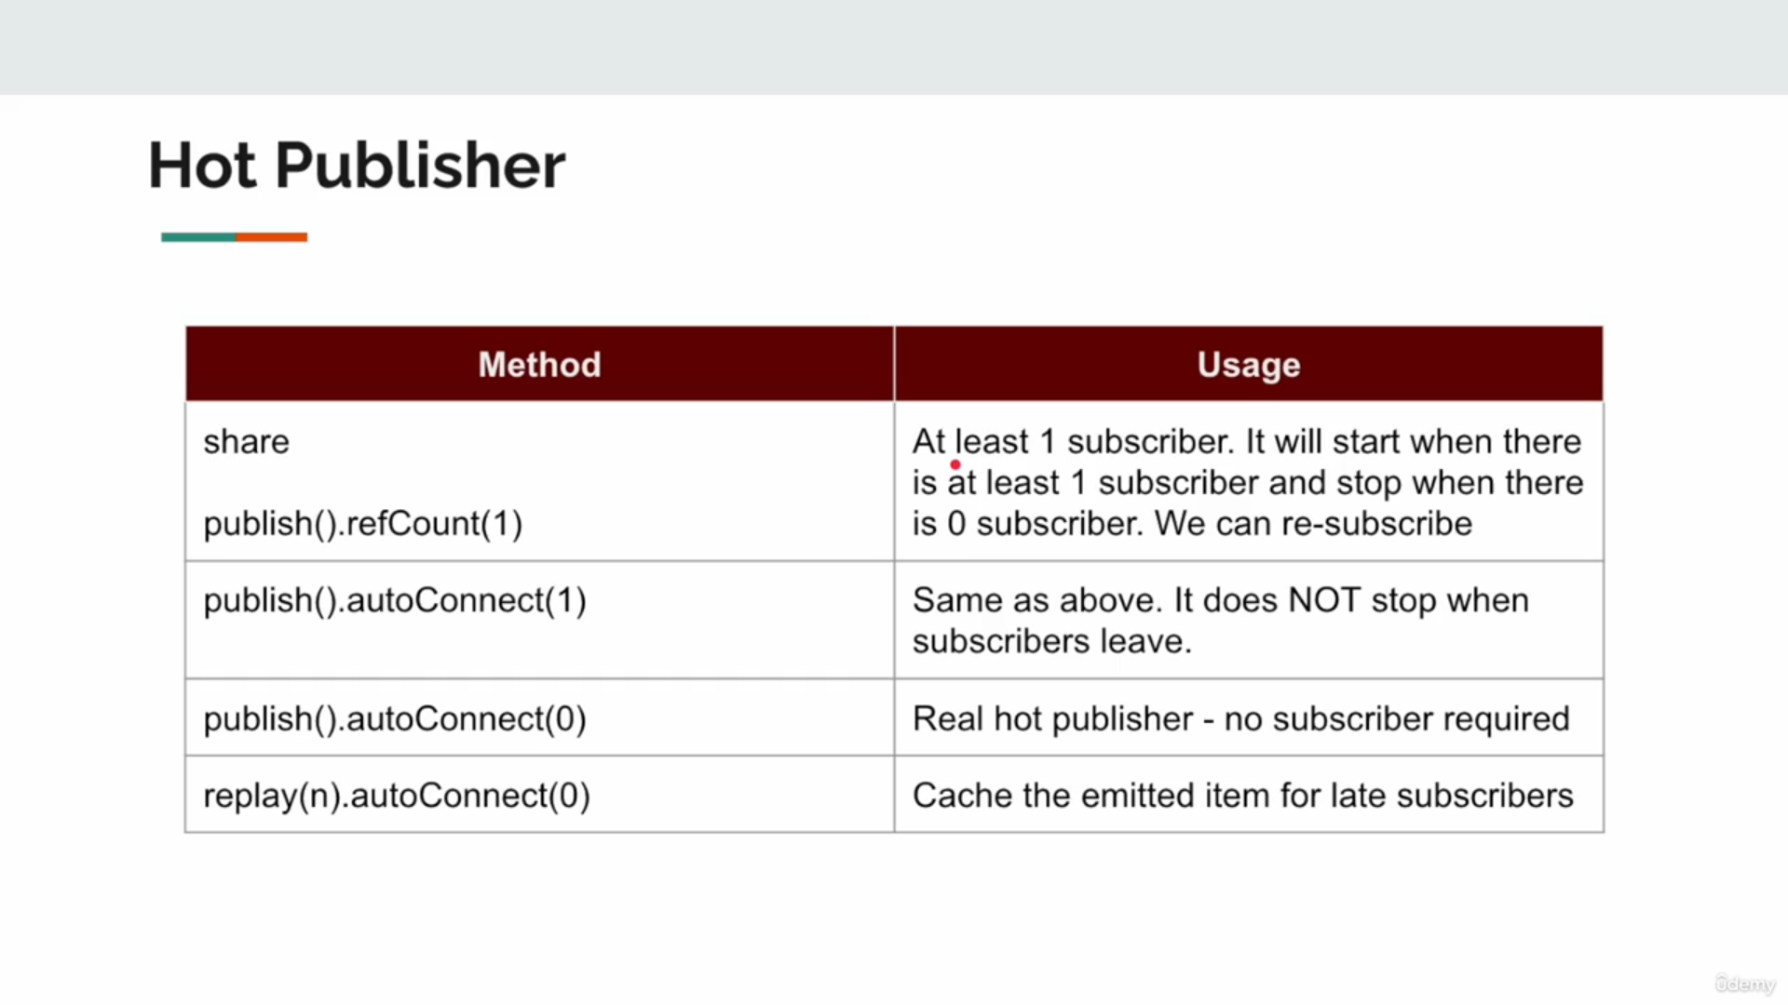
Repeat & Retry
Repeat Operator in Project Reactor
The repeat() operator in Project Reactor is used to re-subscribe to a Flux or Mono after it completes. This allows you to replay the entire sequence multiple times without recreating the publisher manually.

Key Features
- Re-subscribes Automatically:
  - Once the Flux or Mono completes, the repeat() operator will automatically re-subscribe.
- Infinite or Finite Repetition:
  - Infinite Repetition: Using repeat() without parameters causes the stream to repeat indefinitely.
  - Finite Repetition: You can specify a number (repeat(n)) to repeat the stream n times.
- Control with Predicate:
  - You can provide a condition (predicate) to control when to stop repeating.

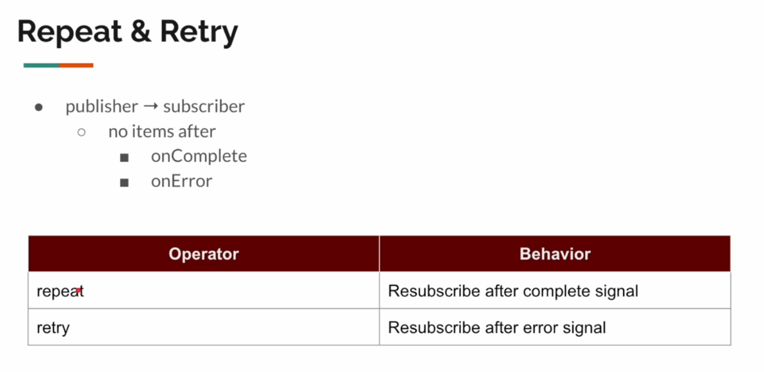

Usage Examples

1. Infinite Repetition
Flux.just("A", "B", "C")
.repeat()
.subscribe(Util.subscriber("infinite-repeat"));

Explanation:
- Emits "A", "B", "C" repeatedly without stopping.
- Caution: Ensure you handle this carefully to avoid infinite loops in production.

2. Finite Repetition
Flux.just("1", "2", "3")
.repeat(2)
.subscribe(Util.subscriber("finite-repeat"));

Explanation:
- Emits "1", "2", "3" a total of 3 times (1 original emission + 2 repeats).
Output:
finite-repeat: 1
finite-repeat: 2
finite-repeat: 3
finite-repeat: 1
finite-repeat: 2
finite-repeat: 3
finite-repeat: 1
finite-repeat: 2
finite-repeat: 3

3. Conditional Repetition
AtomicInteger counter = new AtomicInteger(1);
Flux.just("X", "Y", "Z")
.repeat(() -> counter.getAndIncrement() <= 3) // Repeat 3 times
.subscribe(Util.subscriber("conditional-repeat"));

Explanation:
- Repeats the sequence only if the condition (counter <= 3) evaluates to true.

When to Use repeat()
- Retrying Certain Tasks:
  - If a task needs to be retried (but doesn't involve errors, use retry() for error handling).
- Replaying Streams:
  - Useful for data streams that need to be replayed for different subscribers or components.
- Testing or Simulation:
  - Simulate repetitive events or behaviors.

Repeat vs. Retry
Aspect | repeat() | retry()
Purpose | Repeats the sequence after completion. | Re-subscribes on encountering an error.
When It Triggers | After the stream completes successfully. | Only when the stream fails with an error.
Use Case | Replaying completed streams. | Retrying operations on failure (e.g., network calls).

Real-World Example

Streaming Weather Data
Imagine a service that streams weather updates every 5 seconds and you want to repeat the updates 3 times.
Flux.interval(Duration.ofSeconds(5))
.take(1) // Simulate one weather update per interval
.map(i -> "Weather Update #" + (i + 1))
.repeat(3) // Repeat the stream 3 times
.subscribe(Util.subscriber("weather-stream"));

Behavior:
- The stream emits "Weather Update #1".
- Repeats this update 3 more times.

/**
* Demonstrates the Repeat Operator:
* - The Repeat operator simply re-subscribes to the source upon receiving a "complete" signal.
* - It does not handle "error" signals. If an error occurs, the sequence stops, and the error propagates.
*/
public class Repeat {
public static void main(String[] args) {
// Creates a Mono that emits a random company name using a supplier
var mono = Mono.fromSupplier(() -> Util.faker().company().name());
// Create a subscriber for the Mono
var subscriber = Util.subscriber();
/**
* Repeat Operator:
* - The `repeat(4)` operator re-subscribes to the Mono 4 additional times after the first completion.
* - Total subscriptions = 1 original + 4 repeats = 5 times.
*/
mono.repeat(4).subscribe(subscriber);
/**
* Manual Subscription:
* - This block manually subscribes to the Mono 4 times in a loop.
* - This approach explicitly triggers a subscription without using the `repeat` operator.
* - The output will be similar to the repeat operator but requires manual control.
*/
for (int i = 0; i < 4; i++) {
mono.subscribe(subscriber);
}
}
}

Explanation of the Code
- Mono Creation:
  - The Mono.fromSupplier() creates a Mono that emits a random company name every time it is subscribed to.
Mono.fromSupplier(() -> Util.faker().company().name());

The supplier is invoked every time the Mono is subscribed to, producing a fresh value.

- Repeat Operator:
  - Behavior:
    - The repeat(4) operator ensures the Mono re-subscribes 4 additional times after the initial completion.
    - This results in the total stream being executed 5 times (1 original + 4 repeats).
  - Purpose:
    - Automates the process of re-subscribing without manually managing the subscription.
mono.repeat(4).subscribe(subscriber);

Manual Subscription:
- The for loop manually subscribes to the Mono 4 times, achieving similar behavior to the repeat(4) operator.
- Difference:
  - With manual subscriptions, you have explicit control over the timing and logic for each subscription.
  - The repeat operator, however, handles re-subscriptions automatically.
for (int i = 0; i < 4; i++) {
mono.subscribe(subscriber);
}

Key Takeaways About the Repeat Operator
- Resubscription on Completion:
  - The repeat operator re-subscribes to the source upon receiving a "complete" signal.
- Error Handling:
  - If the Mono or Flux encounters an error signal, the repeat operator will not retry. For error retries, use the retry() operator instead.
- Usage:
  - Automates repetitive subscriptions.
  - Reduces boilerplate code compared to manually subscribing multiple times.

Comparison: Repeat vs. Manual Subscription
Aspect | repeat(n) | Manual Subscription
Control | Automatically re-subscribes n times. | Explicit control over each subscription.
Code Simplicity | Requires fewer lines of code. | Requires additional logic to manage subscriptions.
Flexibility | Limited to re-subscribing the same number of times. | Flexible; you can add custom logic before each subscription.

Output
Assuming Util.faker().company().name() generates random company names, the output might look like:
Using repeat(4):
subscriber: Microsoft
subscriber: Apple
subscriber: Google
subscriber: Amazon
subscriber: Facebook

Using Manual Subscription:
subscriber: Microsoft
subscriber: Apple
subscriber: Google
subscriber: Amazon

The behavior will appear similar, but the manual subscription logic is explicitly controlled in the loop.

Practical Use Cases of repeat
- Data Refresh:
  - When you need to re-fetch or regenerate data periodically upon completion.
- Testing:
  - Useful in test cases to simulate repeated behavior or data streams.
- Simulations:
  - For repetitive tasks like generating random names or simulating event streams.

/**
* Demonstrates the Repeat Operator:
* - The Repeat operator re-subscribes to the source upon receiving a "complete" signal.
* - It does not handle "error" signals; errors propagate and stop the sequence.
*/
public class RepeatPart2 {
public static void main(String[] args) {
// Example 1: Basic Repeat with Flux
Flux.just(1, 2, 3) // Emit 1, 2, 3
.repeat(3) // Repeat the sequence 3 times (total 4 executions)
.subscribe(Util.subscriber()); // Subscribe and print the emitted items
demo(); // Example 2: Repeating a Mono
demo3(); // Example 3: Conditional Repeat with a Predicate
demo4(); // Example 4: Repeat with Delay
demo5(); // Example 5: Repeat with Delay and Limited Repetition
try {
Util.sleepSeconds(2); // Allow enough time for asynchronous operations to complete
} catch (InterruptedException e) {
throw new RuntimeException(e);
}
}
/**
* Example 2: Repeating a Mono with a Fixed Count
* - The Mono emits a random country name.
* - It repeats the emission 3 times after the first completion.
*/
private static void demo() {
getCountryName()
.repeat(3) // Repeat the Mono 3 additional times (4 total emissions)
.subscribe(Util.subscriber()); // Subscribe and print emitted country names
}
/**
* Example 3: Conditional Repeat Using a Predicate
* - Uses a condition to determine whether to repeat the Mono.
* - Repeats until the emitted country name equals "Canada".
*/
private static void demo2() {
getCountryName()
.repeat() // Repeat indefinitely
.takeUntil(c -> c.equalsIgnoreCase("Canada")) // Stop when "Canada" is emitted
.subscribe(Util.subscriber()); // Subscribe and print emitted items
}
/**
* Example 4: Conditional Repeat Using a Dynamic Predicate
* - Repeats the Mono while a condition (based on an AtomicInteger) evaluates to true.
*/
private static void demo3() {
var atomicInteger = new AtomicInteger(0); // Counter to track repetitions
getCountryName()
.repeat(() -> atomicInteger.incrementAndGet() < 4) // Repeat while counter < 4
.subscribe(Util.subscriber()); // Subscribe and print emitted items
}
/**
* Example 5: Repeat with a Delay
* - Repeats the Mono after a delay between completions.
* - Delays the repetition by 2 seconds.
*/
private static void demo4() {
getCountryName()
.repeatWhen(flux -> flux.delayElements(Duration.ofSeconds(2))) // Add 2-second delay before repeating
.subscribe(Util.subscriber()); // Subscribe and print emitted items
}
/**
* Example 6: Repeat with a Delay and Limited Repetition
* - Repeats the Mono after a delay but limits the number of repetitions.
* - The delay is 2 seconds, and it repeats only 3 times.
*/
private static void demo5() {
getCountryName()
.repeatWhen(flux -> flux.delayElements(Duration.ofSeconds(2)).take(3)) // Add delay and limit to 3 repetitions
.subscribe(Util.subscriber()); // Subscribe and print emitted items
}
/**
* A Mono that emits a random country name.
* - Uses Faker library to generate non-blocking random country names.
* - Acts as the data source for the repeat operations.
*/
private static Mono<String> getCountryName() {
return Mono.fromSupplier(() -> Util.faker().country().name()); // Non-blocking IO
}
}

Basic Repeat (repeat(n)):
  - Repeats the sequence n additional times after the first emission.
  - Suitable for scenarios where you know the exact number of repetitions required.
- Infinite Repeat with Condition (repeat() and takeUntil()):
  - Allows you to repeat the sequence until a specific condition is met.
  - Useful for dynamic stopping logic, such as waiting for a particular value.
- Conditional Repeat with Predicate (repeat(Supplier<Boolean>)):
  - Repeats based on a dynamic condition provided as a predicate.
  - Commonly used for scenarios involving counters or state-based logic.
- Repeat with Delay (repeatWhen):
  - Adds a delay between repetitions.
  - Ideal for rate-limiting or delaying retries in streaming systems.
- Repeat with Delay and Limit (repeatWhen with take(n)):
  - Combines delayed repetition with a specific limit.
  - Useful for throttling or retrying operations with backoff.

Key Insights

Behavior
- The repeat operator re-subscribes to the source upon receiving a completion signal.
- It does not handle error signals; if an error occurs, the sequence stops and the error propagates.

Use Cases
- Data Refresh:
  - Repeatedly fetch or process data after completion.
  - Example: Re-fetching weather data periodically.
- Dynamic Stopping Logic:
  - Stop repeating based on certain conditions (e.g., a specific value is emitted).
- Retry Mechanisms:
  - Use with delays to implement custom retry logic in non-error scenarios.
- Simulating Streams:
  - Simulate continuous data streams or repetitive tasks for testing.

Output (Example)

For demo()
subscriber: USA
subscriber: Canada
subscriber: France
subscriber: Germany

For demo3() (Conditional Repeat)
subscriber: USA
subscriber: Canada
subscriber: Mexico
subscriber: Brazil

For demo4() (Delay Between Repeats)
subscriber: Japan
[2-second delay]
subscriber: India
[2-second delay]
subscriber: China

For demo5() (Delay + Limit)
subscriber: Japan
[2-second delay]
subscriber: Germany
[2-second delay]
subscriber: Australia

The repeat operator provides flexible ways to handle repetitive emissions in reactive streams, allowing for fine-grained control through conditions, delays, and limits. It is particularly useful for implementing refreshing mechanisms, simulations, or custom retry behaviors in non-error scenarios.

Retry Operator in Project Reactor
The retry operator in Project Reactor is used to re-subscribe to a Mono or Flux when an error occurs in the reactive pipeline. Unlike the repeat operator (which re-subscribes after a completion signal), retry is specifically designed for error handling.

Key Features
- Retry on Errors:
  - The retry operator re-subscribes to the source upon encountering an error signal.
  - It will continue retrying based on the configured logic or predicate.
- Finite or Infinite Retries:
  - Finite Retries: Retry the source a specific number of times (retry(n)).
  - Infinite Retries: Retry indefinitely until the source succeeds or is terminated manually (retry()).
- Conditional Retry:
  - Retry based on a condition or a predicate (e.g., retry only on certain exceptions).
- Time-Based Retry:
  - Combine with operators like retryWhen for time-based backoff strategies.

Usage Examples

1. Basic Retry
Mono.just("Hello")
.map(value -> {
if (value.equals("Hello")) {
throw new RuntimeException("Error encountered");
}
return value;
})
.retry(3) // Retry up to 3 times upon error
.subscribe(
System.out::println,
error -> System.err.println("Error after retries: " + error.getMessage())
);

Explanation:
- The retry(3) operator re-subscribes to the source up to 3 times if an error occurs.
- After 3 retries, if the error persists, the onError handler will be invoked.

2. Infinite Retry
Mono.just("Hello")
.map(value -> {
if (value.equals("Hello")) {
throw new RuntimeException("Error encountered");
}
return value;
})
.retry() // Retry indefinitely
.subscribe(
System.out::println,
error -> System.err.println("This will never be called")
);

Explanation:
- The retry() operator retries indefinitely, so the onError handler will never be invoked unless the subscription is canceled manually.

3. Conditional Retry
Flux.just(1, 2, 3)
.map(i -> {
if (i == 3) {
throw new IllegalArgumentException("Invalid value: " + i);
}
return i;
})
.retry(e -> e instanceof IllegalArgumentException) // Retry only for specific exceptions
.subscribe(
System.out::println,
error -> System.err.println("Error: " + error.getMessage())
);

Explanation:
- The retry(predicate) operator retries only if the predicate returns true.
- In this example, the stream retries only for IllegalArgumentException.

4. Time-Based Retry with retryWhen
Flux.just("Data1", "Data2")
.map(data -> {
if (data.equals("Data2")) {
throw new RuntimeException("Network error");
}
return data;
})
.retryWhen(errors -> errors.delayElements(Duration.ofSeconds(2))) // Retry with a delay
.subscribe(
System.out::println,
error -> System.err.println("Error after retries: " + error.getMessage())
);

Explanation:
- The retryWhen operator allows for advanced retry strategies.
- In this case, retries are delayed by 2 seconds between each attempt.

When to Use the Retry Operator
- Handling Transient Failures:
  - For operations prone to temporary issues, like:
    - Network errors
    - Database connection timeouts
    - Rate-limited APIs
- Error Recovery:
  - Useful in pipelines where temporary errors should not terminate the entire stream.
- Retry Logic Customization:
  - Use predicates or time-based strategies to handle retries efficiently.

Retry vs. Repeat
Aspect | Retry | Repeat
Trigger | Re-subscribes upon encountering an error. | Re-subscribes upon receiving a complete signal.
Use Case | For error recovery and retrying failed tasks. | For repeating a completed stream or task.
Behavior on Error | Retries until the error condition is resolved or limits are reached. | Stops and propagates the error.

Real-World Example: Database Query
Mono<String> queryDatabase() {
return Mono.fromSupplier(() -> {
if (Math.random() < 0.5) {
throw new RuntimeException("Database connection timeout");
}
return "Query Result";
});
}
public static void main(String[] args) {
queryDatabase()
.retry(3) // Retry the query up to 3 times on failure
.subscribe(
result -> System.out.println("Query succeeded: " + result),
error -> System.err.println("Query failed after retries: " + error.getMessage())
);
}

Retry Operator:
  - Handles errors by re-subscribing to the source.
  - Can be configured for finite, infinite, or conditional retries.
- Error Handling:
  - Ensures transient failures do not terminate the pipeline.
  - Allows for flexible retry strategies using predicates or retryWhen.
- Practical Usage:
  - Network calls, database queries, and API requests where transient failures are common.
  - Simulating retry mechanisms for testing purposes.

/**
* Demonstrates the Retry Operator:
* - The retry operator re-subscribes to the source upon receiving an "error signal."
* - Can be used for handling transient errors or for implementing retry logic.
* - Variants shown include finite retries, infinite retries, condition-based retries, and retries with delays.
*/
public class Retry {
// Logger to log retry events
public static final Logger logger = LoggerFactory.getLogger(reactor.util.retry.Retry.class);
public static void main(String[] args) {
// Example 1: Retry a Mono up to 2 times
demo1();
// Example 2: Retry indefinitely on errors
demo2();
// Example 3: Conditional retry with filtering and retry exhaustion handling
demo3();
// Example 4: Retry with a fixed delay between attempts
demo4();
try {
Util.sleepSeconds(10); // Allow sufficient time for asynchronous retries
} catch (InterruptedException e) {
throw new RuntimeException(e);
}
}
/**
* Example 1: Finite Retry
* - Retries the Mono up to 2 times after an error occurs.
* - After 2 retries, if the error persists, the error propagates to the subscriber.
*/
private static void demo1() {
getCountryName()
.retry(2) // Retry up to 2 times
.subscribe(Util.subscriber()); // Subscribe and handle emissions or errors
}
/**
* Example 2: Infinite Retry
* - Retries the Mono indefinitely upon encountering an error.
* - Use cautiously, as it may lead to infinite loops if the error persists.
*/
private static void demo2() {
getCountryName()
.retryWhen(reactor.util.retry.Retry.indefinitely()) // Retry indefinitely
.subscribe(Util.subscriber()); // Subscribe and handle emissions or errors
}
/**
* Example 3: Conditional Retry
* - Retries the Mono up to 2 times, but only for specific exceptions.
* - Executes logic before and after retries using filters and handlers.
*/
private static void demo3() {
getCountryName()
.retryWhen(
reactor.util.retry.Retry.max(2) // Retry up to 2 times
.filter(ex -> RuntimeException.class.equals(ex.getClass())) // Retry only for RuntimeException
.onRetryExhaustedThrow((retrySpec, signal) -> signal.failure()) // Throw the original error after retries
)
.subscribe(Util.subscriber());
}
/**
* Example 4: Retry with Fixed Delay
* - Retries the Mono up to 2 times, with a 1-second delay between retries.
* - Useful for handling transient failures in a controlled manner.
*/
private static void demo4() {
getCountryName()
.retryWhen(reactor.util.retry.Retry.fixedDelay(2, Duration.ofSeconds(1))) // Retry with a fixed 1-second delay
.subscribe(Util.subscriber());
}
/**
* Generates a Mono that emits a random country name.
* - Simulates non-blocking data generation.
* - Errors can be simulated for retry examples by modifying the supplier logic.
*/
private static Mono<String> getCountryName() {
return Mono.fromSupplier(() -> {
if (Math.random() < 0.5) {
throw new RuntimeException("Transient Error"); // Simulate a transient error
}
return Util.faker().country().name(); // Emit a random country name
});
}
}

Detailed Explanation of retry Variants
- Finite Retry (retry(n)):
  - Retries the source n times before propagating the error.
  - Use Case: When you want to handle transient errors but limit retry attempts to prevent infinite loops.
getCountryName()
.retry(2) // Retry 2 times
.subscribe(Util.subscriber());

Infinite Retry (retryWhen(reactor.util.retry.Retry.indefinitely())):
- Retries the source indefinitely until the error is resolved or the stream is canceled.
- Use Case: Useful for systems where failures are expected to resolve eventually, such as retrying network requests.
getCountryName()
.retryWhen(reactor.util.retry.Retry.indefinitely())
.subscribe(Util.subscriber());
Conditional Retry (retryWhen with Filters and Exhaustion Handling):
- Retries the source for specific exceptions or based on custom conditions.
- Use Case: When retry logic depends on the type of error or custom retry conditions.
getCountryName()
.retryWhen(
reactor.util.retry.Retry.max(2) // Retry 2 times
.filter(ex -> RuntimeException.class.equals(ex.getClass())) // Retry only for RuntimeException
.onRetryExhaustedThrow((retrySpec, signal) -> signal.failure()) // Throw error after retries
)
.subscribe(Util.subscriber());

Retry with Fixed Delay (retryWhen with fixedDelay):
- Retries the source with a fixed delay between each attempt.
- Use Case: Useful for retrying tasks that may require a cooldown period, such as handling rate limits or API failures.
getCountryName()
.retryWhen(reactor.util.retry.Retry.fixedDelay(2, Duration.ofSeconds(1)))
.subscribe(Util.subscriber());

Behavior of the Retry Operator
- The retry operator re-subscribes to the source upon receiving an error signal.
- It is suitable for handling transient failures, where retrying might resolve the issue (e.g., network timeouts).

Error Handling
- If retries are exhausted (e.g., in retry(n)), the original error is propagated to the subscriber.
- For more control, retryWhen provides advanced customization for retry strategies, delays, and conditions.

Practical Use Cases
- Network Failures:
  - Retrying failed HTTP requests or database queries.
- Rate-Limited APIs:
  - Handling API rate limits by introducing delays between retries.
- Resilient Pipelines:
  - Building resilient systems where transient errors (e.g., timeouts) are common but recoverable.

Output Example

Scenario 1: Finite Retry
subscriber: Transient Error
subscriber: France
subscriber: Transient Error
subscriber: Transient Error
Error after retries: Transient Error

Scenario 2: Infinite Retry
subscriber: Transient Error
subscriber: Transient Error
subscriber: France

Scenario 3: Retry with Fixed Delay
emitting country name
retrying after 1s delay
emitting country name
retrying after 1s delay
subscriber: Germany

Key Differences Between retry and repeat
Aspect | retry | repeat
Trigger | Retries on error signals. | Re-subscribes on completion signals.
Use Case | Error handling and transient failures. | Repeating tasks or replaying sequences.
Behavior | Stops on non-transient errors after retries. | Stops after the configured repetition count.

Sinks
A Sink is a concept used in various contexts, especially in programming, data streaming, and event-driven architectures. Here's what it generally means:

What is a Sink?
A Sink represents a destination or endpoint where data, events, or messages are delivered or written. It contrasts with a Source, which produces or originates the data.

Contexts Where Sinks Are Used

1. Data Streaming (Kafka, Flink, etc.)
- Sink: The endpoint where processed data is sent, such as a database, file system, or another data pipeline.
- Example:
  - In Apache Flink:
    - A Source reads data from Kafka.
    - Data is processed in Flink.
    - The processed data is sent to a Sink (e.g., a database or Elasticsearch).

2. Reactive Programming (Project Reactor, RxJava, RSocket)
- Sink: A terminal operation or endpoint where data emitted by a publisher is consumed.
- Example:
  - A FluxSink in Project Reactor lets you programmatically emit signals to a reactive stream.

3. Logging
- Sink: The target where logs are stored or displayed.
- Example:
  - A logging library (like Serilog or Logback) can define multiple sinks, such as:
    - Console.
    - File.
    - External monitoring systems (e.g., Splunk, Elasticsearch).

4. Data Integration (ETL Pipelines)
- Sink: The target system where transformed data is stored.
- Example:
  - Data is extracted from a source like an API, transformed, and then written to a sink like a database or data lake.

5. Networking
- Sink: The receiving end of data in a network stream.
- Example:
  - A server can act as a sink for incoming data packets.

Examples in Practice
- Kafka Connect Sink:
  - A Kafka Sink Connector sends data from Kafka topics to an external system (e.g., PostgreSQL, MongoDB).
- Reactive Stream Sink:
  - A FluxSink is used to generate elements into a Flux programmatically.
- Apache Flink Sink:
  - You can write streaming data from Flink to a Sink like a relational database, HDFS, or an S3 bucket.

When to Use Sinks?
Use sinks when:
- You need to persist or process data after it flows through a pipeline.
- You are building a reactive system that delivers processed results to an endpoint.
- You need to decouple data production and consumption in distributed systems.

